


“Finals Fever”
VERMONT HOLIDAY PROGRAM
Monday 19th September – Thursday 29th September

Where: Sportlink – 2 Hanover Rd Vermont South
Cost: Only $50 per day
Enrol: gary@kellysports.com.au ⋅ 0437 076 897 ⋅ www.kellysports.com.au
WEEK ONE

 | MON | TUES |  | WED | THUR | FRI
9 – 10.30am | INTRO    FUN GAMES   | INTRO  FUN GAMES   |  | INTRO  FUN GAMES   | INTRO  FUN GAMES   | INTRO  FUN GAMES
 | RECESS
11am – 1pm | SOCCER    BASKETBALL   |  | CRAZY KELLY SPORTS OLYMPICS   | FOOTY    HOCKEY   | SOCCER  FRISBEE | CRICKET    BBALL
 | LUNCH
2pm – 4pm | CRAFT    KIDS CHOICE   | SCAVENGER HUNT  KIDS CHOICE |  | SOCCER  KIDS CHOICE | TRIVIA  RELAYS | BADMINTON    KIDS CHOICE

“Finals Fever”
VERMONT HOLIDAY PROGRAM
Monday 19th September – Thursday 29th September

WEEK TWO
Where: Sportlink – 2 Hanover Rd Vermont South
Cost: Only $50 per day
Enrol: gary@kellysports.com.au ⋅ 0437 076 897 ⋅ www.kellysports.com.au

 | MON | TUES | WED | THUR | FRI
9 – 10.30am | INTRO  FUN GAMES   | INTRO  FUN GAMES | INTRO  FUN GAMES | INTRO  FUN GAMES | NO PROGRAM TODAY DUE TO PUBLIC HOLIDAY
 | RECESS
11am – 1pm | SOCCER  RELAYS | FRISBEE  BASKETBALL | FOOTY  HOCKEY | FOOTY EXTRAVAGANZA | NO PROGRAM TODAY DUE TO PUBLIC HOLIDAY
 | LUNCH
2pm – 4pm | ROUNDERS    KIDS CHOICE | SCAVENGER HUNT  ATHLETICS | 4 SQUARE CHALLENGE  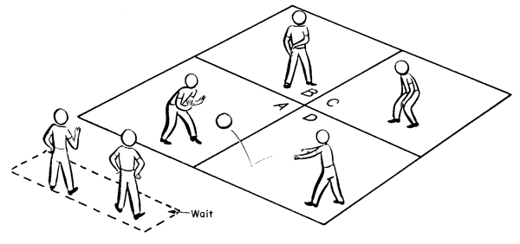  KIDS CHOICE | TRIVIA  KIDS CHOICE | NO PROGRAM TODAY DUE TO PUBLIC HOLIDAY

