


“Summer Fun”
VERMONT HOLIDAY PROGRAM
Monday 9th January – Wednesday 25th September

Where: Sportlink – 2 Hanover Rd Vermont South
Cost: Only $50 per day
Enrol: gary@kellysports.com.au ⋅ 0437 076 897 ⋅ www.kellysports.com.au
WEEK ONE

 | MON | TUES |  |  | WED | THUR | FRI
9 – 10.30am | INTRO    FUN GAMES   | INTRO  FUN GAMES   |  |  | INTRO  FUN GAMES   | INTRO  FUN GAMES   | INTRO  FUN GAMES
 | RECESS
11am –12.30pm | SOCCER    BASKETBALL   |  | NETBALL    BAT TENNIS   | FOOTY    HOCKEY   |  | SOCCER  FRISBEE | CRICKET    BBALL
 | LUNCH
1.15pm – 4pm | CRAFT    KIDS CHOICE   | SCAVENGER HUNT  KIDS CHOICE |  |  | SOCCER  KIDS CHOICE | TRIVIA  RELAYS   | BADMINTON    KIDS CHOICE
“Summer Fun”
VERMONT HOLIDAY PROGRAM
Monday 9th January – Wednesday 25th September

WEEK TWO
Where: Sportlink – 2 Hanover Rd Vermont South
Cost: Only $50 per day
Enrol: gary@kellysports.com.au ⋅ 0437 076 897 ⋅ www.kellysports.com.au

 | MON | TUES | WED | THUR | FRI
9 – 10.30am | INTRO  FUN GAMES   | INTRO  FUN GAMES | INTRO  FUN GAMES | INTRO  FUN GAMES | INTRO  FUN GAMES
 | RECESS
11am – 12.30pm | SOCCER  RELAYS | FRISBEE  BASKETBALL | FOOTY  HOCKEY | NETBALL  BAT TENNIS   | BASKETBALL  CRICKET
 | LUNCH
1.15pm – 4pm | ROUNDERS    KIDS CHOICE | SCAVENGER HUNT  ATHLETICS | 4 SQUARE CHALLENGE  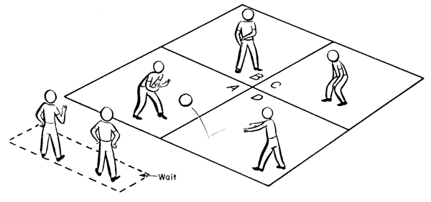  KIDS CHOICE | TRIVIA  KIDS CHOICE | CRAFT  KIDS CHOICE
“Summer Fun”
VERMONT HOLIDAY PROGRAM
“Summer Fun”
VERMONT HOLIDAY PROGRAM
Monday 9th January – Wednesday 25th September

 | MON | TUES | WED
9 – 10.30am | INTRO  FUN GAMES | INTRO  FUN GAMES | INTRO  FUN GAMES
 | RECESS
11am – 12.30pm | SOCCER  RELAYS | FRISBEE  BASKETBALL |  | CRICKET  HOCKEY
 | LUNCH
1.15pm – 4pm | ROUNDERS  KIDS CHOICE | SCAVENGER HUNT  ATHLETICS |  | CRAFT  KIDS CHOICE
Monday 9th January – Wednesday 25th September
“Summer Fun”
WEEK THREE
Where: Sportlink – 2 Hanover Rd Vermont South
Cost: Only $50 per day
Enrol: gary@kellysports.com.au ⋅ 0437 076 897 ⋅ www.kellysports.com.au

VERMONT HOLIDAY PROGRAM
Monday 9th January – Wednesday 25th September

