


“Dry in July”
VERMONT HOLIDAY PROGRAM
Monday 27th June – Friday 8th July

Where: Sportlink – 2 Hanover Rd Vermont South
Cost: Only $50 per day
Enrol: gary@kellysports.com.au ⋅ 0437 076 897 ⋅ www.kellysports.com.au
WEEK ONE

 | MON | TUES | WED | THUR | FRI
9 – 10.30am | INTRO    FUN GAMES   | INTRO  FUN GAMES   | INTRO  FUN GAMES   | INTRO  FUN GAMES   | INTRO  FUN GAMES
 | RECESS
11am – 1pm | SOCCER    HANDBALL | BBALL    RELAYS   | FOOTY    HOCKEY   | SOCCER  FRISBEE | CRICKET    BBALL
 | LUNCH
2pm – 4pm | CRAFT    KIDS CHOICE   | SCAVENGER HUNT  ATHLETICS | SOCCER  KIDS CHOICE | TRIVIA  RELAYS | BADMINTON    KIDS CHOICE

“Dry in July”
VERMONT HOLIDAY PROGRAM
Monday 27th June – Friday 8th July

WEEK TWO
Where: Sportlink – 2 Hanover Rd Vermont South
Cost: Only $50 per day
Enrol: gary@kellysports.com.au ⋅ 0437 076 897 ⋅ www.kellysports.com.au

 | MON | TUES | WED | THUR | FRI
9 – 10.30am | INTRO  FUN GAMES   | INTRO  FUN GAMES | INTRO  FUN GAMES | INTRO  FUN GAMES | INTRO  FUN GAMES
 | RECESS
11am – 1pm | SOCCER  RELAYS | FRISBEE  HANDBALL | FOOTY  HOCKEY | BBALL  BADMINTON | BBALL  FOOTY
 | LUNCH
2pm – 4pm | ROUNDERS    KIDS CHOICE | SCAVENGER HUNT  ATHLETICS | 4 SQUARE CHALLENGE  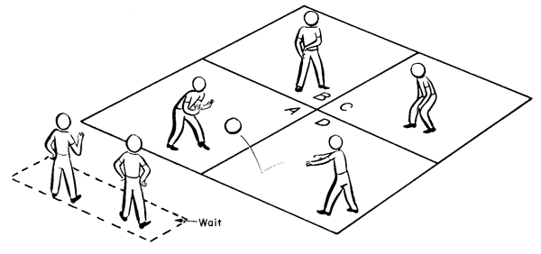  KIDS CHOICE | TRIVIA  HOCKEY | SOCCER  KIDS CHOICE

