

T 0437 076 897
FOLLOW US
ONLINE

E gary@kellysports.com.au




PARKSIDE PRESCHOOL



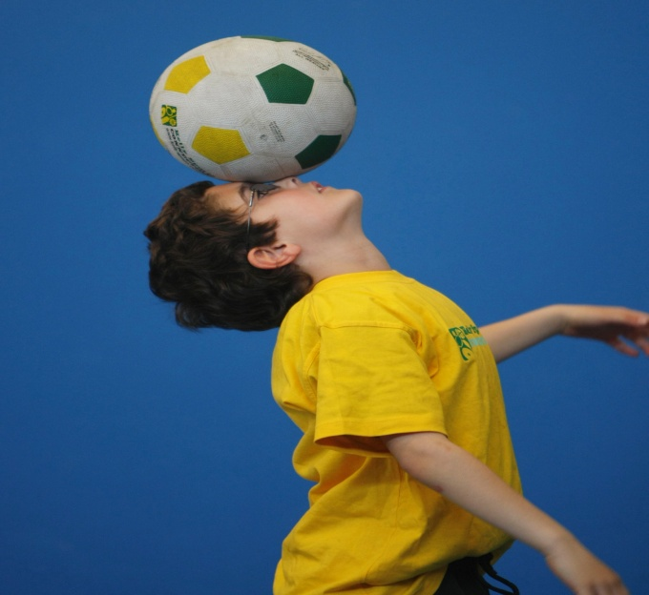
FUNDAMENTAL MOTOR SKILLS PROGRAM

Kelly Sports runs programs to teach children the fundamentals of sport. This 11 WEEK program is all inclusive with high participation. Our key aims are to develop and enhance the following skills – running, jumping, catching, throwing, passing, kicking and striking:
The Fundamental Skills Program includes:
- Motor Skill Development
- Balance and Hand- Eye Coordination
- Introduction to a variety of sports -Soccer, Basketball, Handball, Hockey, Football and more.
WHEN: Wednesday
COMMENCING: 13/04/16
CONCLUDING: 22/06/16
TIME: 9:30am – 10:30am
COST: $99 for 11 weeks

HOW DO YOU ENROL?
SIMPLY GO TO WWW.KELLYSPORTS.COM.AU ENTER YOUR POSTCODE, SELECT PARKSIDE PRESCHOOL AND ENROL FROM THERE.

It’s here online enrolments !
To enrol, please visit www.kellysports.com.au or
fill out the enrolment form & send with a cheque or credit card details to:
Kelly Sports PO BOX 71, Moonee Vale, VIC, 3055.
Payment options available!
Do not leave enrolment forms at the school office

