

P.O. Box 5185, Pinewood, 3149
FOLLOW US
ONLINE

T 0437 076 897
E gary@kellysports.com.au





MITCHAM PRIMARY SCHOOL
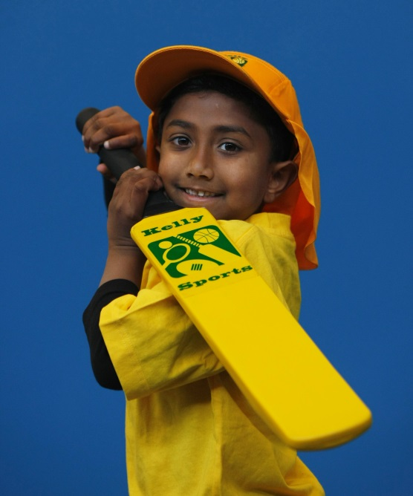
SUPER SUMMER SPORTS

Soccer – Cricket – Hockey – Basketball – Team Games Have fun in the sun this term! Spring into Sports dynamic and active programs run over 10 weeks; these include: Soccer, Hockey, Basketball, Cricket and team games. This Program will not only provide an essential base for your child's motor skills but help build awareness, co-ordination and friendship all in an enjoyable environment.

WHEN: Monday
COMMENCING: 8/2/16
CONCLUDING: 21/3/16
TIME: 3.20pm – 4.20pm
YEAR LEVELS: P – 4
COST: $70


GYM CLUB
GYM CLUB

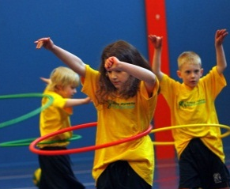
BEND YOUR WAY TO GYM CLUB THIS TERM! This fast paced, highly active and nonstop program is an introduction for your child to the world of gymnastic. Colourful Ribbons, Entertaining Hula Hoops, Fantastic Rhythmical Routines and Group Dynamics allow your child to build up their thirst for energetic activities

WHEN: Monday
COMMENCING: 8/2/16
CONCLUDING: 21/3/16
TIME: 1.20pm – 2.20pm
YEAR LEVELS: P – 4
COST: $70

GET IN QUICK FOR TERM 1 AS PLACES FILLING FAST
It’s here online enrolments !
To enrol, please visit www.kellysports.com.au or
fill out the enrolment form & send with a cheque or credit card details to:
Kelly Sports PO BOX 71, Moonee Vale, VIC, 3055.
Payment options available!
Do not leave enrolment forms at the school office

$70 FOR 7 WEEK PROGRAM

NEW IMPROVED ONLINE BOOKING SYSTEM!!!
SIMPLY GO TO WWW.KELLYSPORTS.COM.AU ENTER YOUR POST CODE AND ENROL FROM THERE. OR
FILL OUT THE BELOW ENROLMENT FOR & SEND WITH A CHEQUE OR CREDIT CARDS DETAILS TO:
PO BOX 5185, PINEWOOD 3149
PAYMENT OPTIONS AVALIABLE!

It’s here online enrolments !
To enrol, please visit www.kellysports.com.au or
fill out the enrolment form & send with a cheque or credit card details to:
Kelly Sports PO BOX 71, Moonee Vale, VIC, 3055.
Payment options available!
Do not leave enrolment forms at the school office

ENROLMENT FORM
Super Summer Sports Gym Club
School: Year Level:
Name: Room No:
Address: Post Code:
Phone: Mobile/Work:
Email: Medical Conditions:

At the completion of after school clinics, does your child? Go to after care Get collected
Parents’ consent: I hereby authorise Kelly Sports to act on my behalf should my child require medical attention, and release
Kelly Sports Blackburn from any liability for injury incurred by my child at Kelly Sports programs.
Parent/Caregiver name: Signature:
Amount Paid: $ Credit card payment: Visa Master card
Card Number: Expiry Date: /CVV:
THINGS TO KNOW
Kelly Sports is a Registered Child Care provider
Don’t leave forms at the School Office
Spaces are limited so please make sure you enrol online or return form to Kelly Sports.

It’s here online enrolments !
To enrol, please visit www.kellysports.com.au or
fill out the enrolment form & send with a cheque or credit card details to:
Kelly Sports PO BOX 71, Moonee Vale, VIC, 3055.
Payment options available!
Do not leave enrolment forms at the school office

It’s here online enrolments !
To enrol, please visit www.kellysports.com.au or
fill out the enrolment form & send with a cheque or credit card details to:
Kelly Sports PO BOX 71, Moonee Vale, VIC, 3055.
Payment options available!
Do not leave enrolment forms at the school office

It’s here online enrolments !
To enrol, please visit www.kellysports.com.au or
fill out the enrolment form & send with a cheque or credit card details to:
Kelly Sports PO BOX 71, Moonee Vale, VIC, 3055.
Payment options available!
Do not leave enrolment forms at the school office

