


P.O. Box 5185, Pinewood, 3149
T 0437 076 897
FOLLOW US
ONLINE

E gary@kellysports.com.au





KERRIMUIR PRIMARY SCHOOL
DANCE

Hip Hop (P-2) - Our Specialized dance coaches can get your child’s hips swinging, feet rocking and heads bumping to all of the modern music contemporary hits.
Sign up fast as places are limited for our 10 week program and let our coaches beat, ignite your child’s feet!


WHEN: Tuesday
COMMENCING: 19/4/16
CONCLUDING: 21/6/16
TIME: 1.40pm – 2.30pm
YEAR LEVELS: P – 4
COST: $100



NEW IMPROVED ONLINE BOOKING SYSTEM!!!
SIMPLY GO TO WWW.KELLYSPORTS.COM.AU ENTER YOUR POST CODE AND ENROL FROM THERE.

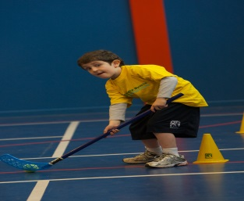
It’s here online enrolments !
To enrol, please visit www.kellysports.com.au or
fill out the enrolment form & send with a cheque or credit card details to:
Kelly Sports PO BOX 71, Moonee Vale, VIC, 3055.
Payment options available!
Do not leave enrolment forms at the school office

It’s here online enrolments !
To enrol, please visit www.kellysports.com.au or
fill out the enrolment form & send with a cheque or credit card details to:
Kelly Sports PO BOX 71, Moonee Vale, VIC, 3055.
Payment options available!
Do not leave enrolment forms at the school office

It’s here online enrolments !
To enrol, please visit www.kellysports.com.au or
fill out the enrolment form & send with a cheque or credit card details to:
Kelly Sports PO BOX 71, Moonee Vale, VIC, 3055.
Payment options available!
Do not leave enrolment forms at the school office

It’s here online enrolments !
To enrol, please visit www.kellysports.com.au or
fill out the enrolment form & send with a cheque or credit card details to:
Kelly Sports PO BOX 71, Moonee Vale, VIC, 3055.
Payment options available!
Do not leave enrolment forms at the school office

