

P.O. Box 5185, Pinewood, 3149
FOLLOW US
ONLINE

T 0437 076 897
E gary@kellysports.com.au





HOLY SAVIOUR PRIMARY SCHOOL
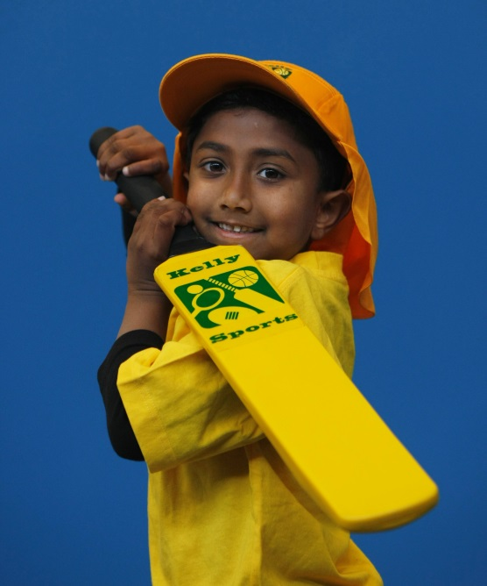
SUPER SUMMER SPORTS
Soccer – Cricket – Basketball Have fun in the sun this term! Super Summer Sports dynamic and active programs run over 7 weeks; these include: Soccer, Basketball and Cricket.. This Program will not only provide an essential base for your child's motor skills but help build awareness, co-ordination and friendship all in an enjoyable environment.

WHEN: Friday
COMMENCING: 12/2/16
CONCLUDING: 18/3/16
TIME: 3.40pm – 4.40pm
YEAR LEVELS: P – 4
COST: $60


DANCE


WHEN: Monday
COMMENCING: 8/2/16
CONCLUDING: 21/3/16
TIME: 1.30pm – 2.30pm
YEAR LEVELS: P – 4
COST: $70

Hip Hop (P-4) Our Specialized dance coaches can get your child’s hips swinging, feet rocking and heads bumping to all of the modern music contemporary music classics.
Sign up fast as places are limited for our 7 week program and let our coaches beat, ignite your child’s feet!

GET IN QUICK FOR TERM 1 AS PLACES FILLING FAST
It’s here online enrolments !
To enrol, please visit www.kellysports.com.au or
fill out the enrolment form & send with a cheque or credit card details to:
Kelly Sports PO BOX 71, Moonee Vale, VIC, 3055.
Payment options available!
Do not leave enrolment forms at the school office


NEW IMPROVED ONLINE BOOKING SYSTEM!!!
SIMPLY GO TO WWW.KELLYSPORTS.COM.AU ENTER YOUR POST CODE AND ENROL FROM THERE. OR
FILL OUT THE BELOW ENROLMENT FORM & SEND WITH A CHEQUE OR CREDIT CARDS DETAILS TO:
PO BOX 5185, PINEWOOD, 3149
PAYMENT OPTIONS AVAILABLE!

It’s here online enrolments !
To enrol, please visit www.kellysports.com.au or
fill out the enrolment form & send with a cheque or credit card details to:
Kelly Sports PO BOX 71, Moonee Vale, VIC, 3055.
Payment options available!
Do not leave enrolment forms at the school office

ENROLMENT FORM
Super Summer Sports End of Year Cheer
School: Year Level:
Name: Room No:
Address: Post Code:
Phone: Mobile/Work:
Email: Medical Conditions:

At the completion of after school clinics, does your child? Go to after care Get collected
Parents’ consent: I hereby authorise Kelly Sports to act on my behalf should my child require medical attention, and release
Kelly Sports Blackburn from any liability for injury incurred by my child at Kelly Sports programs.
Parent/Caregiver name: Signature:
Amount Paid: $ Credit card payment: Visa Master card
Card Number: Expiry Date: /CVV:
THINGS TO KNOW
Kelly Sports is a Registered Child Care provider
Don’t leave forms at the School Office
Spaces are limited so please make sure you enrol online or return form to Kelly Sports.

It’s here online enrolments !
To enrol, please visit www.kellysports.com.au or
fill out the enrolment form & send with a cheque or credit card details to:
Kelly Sports PO BOX 71, Moonee Vale, VIC, 3055.
Payment options available!
Do not leave enrolment forms at the school office

It’s here online enrolments !
To enrol, please visit www.kellysports.com.au or
fill out the enrolment form & send with a cheque or credit card details to:
Kelly Sports PO BOX 71, Moonee Vale, VIC, 3055.
Payment options available!
Do not leave enrolment forms at the school office

It’s here online enrolments !
To enrol, please visit www.kellysports.com.au or
fill out the enrolment form & send with a cheque or credit card details to:
Kelly Sports PO BOX 71, Moonee Vale, VIC, 3055.
Payment options available!
Do not leave enrolment forms at the school office

