

T 0437 076 897
FOLLOW US
ONLINE

E gary@kellysports.com.au





CASA BAMBINI ELC AND KINDER
FUNDAMENTAL MOTOR SKILLS PROGRAM
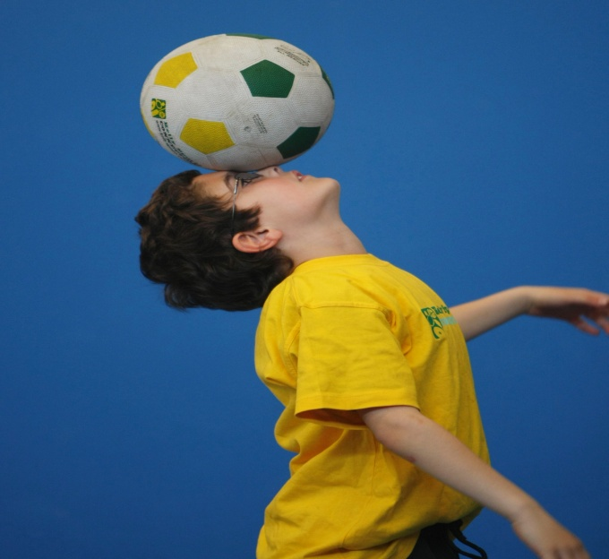
Kelly Sports runs programs to teach children the fundamentals of sport. This 19 WEEK program is all inclusive with high participation. Our key aims are to develop and enhance the following skills – running, jumping, catching, throwing, passing, kicking and striking:
The Fundamental Skills Program includes:
- Motor Skill Development
- Balance and Hand- Eye Coordination
- Introduction to a variety of sports -Soccer, Basketball, Handball, Hockey, Football and more.
WHEN: Tuesday
COMMENCING: 02/02/16
CONCLUDING: 21/06/16
TIME: 9:15am – 10:15am
COST: $152 for 19 weeks

GET IN QUICK FOR TERM 1 2016 AS PLACES FILLING FAST
$152 FOR 19 WEEK PROGRAM

It’s here online enrolments !
To enrol, please visit www.kellysports.com.au or
fill out the enrolment form & send with a cheque or credit card details to:
Kelly Sports PO BOX 71, Moonee Vale, VIC, 3055.
Payment options available!
Do not leave enrolment forms at the school office

NEW IMPROVED ONLINE BOOKING SYSTEM!!!
SIMPLY GO TO WWW.KELLYSPORTS.COM.AU ENTER YOUR POSTCODE AND ENROL FROM THERE. OR
FILL OUT THE BELOW ENROLMENT FORM

ENROLMENT FORM
Fundamental Motor Skills
School: Year Level:
Name: Room No:
Address: Post Code:
Phone: Mobile/Work:
Email: Medical Conditions:
Parents’ consent: I hereby authorise Kelly Sports to act on my behalf should my child require medical attention, and release
Kelly Sports Perth from any liability for injury incurred by my child at Kelly Sports programs.
Parent/Caregiver name: Signature:
Amount Paid: $ Credit card payment: Visa Master card
Card Number: Expiry Date: /CVV:
THINGS TO KNOW
Kelly Sports is a Registered Child Care provider
Don’t leave forms at the School Office
Spaces are limited so please make sure you enrol online or return form to Kelly Sports.

It’s here online enrolments !
To enrol, please visit www.kellysports.com.au or
fill out the enrolment form & send with a cheque or credit card details to:
Kelly Sports PO BOX 71, Moonee Vale, VIC, 3055.
Payment options available!
Do not leave enrolment forms at the school office

It’s here online enrolments !
To enrol, please visit www.kellysports.com.au or
fill out the enrolment form & send with a cheque or credit card details to:
Kelly Sports PO BOX 71, Moonee Vale, VIC, 3055.
Payment options available!
Do not leave enrolment forms at the school office

It’s here online enrolments !
To enrol, please visit www.kellysports.com.au or
fill out the enrolment form & send with a cheque or credit card details to:
Kelly Sports PO BOX 71, Moonee Vale, VIC, 3055.
Payment options available!
Do not leave enrolment forms at the school office

