

P.O. Box 5185, Pinewood, 3149
FOLLOW US
ONLINE

T 0437 076 897
E gary@kellysports.com.au





BOX HILL NORTH PRIMARY SCHOOL
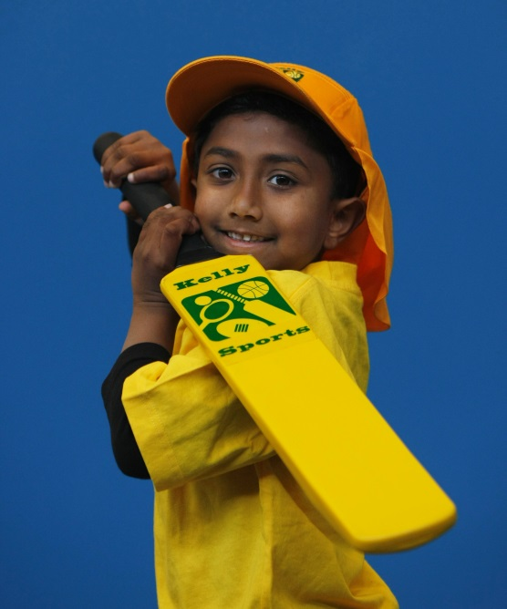
SUPER SUMMER SPORTS
Soccer – Cricket – Basketball
Have fun in the sun this term! Super Summer Sports dynamic and active programs run over 7 weeks; these include: Soccer, Basketball and Cricket.. This Program will not only provide an essential base for your child's motor skills but help build awareness, co-ordination and friendship all in an enjoyable environment.

WHEN: Thursday
COMMENCING: 11/2/16
CONCLUDING: 24/3/16
TIME: 3.40pm – 4.40pm
YEAR LEVELS: P – 4
COST: $70

Try out this fun and exciting game that’s played every weekend in summer by thousands. Ultimate Frisbee is an action packed game that develops speed, hand-eye co-ordination and fitness. Don’t miss out!


ULTIMATE FRISBEE

WHEN: Friday
COMMENCING: 12/2/16
CONCLUDING: 18/3/16
TIME: 1.40pm – 2.30pm
YEAR LEVELS: P – 4
COST: $70


GET IN QUICK FOR TERM 1 AS PLACES FILLING FAST
It’s here online enrolments !
To enrol, please visit www.kellysports.com.au or
fill out the enrolment form & send with a cheque or credit card details to:
Kelly Sports PO BOX 71, Moonee Vale, VIC, 3055.
Payment options available!
Do not leave enrolment forms at the school office

NEW IMPROVED ONLINE BOOKING SYSTEM!!!
SIMPLY GO TO WWW.KELLYSPORTS.COM.AU ENTER YOUR POST CODE AND ENROL FROM THERE. OR
FILL OUT THE BELOW ENROLMENT FORM & SEND WITH A CHEQUE OR CREDIT CARDS DETAILS TO:
PO BOX 5185, PINEWOOD, 3149
PAYMENT OPTIONS AVAILABLE!

It’s here online enrolments !
To enrol, please visit www.kellysports.com.au or
fill out the enrolment form & send with a cheque or credit card details to:
Kelly Sports PO BOX 71, Moonee Vale, VIC, 3055.
Payment options available!
Do not leave enrolment forms at the school office

ENROLMENT FORM
Super Summer Sports End of Year Cheer
School: Year Level:
Name: Room No:
Address: Post Code:
Phone: Mobile/Work:
Email: Medical Conditions:

At the completion of after school clinics, does your child? Go to after care Get collected
Parents’ consent: I hereby authorise Kelly Sports to act on my behalf should my child require medical attention, and release
Kelly Sports Blackburn from any liability for injury incurred by my child at Kelly Sports programs.
Parent/Caregiver name: Signature:
Amount Paid: $ Credit card payment: Visa Master card
Card Number: Expiry Date: /CVV:
THINGS TO KNOW
Kelly Sports is a Registered Child Care provider
Don’t leave forms at the School Office
Spaces are limited so please make sure you enrol online or return form to Kelly Sports.

It’s here online enrolments !
To enrol, please visit www.kellysports.com.au or
fill out the enrolment form & send with a cheque or credit card details to:
Kelly Sports PO BOX 71, Moonee Vale, VIC, 3055.
Payment options available!
Do not leave enrolment forms at the school office

It’s here online enrolments !
To enrol, please visit www.kellysports.com.au or
fill out the enrolment form & send with a cheque or credit card details to:
Kelly Sports PO BOX 71, Moonee Vale, VIC, 3055.
Payment options available!
Do not leave enrolment forms at the school office

It’s here online enrolments !
To enrol, please visit www.kellysports.com.au or
fill out the enrolment form & send with a cheque or credit card details to:
Kelly Sports PO BOX 71, Moonee Vale, VIC, 3055.
Payment options available!
Do not leave enrolment forms at the school office

