

P.O. Box 5185, Pinewood, 3149
FOLLOW US
ONLINE

T 0437 076 897
E gary@kellysports.com.au





BLACKBURN PRIMARY SCHOOL
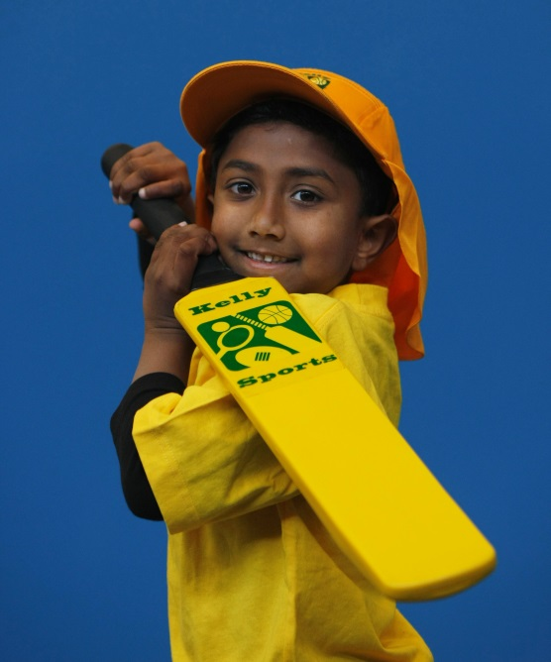
BASKETBALL
Have fun learning how to play Basketball with your friends in the Kelly Sports 7 week Basketball Clinic. Learn all the basic skills required to play the game in a safe and challenging environment.
Learn how to play like your heroes and have lots of fun learning all the skills in the game of Basketball.

WHEN: Wednesday
COMMENCING: 10/2/16
CONCLUDING: 23/3/16
TIME: 3.40pm – 4.40pm
YEAR LEVELS: P – 4
COST: $70


DANCE


WHEN: Thursday
COMMENCING: 11/2/16
CONCLUDING: 24/3/16
TIME: 1.30pm – 2.30pm
YEAR LEVELS: P – 4
COST: $70

Children have the opportunity to learn a variety of modern and traditional Dance steps culminating in a routine performed in front of the class. Come and learn fun dance routines and have fun and laughter with your friends. Easy for all ages and experience to pick up from trained Kelly Sports instructors.

GET IN QUICK FOR TERM 1 AS PLACES FILLING FAST
It’s here online enrolments !
To enrol, please visit www.kellysports.com.au or
fill out the enrolment form & send with a cheque or credit card details to:
Kelly Sports PO BOX 71, Moonee Vale, VIC, 3055.
Payment options available!
Do not leave enrolment forms at the school office


NEW IMPROVED ONLINE BOOKING SYSTEM!!!
SIMPLY GO TO WWW.KELLYSPORTS.COM.AU ENTER YOUR POST CODE AND ENROL FROM THERE. OR
FILL OUT THE BELOW ENROLMENT FORM & SEND WITH A CHEQUE OR CREDIT CARDS DETAILS TO:
PO BOX 5185, PINEWOOD, 3149
PAYMENT OPTIONS AVAILABLE!

It’s here online enrolments !
To enrol, please visit www.kellysports.com.au or
fill out the enrolment form & send with a cheque or credit card details to:
Kelly Sports PO BOX 71, Moonee Vale, VIC, 3055.
Payment options available!
Do not leave enrolment forms at the school office

ENROLMENT FORM
Super Summer Sports End of Year Cheer
School: Year Level:
Name: Room No:
Address: Post Code:
Phone: Mobile/Work:
Email: Medical Conditions:

At the completion of after school clinics, does your child? Go to after care Get collected
Parents’ consent: I hereby authorise Kelly Sports to act on my behalf should my child require medical attention, and release
Kelly Sports Blackburn from any liability for injury incurred by my child at Kelly Sports programs.
Parent/Caregiver name: Signature:
Amount Paid: $ Credit card payment: Visa Master card
Card Number: Expiry Date: /CVV:
THINGS TO KNOW
Kelly Sports is a Registered Child Care provider
Don’t leave forms at the School Office
Spaces are limited so please make sure you enrol online or return form to Kelly Sports.

It’s here online enrolments !
To enrol, please visit www.kellysports.com.au or
fill out the enrolment form & send with a cheque or credit card details to:
Kelly Sports PO BOX 71, Moonee Vale, VIC, 3055.
Payment options available!
Do not leave enrolment forms at the school office

It’s here online enrolments !
To enrol, please visit www.kellysports.com.au or
fill out the enrolment form & send with a cheque or credit card details to:
Kelly Sports PO BOX 71, Moonee Vale, VIC, 3055.
Payment options available!
Do not leave enrolment forms at the school office

It’s here online enrolments !
To enrol, please visit www.kellysports.com.au or
fill out the enrolment form & send with a cheque or credit card details to:
Kelly Sports PO BOX 71, Moonee Vale, VIC, 3055.
Payment options available!
Do not leave enrolment forms at the school office

