

PO BOX 5185, Pinewood, 3149
Special Offer
$9.50/week
for 7 weeks
when you enrol
on-line!

T 0437 076 897

E gary@kellysports.com.au


ANTONIO PARK PS
SUPER SUMMER SPORT

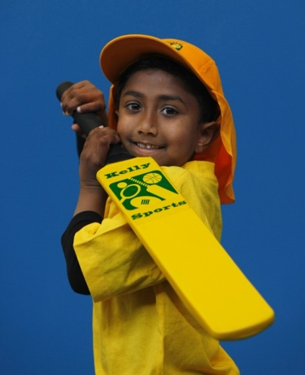

Soccer – Cricket – Basketball
Have fun in the sun this term! Super Summer Sports dynamic and active programs run over 7 weeks; these include: Soccer, Basketball,and Cricket.. This Program will not only provide an essential base for your child's motor skills but help build awareness, co-ordination and friendship all in an enjoyable environment.

WHEN: Wednesday
COMMENCING: 10/2/16
CONCLUDING: 23/3/16
TIME: 3.30-4.30pm
YEAR LEVELS: P – 4

COST: $70 (enrol online for $66.50 – go to www.kellysports.com.au and search for your school)
It’s here online enrolments !
To enrol, please visit www.kellysports.com.au or
fill out the enrolment form & send with a cheque or credit card details to:
Kelly Sports PO BOX 71, Moonee Vale, VIC, 3055.
Payment options available!
Do not leave enrolment forms at the school office

VENUE: Antonio Park PS

It’s here online enrolments !
To enrol, please visit www.kellysports.com.au or
fill out the enrolment form & send with a cheque or credit card details to:
Kelly Sports PO BOX 71, Moonee Vale, VIC, 3055.
Payment options available!
Do not leave enrolment forms at the school office

ENROLMENT FORM
School: Year Level:
Name: Room No:
Address: Post Code:
Phone: Mobile/Work:
Email: Medical Conditions:

At the completion of after school clinics, does your child? Go to after care Get collected
Parents’ consent
I hereby authorise Kelly Sports to act on my behalf should my child require medical attention, and release Kelly Sports Templestowe from
any liability for injury incurred by my child at Kelly Sports programmes.
I authorise the use by Kelly Sports of any photographs or video image of my child or legal charge for any reasonable purpose.
Parent/Caregiver name: Signature:
Amount Paid: $ Credit card payment: Visa Mastercard
Card Number: Expiry Date: /
To enrol, please visit www.kellysports.com.au or fill out the
below enrolment form & send with a cheque or credit card details to:
PO BOX 5185, Pinewood 3149 Payment options available!
Do not leave enrolment forms at the school office.

ONLINE ENROLMENT
www.kellysports.com.au

It’s here online enrolments !
To enrol, please visit www.kellysports.com.au or
fill out the enrolment form & send with a cheque or credit card details to:
Kelly Sports PO BOX 71, Moonee Vale, VIC, 3055.
Payment options available!
Do not leave enrolment forms at the school office

It’s here online enrolments !
To enrol, please visit www.kellysports.com.au or
fill out the enrolment form & send with a cheque or credit card details to:
Kelly Sports PO BOX 71, Moonee Vale, VIC, 3055.
Payment options available!
Do not leave enrolment forms at the school office

It’s here online enrolments !
To enrol, please visit www.kellysports.com.au or
fill out the enrolment form & send with a cheque or credit card details to:
Kelly Sports PO BOX 71, Moonee Vale, VIC, 3055.
Payment options available!
Do not leave enrolment forms at the school office

