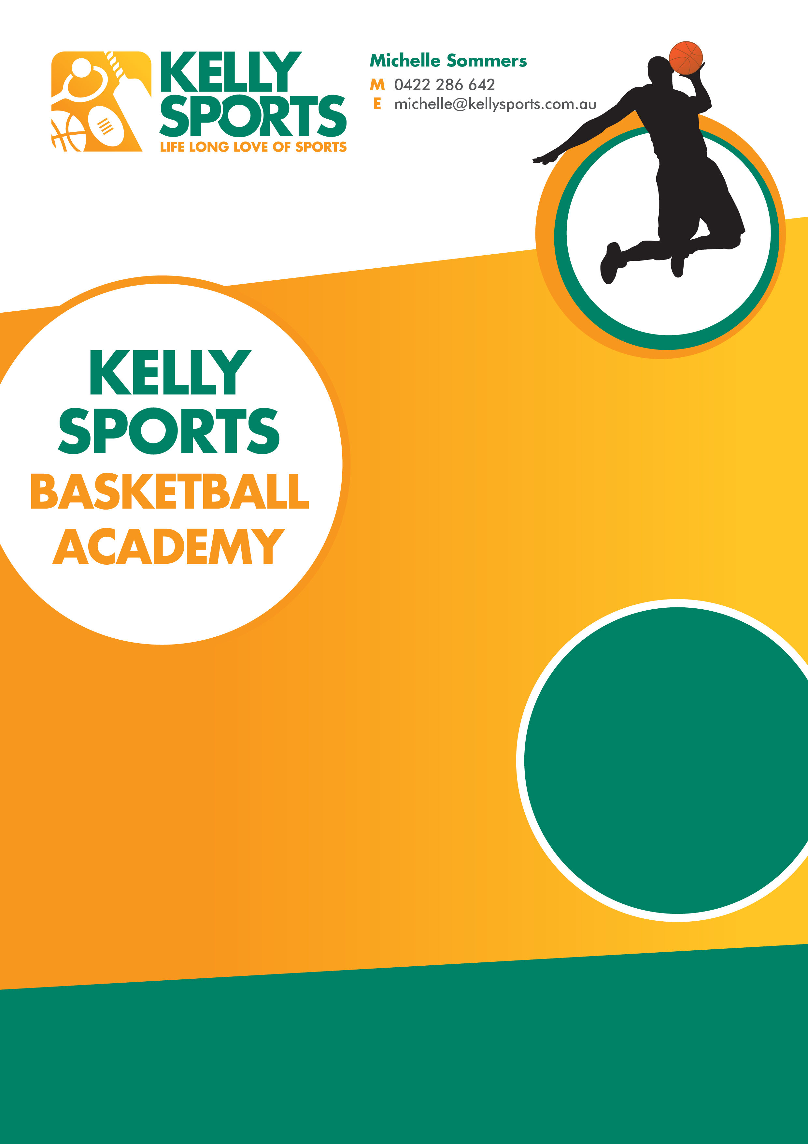
Kelly Sports is here in term 4 with a NEW program.
Over 9 weeks your child will participate in a number of Basketball skills and drills in a positive and inclusive environment.
Run at the school straight after the bell. This program will get your child active and ready to play against other schools in a round robin competition run in the last week of term.
Enrol them now and let Kelly Sports give them a Life Long Love of Sports.

WHEN: Wednesdays
WHERE: On School Grounds
COMMENCING: 18th October
CONCLUDING: 13th December
TIME: 3.25pm to 4.25pm
YEAR LEVELS: Grade 3 to 6
COST: $99
FEES TO BE PAID BY WEEK 3

GET IN QUICK FOR TERM 4 AS PLACES ARE LIMITED AND WILL FILL FAST
$99 FOR THE 9 WEEK PROGRAM.
NEW IMPROVED ONLINE BOOKING SYSTEM!!!
SIMPLY GO TO WWW.KELLYSPORTS.COM.AU ENTER IN YOUR POSTCODE AND CLICK ON
KINGSLEY PARK PRIMARY SCHOOL’S BASKETBALLPROGRAM
KINGSLEY PARK PRIMARY SCHOOL

