
MT ELIZA NORTH
PRIMARY SCHOOL P (03) 9384 2204
M 0466 501 822

E ann@kellysports.com.au
SPRING MULTI SPORTS – Thursday
Come and experience all the fun in our 9 week Kelly Sports
Spring Multi Sport program.
Our Kelly Sports classes are all inclusive, fun & interactive with a key focus on maximum participation. Each week children will be introduced to new sports & activities in a positive environment. It’s a fantastic way to get your child active while having fun as well as building confidence and social skills!
BASKETBALL – Tuesday
Speed! Precision! Athleticism! Fun!
Vibrant 9 week Basketball program we have on offer. This Basketball Program includes all the skill and activities required to help enhance your child’s skills and get them on the way to being the next basketball superstar. Hop on board and shoot a goal this term.



How To Enrol?
Please visit www.kellysports.com.au/events and search for your school.
Our new booking system requires upfront payments to secure your position. For more information, please call the head office.


"The Kelly Sports Programs offer our students opportunities for physical activities; including dance & multi-sports. Conveniently located on our school grounds, they are popular with students and their families. Staff are skilled in working with young people to love active participation.”


Amanda Hay, Principal – Newtown Primary School
CLASS INFORMATION
Only 30 spots available for each program so sign up fast to secure your position
Mighty Multi Sports include Soccer, Hockey, Basketball, Cricket & Crazy games, plus we will incorporate our Kelly Sports Modified games children love.

Come and join us every Tuesday and Thursday afterschool
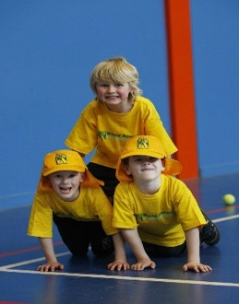
When: Tuesdays & Thursdays
Starts: 16th October & 18th October
Finishes: 18th Dec & 13th Dec
Sports: 3:40pm – 4:40pm
Basketball: 3:40pm – 4:40pm
Year Levels: Prep – 4
Cost: $118.80 (Inc GST)
Tuesday Make up session on the 18th Dec for Melbourne Cup Public Holiday

