
P.O. Box 71 Monee Vale 3055
Enrol before 8/02/16 and get the 7 weeks for the price of 6 that’s $42 for 7 weeks.
T 0422 286 642
E Michelle@kellysports.com.au
W www.kellysports.com.au

GOODSTART EARLY LEARNING LANGWARRIN

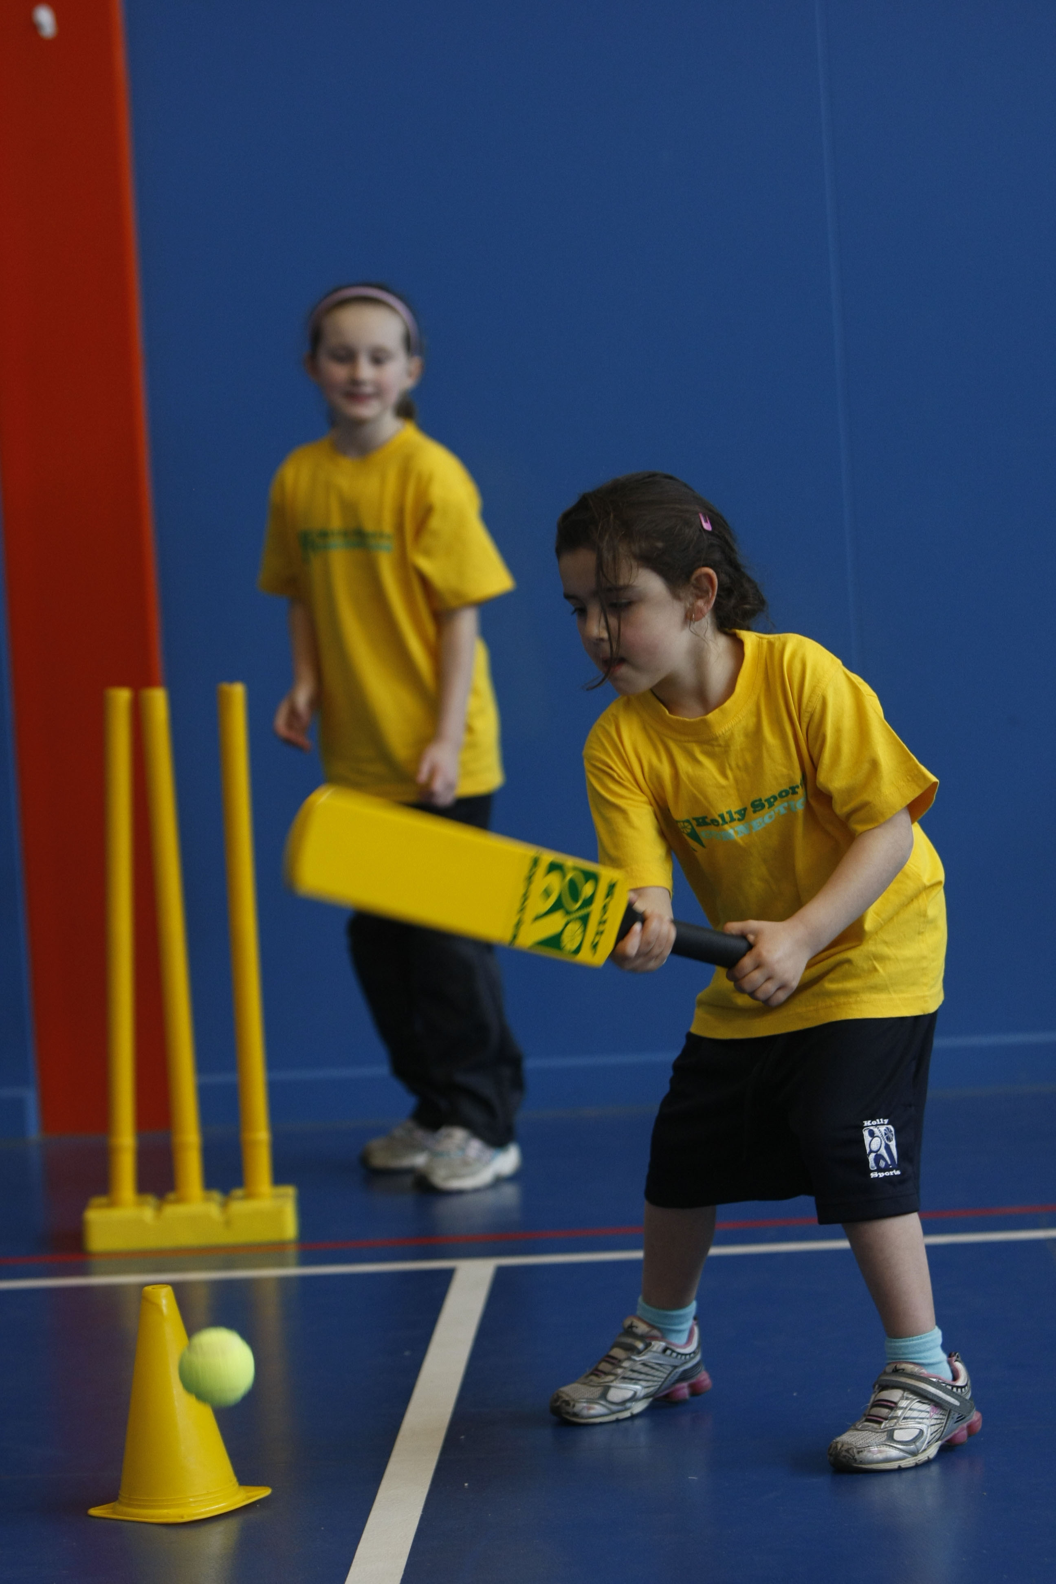
FUNDAMENTAL
SKILLS PROGRAM

Kelly Sports runs a half an hour program to teach children the fundamentals of sport. This 7 WEEK program is all inclusive with high participation. Our aim is to develop and enhance the following skills – running, jumping, catching, throwing, passing, kicking and striking:
The Fundamental Skills Program includes:
- Motor Skill Development
- Balance and Hand- Eye Coordination
- Introduction to a variety of Sports

WHEN: Thursday
COMMENCING: 11/02/2016
CONCLUDING: 24/03/2016
TIME: 10:00am – 10:30am – (3 to 5 Yrs)

COST: $49
It’s here online enrolments !
To enrol, please visit www.kellysports.com.au or
fill out the enrolment form & send with a cheque or credit card details to:
Kelly Sports PO BOX 71, Moonee Vale, VIC, 3055.
Payment options available!
Do not leave enrolment forms at the school office


VENUE: Goodstart Early Learning Langwarrin
It’s here online enrolments !
To enrol, please visit www.kellysports.com.au or
fill out the enrolment form & send with a cheque or credit card details to:
Kelly Sports PO BOX 71, Moonee Vale, VIC, 3055.
Payment options available!
Do not leave enrolment forms at the school office

ONLINE ENROLMENT
www.kellysports.com.au

To enrol, please visit www.kellysports.com.au and search for your centre or fill out the enrolment form below & scan/ send it to michelle@kellysports.com.au

ENROLMENT FORM – Goodstart Langwarrin
Name: Birth Date: _____
Address: Post Code:
Phone: Mobile/Work:
Email: Medical Conditions:

Parents’ consent: I hereby authorise Kelly Sports to act on my behalf should my child require medical attention, and release
Kelly Sports from any liability for injury incurred by my child at Kelly Sports programmes.
Parent/Caregiver name: Signature:
Amount Paid: $ Credit card payment: Visa Mastercard (surcharge applies)
Card Number: Expiry Date: /
CVV:
THINGS TO KNOW
Kelly Sports is a Registered Child Care provider
Don’t leave forms at the centre
Spaces are limited so please make sure you enrol online or return form to Kelly Sports.

It’s here online enrolments !
To enrol, please visit www.kellysports.com.au or
fill out the enrolment form & send with a cheque or credit card details to:
Kelly Sports PO BOX 71, Moonee Vale, VIC, 3055.
Payment options available!
Do not leave enrolment forms at the school office

It’s here online enrolments !
To enrol, please visit www.kellysports.com.au or
fill out the enrolment form & send with a cheque or credit card details to:
Kelly Sports PO BOX 71, Moonee Vale, VIC, 3055.
Payment options available!
Do not leave enrolment forms at the school office

It’s here online enrolments !
To enrol, please visit www.kellysports.com.au or
fill out the enrolment form & send with a cheque or credit card details to:
Kelly Sports PO BOX 71, Moonee Vale, VIC, 3055.
Payment options available!
Do not leave enrolment forms at the school office

