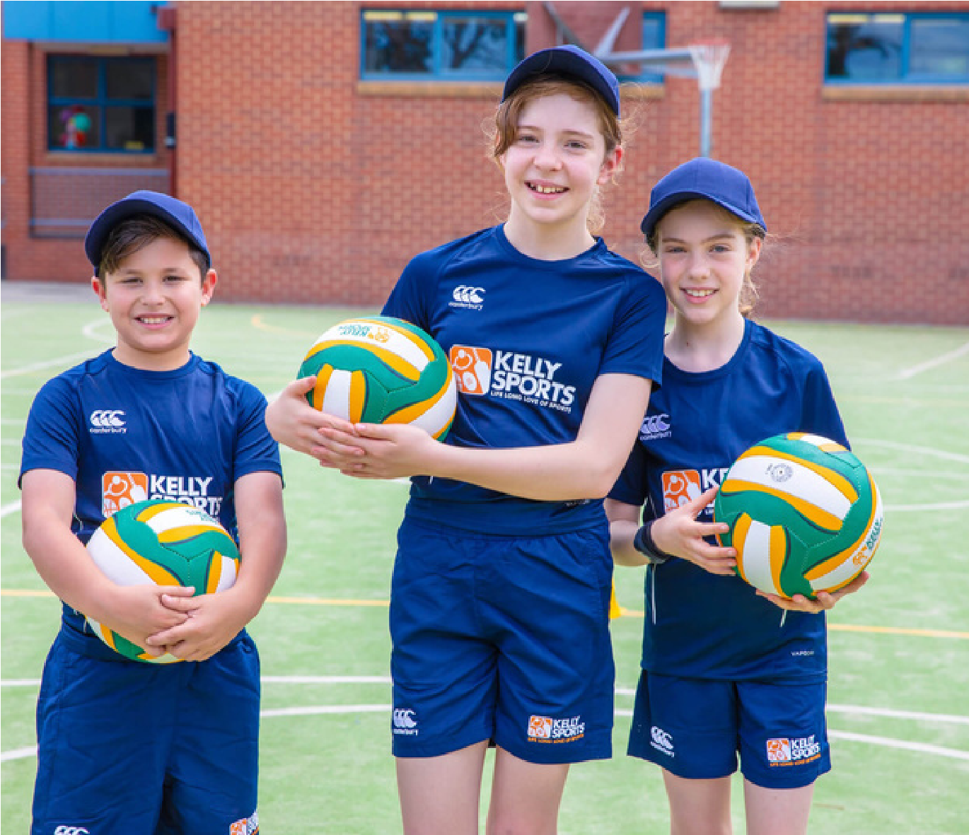
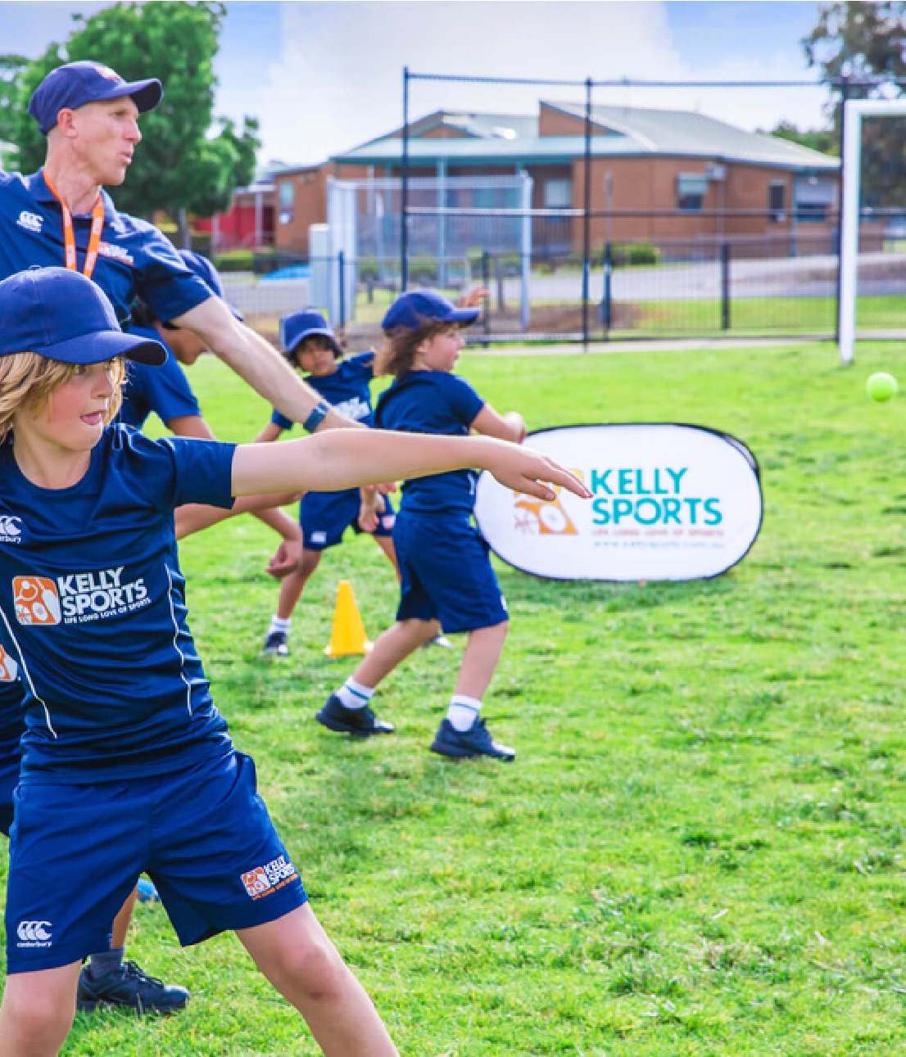


SIZZLING SUMMER
SPORTS
MULTI SPORTS PROGRAM - AFTER
SCHOOL
NETBALL, SOCCER &
HOCKEY PROGRAM
AFTER SCHOOL
THE KNOX SCHOOL


Teamwork
MULTI-SPORT
PROGRAMME
TERM 1 2024 INFORMATION
$126
FOR 7 WEEKS

For Prep – Year 4 students.
This term we will focus on the following sports:
Soccer

Programme runs 7 afternoons for one hour after school.

Basketball
Cricket

This weekly programme gives children skills and confidence in a fun
and enjoyable environment. It also encourages their enthusiasm for
sport and the life skills that such involvement brings – giving them
confidence to join sports clubs and teams in the future.
southeast@kellysports.com.au
www.kellysports.com.au
TERM 1 2024 INFORMATION
$144 FOR 8 WEEKS
For Prep – Year 4 students.
This

program will include the following:
Skills Practice
Game Rules

Modified Games

Match Play
Our Netball, soccer & hockey

program focuses on fundamental
skills such as passing, dribbling, offense, defence and shooting
whilst using a mixture of skill related activities and modified games
to do so. This program is designed to improve overall motor skills
and coordination, and is sure to bring out the little sports star in
everyone!
Sign up anytime and only pay for the remaining weeks left in
the term. $18 per week.

Sign up anytime and only pay for the remaining weeks left in
the term. $18 per week.

No session 11th March ( Labour Day )
School: The Knox School

Day: Monday's

Start Date: 5th February
End Date: 25th March
Time: 3: 30pm - 4.30pm
School: The Knox School
Day: Wednesday's
Start Date: 7th February
End Date: 27th March

Time: 3:30pm - 4:30pm
T-Ball
Programme runs 8 afternoons for one hour after school.

Book before 22nd January to receive one week free!

NETBALL, SOCCER &
HOCKEY PROGRAM

