
P.O. 4004, Keilor Downs 3038
T 0433 530 316
F (03) 9384 2205
Special O

E belinda@kellysports.com.au


COMMUNITY KIDS MELTON
FUNDAMENTAL
SKILLS PROGRAM

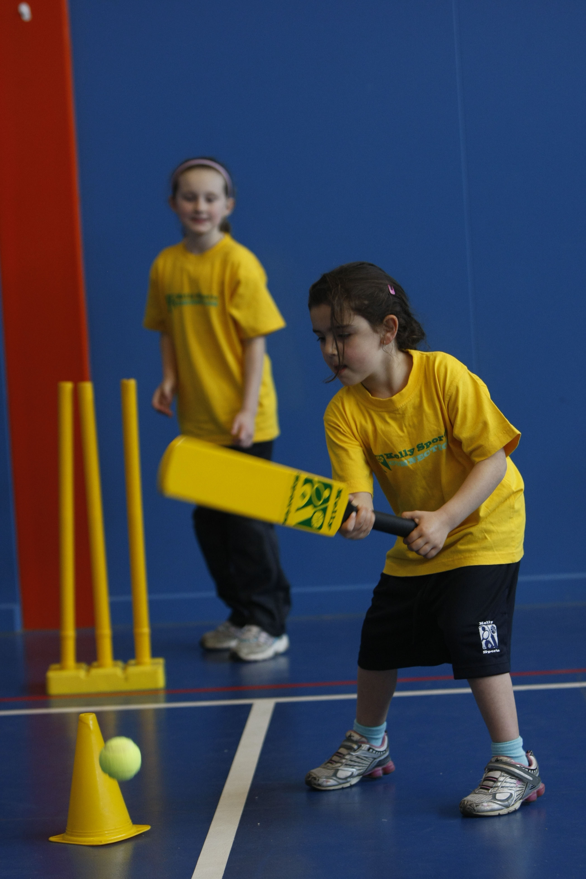

Kelly Sports runs programs to teach children the fundamentals of sport. This 10 WEEK program is all inclusive with high participation. Our key aims are to develop and enhance the following skills – running, jumping, catching, throwing, passing, kicking and striking:
The Fundamental Skills Program includes:
- Motor Skill Development
- Balance and Hand- Eye Coordination
- Introduction to a variety of sports -Soccer, Basketball, Handball, Hockey, Football and more.

WHEN: Friday
COMMENCING: 17/07/2015
CONCLUDING: 18/09/2015
TIME: 10:00am – 10:30am - Pre School
10:30am – 11:00am – Kinder

COST: $35 (enrol online go to www.kellysports.com.au)
It’s here online enrolments !
To enrol, please visit www.kellysports.com.au or
fill out the enrolment form & send with a cheque or credit card details to:
Kelly Sports PO BOX 71, Moonee Vale, VIC, 3055.
Payment options available!
Do not leave enrolment forms at the school office


VENUE: Community Kids Melton
It’s here online enrolments !
To enrol, please visit www.kellysports.com.au or
fill out the enrolment form & send with a cheque or credit card details to:
Kelly Sports PO BOX 71, Moonee Vale, VIC, 3055.
Payment options available!
Do not leave enrolment forms at the school office

ENROLMENT FORM
Pre School Kinder
Centre: Community Kids Melton Age:
Name: Class:
Address: Post Code:
Phone: Mobile/Work:
Email: Medical Conditions:

At the completion of after school clinics, does your child? Go to after care Get collected
Parents’ consent: I hereby authorise Kelly Sports to act on my behalf should my child require medical attention, and release
Kelly Sports from any liability for injury incurred by my child at Kelly Sports programmes.
Parent/Caregiver name: Signature:
Amount Paid: $ Credit card payment: Visa Mastercard
Card Number: Expiry Date: /
ONLINE ENROLMENT
www.kellysports.com.au

To enrol, please visit www.kellysports.com.au or fill out the
below enrolment form & send with a cheque or credit card details to:
PO BOX 4004, Keilor Downs 3138. Payment options available!
Do not leave enrolment forms at the school office.

It’s here online enrolments !
To enrol, please visit www.kellysports.com.au or
fill out the enrolment form & send with a cheque or credit card details to:
Kelly Sports PO BOX 71, Moonee Vale, VIC, 3055.
Payment options available!
Do not leave enrolment forms at the school office

It’s here online enrolments !
To enrol, please visit www.kellysports.com.au or
fill out the enrolment form & send with a cheque or credit card details to:
Kelly Sports PO BOX 71, Moonee Vale, VIC, 3055.
Payment options available!
Do not leave enrolment forms at the school office

It’s here online enrolments !
To enrol, please visit www.kellysports.com.au or
fill out the enrolment form & send with a cheque or credit card details to:
Kelly Sports PO BOX 71, Moonee Vale, VIC, 3055.
Payment options available!
Do not leave enrolment forms at the school office

