
P.O. Box 3011, The Pines 3109
T 0414 381 368
E davidkight@kellysports.com.au

MILGATE PRIMARY SCHOOL


GYM FUN
This fun fast paced, highly active and non-stop program is an introduction for your child to the world of gymnastics. Colourful ribbons, Entertaining Hula Hoops, Incredible Rhythmical Routines and Group Dynamics. Allow your child to build their gymnastics skills and their thirst for exciting energetic activities.

WHEN: Thursday
COMMENCING: 4/2/2016
CONCLUDING: 24/3/2016
TIME: 12.50pm – 1.50pm
YEAR LEVELS: P – 4

SUPER SUMMER SPORTS
DONT MISS OUT ON SHOOTING A GOAL! SUPER SUMMER SPORTS allows your child to play a range of dynamic and active programs run over 8 weeks these include; Soccer, Cricket, Basketball and Hockey! This Program will not only provide an essential base for your child's motor skills but help build awareness, co-ordination and friendship all in an enjoyable environment

WHEN: Tuesday
COMMENCING: 2/2/2016
CONCLUDING: 8/3/2016
TIME: 3.40pm – 4.40pm
YEAR LEVELS: P – 4

COST: $80 (go to www.kellysports.com.au and search for your school).
It’s here online enrolments !
To enrol, please visit www.kellysports.com.au or
fill out the enrolment form & send with a cheque or credit card details to:
Kelly Sports PO BOX 71, Moonee Vale, VIC, 3055.
Payment options available!
Do not leave enrolment forms at the school office

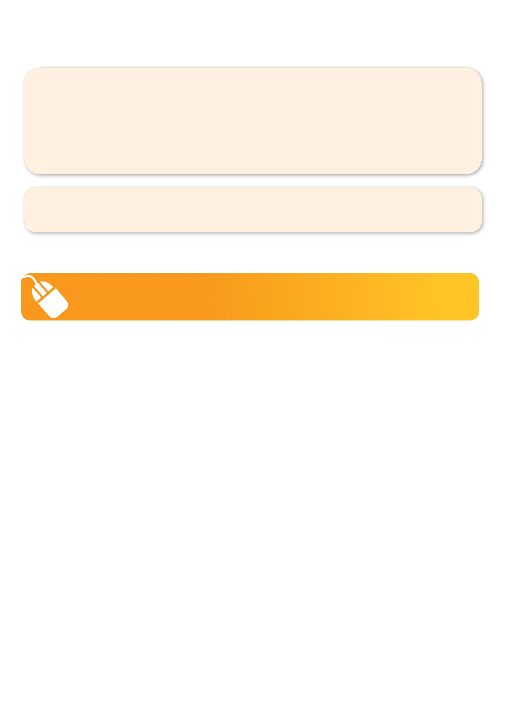
VENUE: Milgate Primary School
To enrol, please visit www.kellysports.com.au or fill
out the below enrolment form & send with a cheque
to: PO BOX 3011, The Pines VIC 3109. Payment options available!
Do not leave enrolment forms at the school office.

ONLINE ENROLMENT
www.kellysports.com.au

It’s here online enrolments !
To enrol, please visit www.kellysports.com.au or
fill out the enrolment form & send with a cheque or credit card details to:
Kelly Sports PO BOX 71, Moonee Vale, VIC, 3055.
Payment options available!
Do not leave enrolment forms at the school office

ENROLMENT FORM
Gym Fun (Lunch time) Super Summer Sports (After school)
School: Year Level:
Name: Room No:
Address: Post Code:
Phone: Mobile/Work:
Email: Medical Conditions:

At the completion of after school clinics, does your child? Go to after care Get collected
Parents’ consent: I hereby authorise Kelly Sports to act on my behalf should my child require medical attention, and release
Kelly Sports Templestowe from any liability for injury incurred by my child at Kelly Sports programmes.
Payment Options: Go online and pay via Direct Deposit or credit card.
Parent/Caregiver name: Signature:
Amount Paid: $ __________________
It’s here online enrolments !
To enrol, please visit www.kellysports.com.au or
fill out the enrolment form & send with a cheque or credit card details to:
Kelly Sports PO BOX 71, Moonee Vale, VIC, 3055.
Payment options available!
Do not leave enrolment forms at the school office

It’s here online enrolments !
To enrol, please visit www.kellysports.com.au or
fill out the enrolment form & send with a cheque or credit card details to:
Kelly Sports PO BOX 71, Moonee Vale, VIC, 3055.
Payment options available!
Do not leave enrolment forms at the school office

It’s here online enrolments !
To enrol, please visit www.kellysports.com.au or
fill out the enrolment form & send with a cheque or credit card details to:
Kelly Sports PO BOX 71, Moonee Vale, VIC, 3055.
Payment options available!
Do not leave enrolment forms at the school office

