
DONCASTER EARLY
LEARNING CENTRE P (03) 9384 2204
M 0403 149 391

E templestowe@kellysports.com.au
Fundamental Motor Skills
Kelly Sports is offering our fundamental motor skills program again in Semester Term 3 2019.
Our program consists of fun-filled sports activities including Soccer, Basketball and AFL while also using bean bags, tennis balls, hula hoops, and more! Our focus as always with kinder aged children is fun, excitement, maximum participation and of course fundamental motor skill development including jumping, bouncing, striking, catching, throwing, balance and hand-eye coordination.

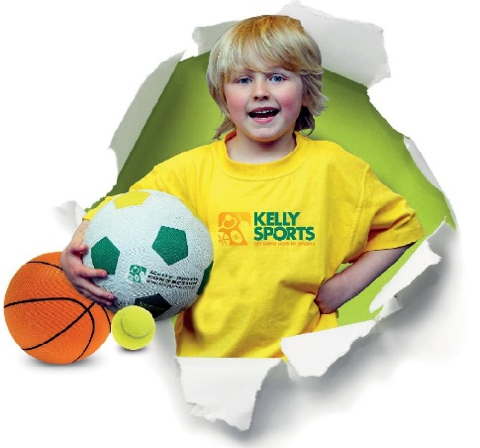

How To Enrol?
Please visit www.kellysports.com.au/events and search for your pre school.
Our new booking system requires upfront payments to secure your position. For more information, please call the head office.


"The Kelly Sports Programs offer our students opportunities for physical activities; including dance & multi-sports. Conveniently located on our school grounds, they are popular with students and their families. Staff are skilled in working with young people to love active participation.”


Amanda Hay, Principal – Newtown Primary School
CLASS INFORMATION

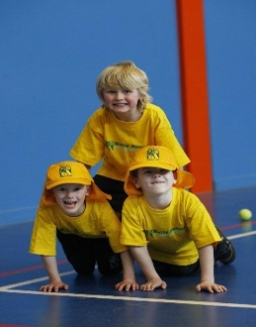
When: Wednesday’s
Starts: July 24th
Finishes: September 18th
Time: 2:30pm to 3pm
Year Levels: Pre kinder & Kinder
Cost: $90 (Inc GST)

Only $10 Per week
1 x 30 minute class for up to 15 Children
9 weeks total
Sign up anytime and only pay for the remaining weeks in the term.

