
P.O. Box 3011, The Pines 3109
T 0414 381 368
E davidkight@kellysports.com.au


TEMPLESTOWE VALLEY PRIMARY SCHOOL
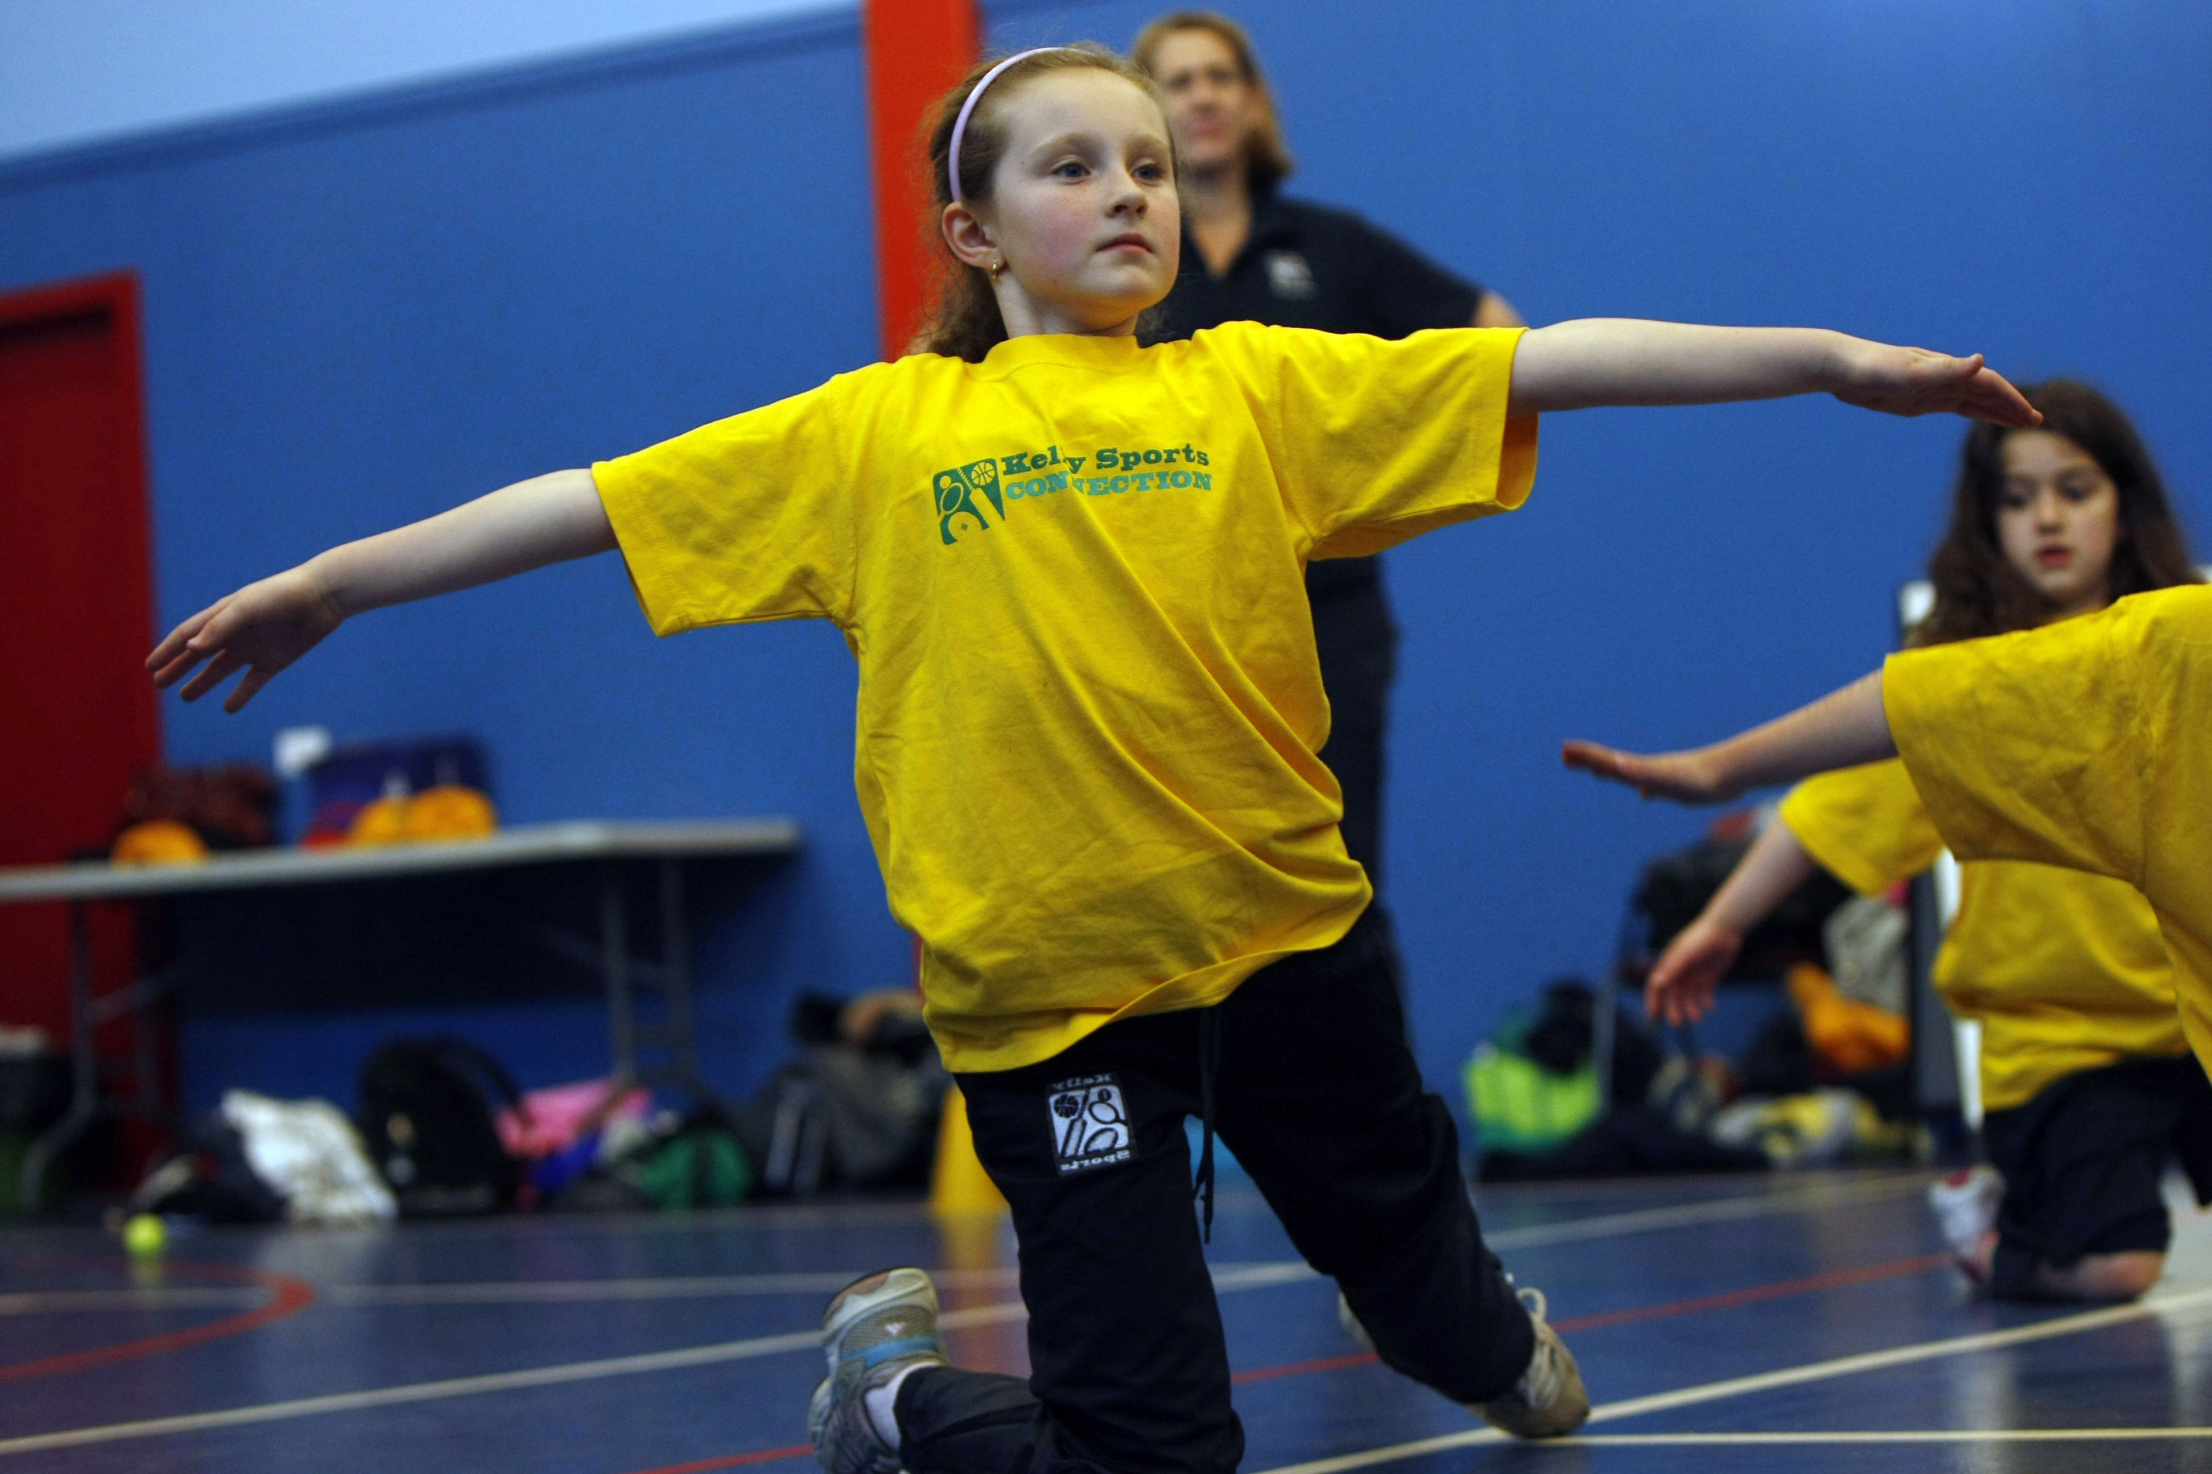

DANCE

WHEN: Wednesday
COMMENCING: 3/10/2016
CONCLUDING: 5/12/2016
TIME: 1.30pm – 2.30pm
YEAR LEVELS: P – 4
LET THE BEAT ENTER YOUR FEET! Our specialized Dance coaches can get your child’s hips swinging, feet rocking and heads bumping to all of modern contemporary music’s classics. Sign up fast as places are limited and let our coaches beat ignite your child’s feet!

COST: $100-EARLY BIRD RATE –JUST $90 IF YOU ENROL BY Friday 23rd SEPTEMBER (go to www.kellysports.com.au and search for your school)
It’s here online enrolments !
To enrol, please visit www.kellysports.com.au or
fill out the enrolment form & send with a cheque or credit card details to:
Kelly Sports PO BOX 71, Moonee Vale, VIC, 3055.
Payment options available!
Do not leave enrolment forms at the school office

VENUE: Templestowe Valley Primary School

To enrol, please visit www.kellysports.com.au or fill
out the below enrolment form & send with a cheque to:
PO BOX 3011, The Pines VIC 3109. Payment options
available! Do not leave enrolment forms at the school office.

ONLINE ENROLMENT
www.kellysports.com.au/zone/templestowe

It’s here online enrolments !
To enrol, please visit www.kellysports.com.au or
fill out the enrolment form & send with a cheque or credit card details to:
Kelly Sports PO BOX 71, Moonee Vale, VIC, 3055.
Payment options available!
Do not leave enrolment forms at the school office

ENROLMENT FORM
Dance (Lunchtime)
School: Year Level:
Name: Room No:
Address: Post Code:
Phone: Mobile/Work:
Email: Medical Conditions:

At the completion of after school clinics, does your child? Go to after care Get collected
Parents’ consent: I hereby authorise Kelly Sports to act on my behalf should my child require medical attention, and release
Kelly Sports Templestowe from any liability for injury incurred by my child at Kelly Sports programmes.
Payment Options: Go online and pay via Direct Deposit or credit card.
Parent/Caregiver name: Signature:
Amount Paid: $
It’s here online enrolments !
To enrol, please visit www.kellysports.com.au or
fill out the enrolment form & send with a cheque or credit card details to:
Kelly Sports PO BOX 71, Moonee Vale, VIC, 3055.
Payment options available!
Do not leave enrolment forms at the school office

It’s here online enrolments !
To enrol, please visit www.kellysports.com.au or
fill out the enrolment form & send with a cheque or credit card details to:
Kelly Sports PO BOX 71, Moonee Vale, VIC, 3055.
Payment options available!
Do not leave enrolment forms at the school office

It’s here online enrolments !
To enrol, please visit www.kellysports.com.au or
fill out the enrolment form & send with a cheque or credit card details to:
Kelly Sports PO BOX 71, Moonee Vale, VIC, 3055.
Payment options available!
Do not leave enrolment forms at the school office

