

P.O. Box 3011, The Pines 3109

T 0414 381 368
E davidkight@kellysports.com.au


WARRANWOOD PRIMARY SCHOOL
WICKED WINTER SPORTS

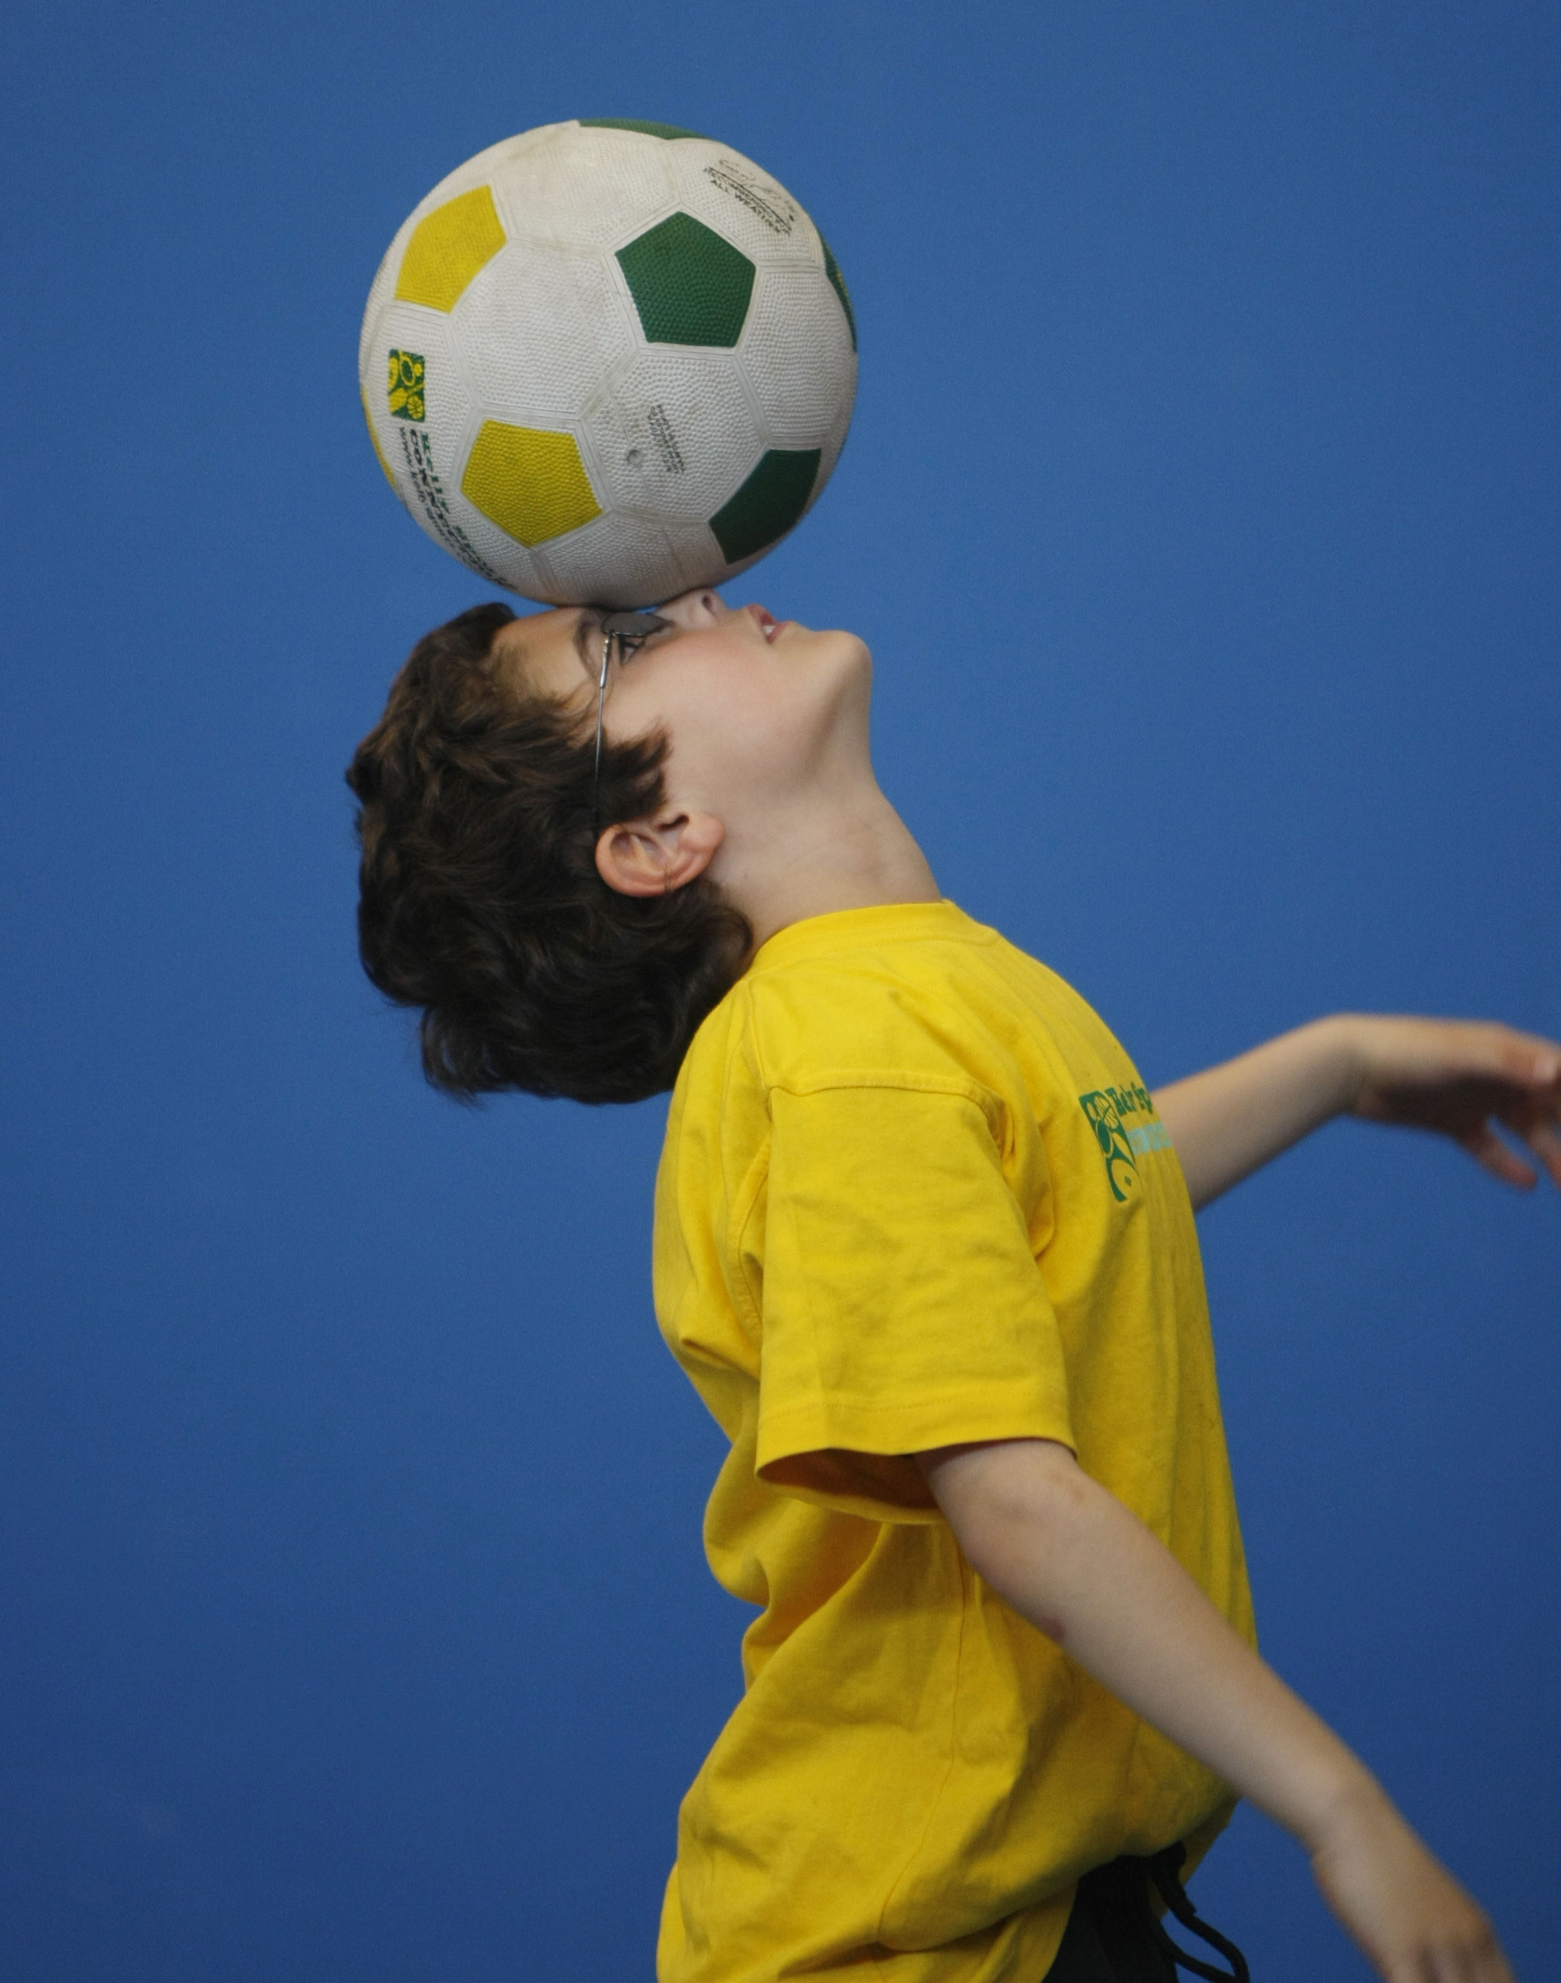
WHEN: Wednesday
COMMENCING: 16/7/2014
CONCLUDING: 17/9/2014
TIME: 3.40pm – 4.40pm
YEAR LEVELS: P – 4
DONT MISS OUT ON KICKING A GOAL! WICKED WINTER SPORTS allows your child to play a range of dynamic and active programs run over 10 weeks; these include; Soccer, Football, Tee-Ball, Basketball and Netball! This Program will not only provide an essential base for your child's motor skills but help build awareness, co-ordination and friendship all in an enjoyable environment.

WHEN: Thursday
COMMENCING: 17/7/2014
CONCLUDING: 18/9/2014
TIME: 12.50pm –1.50pm
YEAR LEVELS: P – 4

DANCE

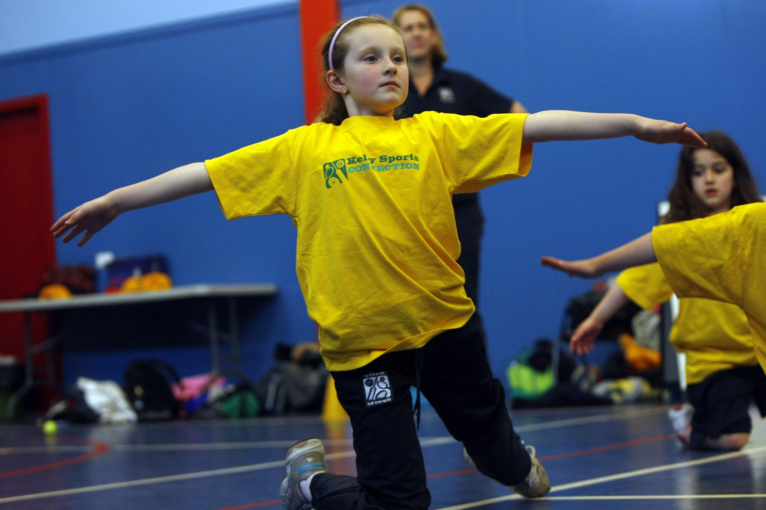
LET THE BEAT ENTER YOUR FEET! Our specialized Dance coaches can get your child’s hips swinging, feet rocking and heads bumping to all of modern contemporary music’s classics. Sign up fast as places are limited and let our coaches beat; ignite your child’s feet!

COST: $100 ( go to www.kellysports.com.au/zone/templestowe and search for your school)
It’s here online enrolments !
To enrol, please visit www.kellysports.com.au or
fill out the enrolment form & send with a cheque or credit card details to:
Kelly Sports PO BOX 71, Moonee Vale, VIC, 3055.
Payment options available!
Do not leave enrolment forms at the school office


VENUE: Warranwood Primary School
To enrol, please visit www.kellysports.com.au/templestowe or fill out
the enrolment form below & send with a cheque to:
PO BOX 3011, The Pines VIC 3109. Payment options available!
Do not leave enrolment forms at the school office.

ONLINE ENROLMENT
www.kellysports.com.au/zone/
templestowe

It’s here online enrolments !
To enrol, please visit www.kellysports.com.au or
fill out the enrolment form & send with a cheque or credit card details to:
Kelly Sports PO BOX 71, Moonee Vale, VIC, 3055.
Payment options available!
Do not leave enrolment forms at the school office

ENROLMENT FORM
Wicked Winter Sports (After School) Dance (Lunchtime)
School: Year Level:
Name: Room No:
Address: Post Code:
Phone: Mobile/Work:
Email: Medical Conditions:

At the completion of after school clinics, does your child? Go to after care Get collected
Payment Options: Go online and pay via Direct Deposit or credit card via Pay Pal.
Parents’ consent: I hereby authorise Kelly Sports to act on my behalf should my child require medical attention, and release
Kelly Sports Templestowe from any liability for injury incurred by my child at Kelly Sports programmes.
Parent/Caregiver name: Signature:
Amount Paid: $

It’s here online enrolments !
To enrol, please visit www.kellysports.com.au or
fill out the enrolment form & send with a cheque or credit card details to:
Kelly Sports PO BOX 71, Moonee Vale, VIC, 3055.
Payment options available!
Do not leave enrolment forms at the school office

It’s here online enrolments !
To enrol, please visit www.kellysports.com.au or
fill out the enrolment form & send with a cheque or credit card details to:
Kelly Sports PO BOX 71, Moonee Vale, VIC, 3055.
Payment options available!
Do not leave enrolment forms at the school office

It’s here online enrolments !
To enrol, please visit www.kellysports.com.au or
fill out the enrolment form & send with a cheque or credit card details to:
Kelly Sports PO BOX 71, Moonee Vale, VIC, 3055.
Payment options available!
Do not leave enrolment forms at the school office

