

P.O. Box 3011, The Pines 3109
T 0414 381 368
E davidkight@kellysports.com.au


SERPELL PRIMARY SCHOOL
DANCE
Shake ,move and let the beat enter your feet with Kelly Sports. Our trained dance coaches can get your child’s hips swinging, heads bumping, feet rocking and bodies shaking to all of modern contemporary music’s classics. Sign up fast as places are limited and let our coaches beat ignite your child’s dancing feet!

WHEN: Tuesday
COMMENCING: 15/7/2014
CONCLUDING: 16/9/2014
TIME: 12.30pm – 1.30pm
YEAR LEVELS: P – 4

GYM FUN
This fun fast paced, highly active and non-stop program is an introduction for your child to the world of gymnastics. Colourful ribbons, Entertaining Hula Hoops, Incredible Rhythmical Routines and Group Dynamics. Allow your child to build their gymnastics skills and their thirst
for exciting energetic activities.

WHEN: Friday
COMMENCING: 18/7/2014
CONCLUDING: 19/9/2014
TIME: 12.30pm – 1.30pm
YEAR LEVELS: P – 4

WICKED WINTER SPORTS
WHEN: Monday
COMMENCING: 14/7/2014
CONCLUDING: 15/9/2014
TIME: 3.40pm – 4.40pm
YEAR LEVELS: P – 4
DONT MISS OUT ON KICKING A GOAL! AWESOME AUTUMN SPORTS allows your child to play a range of dynamic and active programs run 10 weeks; these include; Soccer, Football, Tee-Ball, Basketball and Netball! This Program will not only provide an essential base for your child's motor skills but help build awareness, co-ordination and friendship all in an enjoyable environment

COST: $100 ( – go to www.kellysports.com.au/zone/templestowe and search for your school)
It’s here online enrolments !
To enrol, please visit www.kellysports.com.au or
fill out the enrolment form & send with a cheque or credit card details to:
Kelly Sports PO BOX 71, Moonee Vale, VIC, 3055.
Payment options available!
Do not leave enrolment forms at the school office

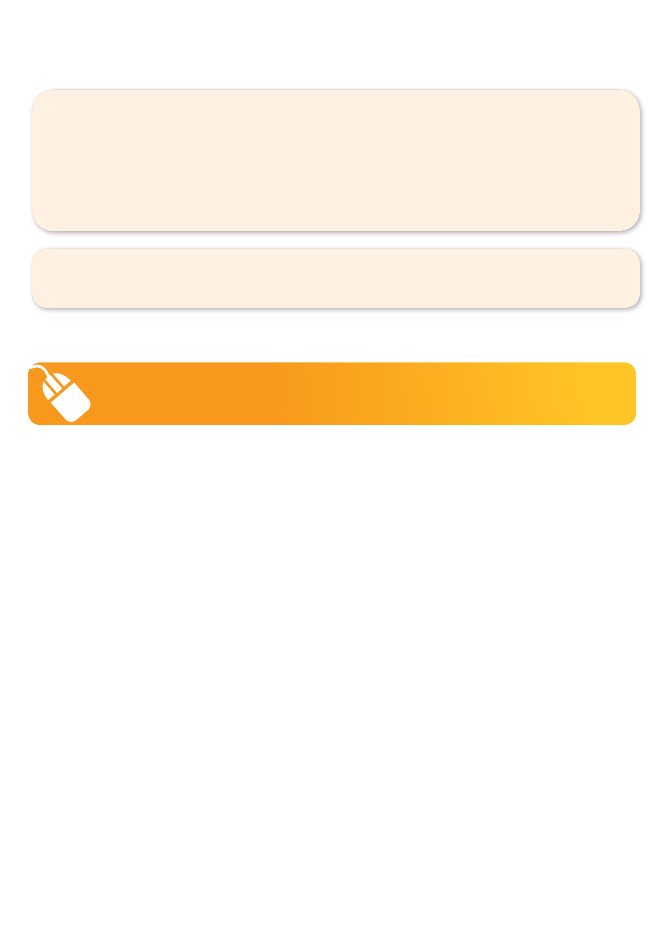
VENUE: Serpell Primary School
To enrol, please visit www.kellysports.com.au/templestowe or fill
out the below enrolment form & send with a cheque
to: PO BOX 3011, The Pines VIC 3109. Payment options available!
Do not leave enrolment forms at the school office.

ONLINE ENROLMENT
www.kellysports.com.au/zone/templestowe

It’s here online enrolments !
To enrol, please visit www.kellysports.com.au or
fill out the enrolment form & send with a cheque or credit card details to:
Kelly Sports PO BOX 71, Moonee Vale, VIC, 3055.
Payment options available!
Do not leave enrolment forms at the school office

ENROLMENT FORM
Dance (Lunchtime) Gym Fun (Lunch time) Wicked Winter Sports (After school)
School: Year Level:
Name: Room No:
Address: Post Code:
Phone: Mobile/Work:
Email: Medical Conditions:

At the completion of after school clinics, does your child? Go to after care Get collected
Parents’ consent: I hereby authorise Kelly Sports to act on my behalf should my child require medical attention, and release
Kelly Sports Templestowe from any liability for injury incurred by my child at Kelly Sports programmes.
Payment Options: Go online and pay via Direct Deposit or credit card via Pay Pal.
Parent/Caregiver name: Signature:
Amount Paid: $ __________________
It’s here online enrolments !
To enrol, please visit www.kellysports.com.au or
fill out the enrolment form & send with a cheque or credit card details to:
Kelly Sports PO BOX 71, Moonee Vale, VIC, 3055.
Payment options available!
Do not leave enrolment forms at the school office

It’s here online enrolments !
To enrol, please visit www.kellysports.com.au or
fill out the enrolment form & send with a cheque or credit card details to:
Kelly Sports PO BOX 71, Moonee Vale, VIC, 3055.
Payment options available!
Do not leave enrolment forms at the school office

It’s here online enrolments !
To enrol, please visit www.kellysports.com.au or
fill out the enrolment form & send with a cheque or credit card details to:
Kelly Sports PO BOX 71, Moonee Vale, VIC, 3055.
Payment options available!
Do not leave enrolment forms at the school office

