

P.O. Box 3011, The Pines 3109

T 0414 381 368
E davidkight@kellysports.com.au


OUR LADY OF THE PINES PRIMARY SCHOOL
SUPER SPRING SPORTS

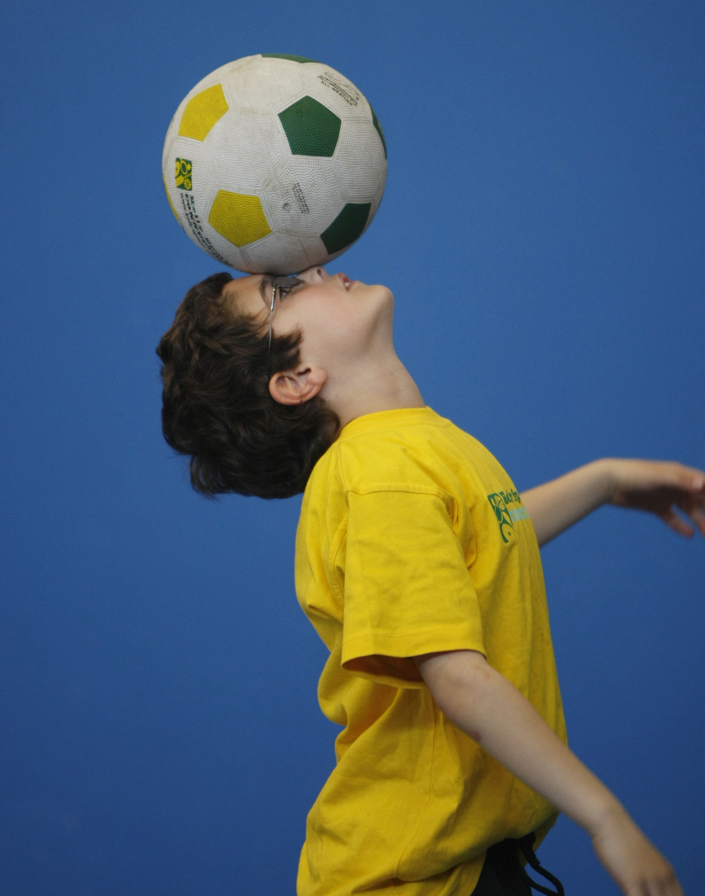
WHEN: Tuesday
COMMENCING: 7/10/2014
CONCLUDING: 9/12/2014
TIME: 3.35pm – 4.35pm
YEAR LEVELS: P – 4
DONT MISS OUT ON KICKING A GOAL! SUPER SPRING SPORTS allows your child to play a range of dynamic and active programs run over 10 weeks; these include; Soccer, Cricket, Football, Basketball and Hockey! This Program will not only provide an essential base for your child's motor skills but help build awareness, co-ordination and friendship all in an enjoyable environment.

WHEN: Monday
COMMENCING: 6/10/2014
CONCLUDING: 8/12/2014
TIME: 11.10am –12.00pm
YEAR LEVELS: P – 4

DANCE

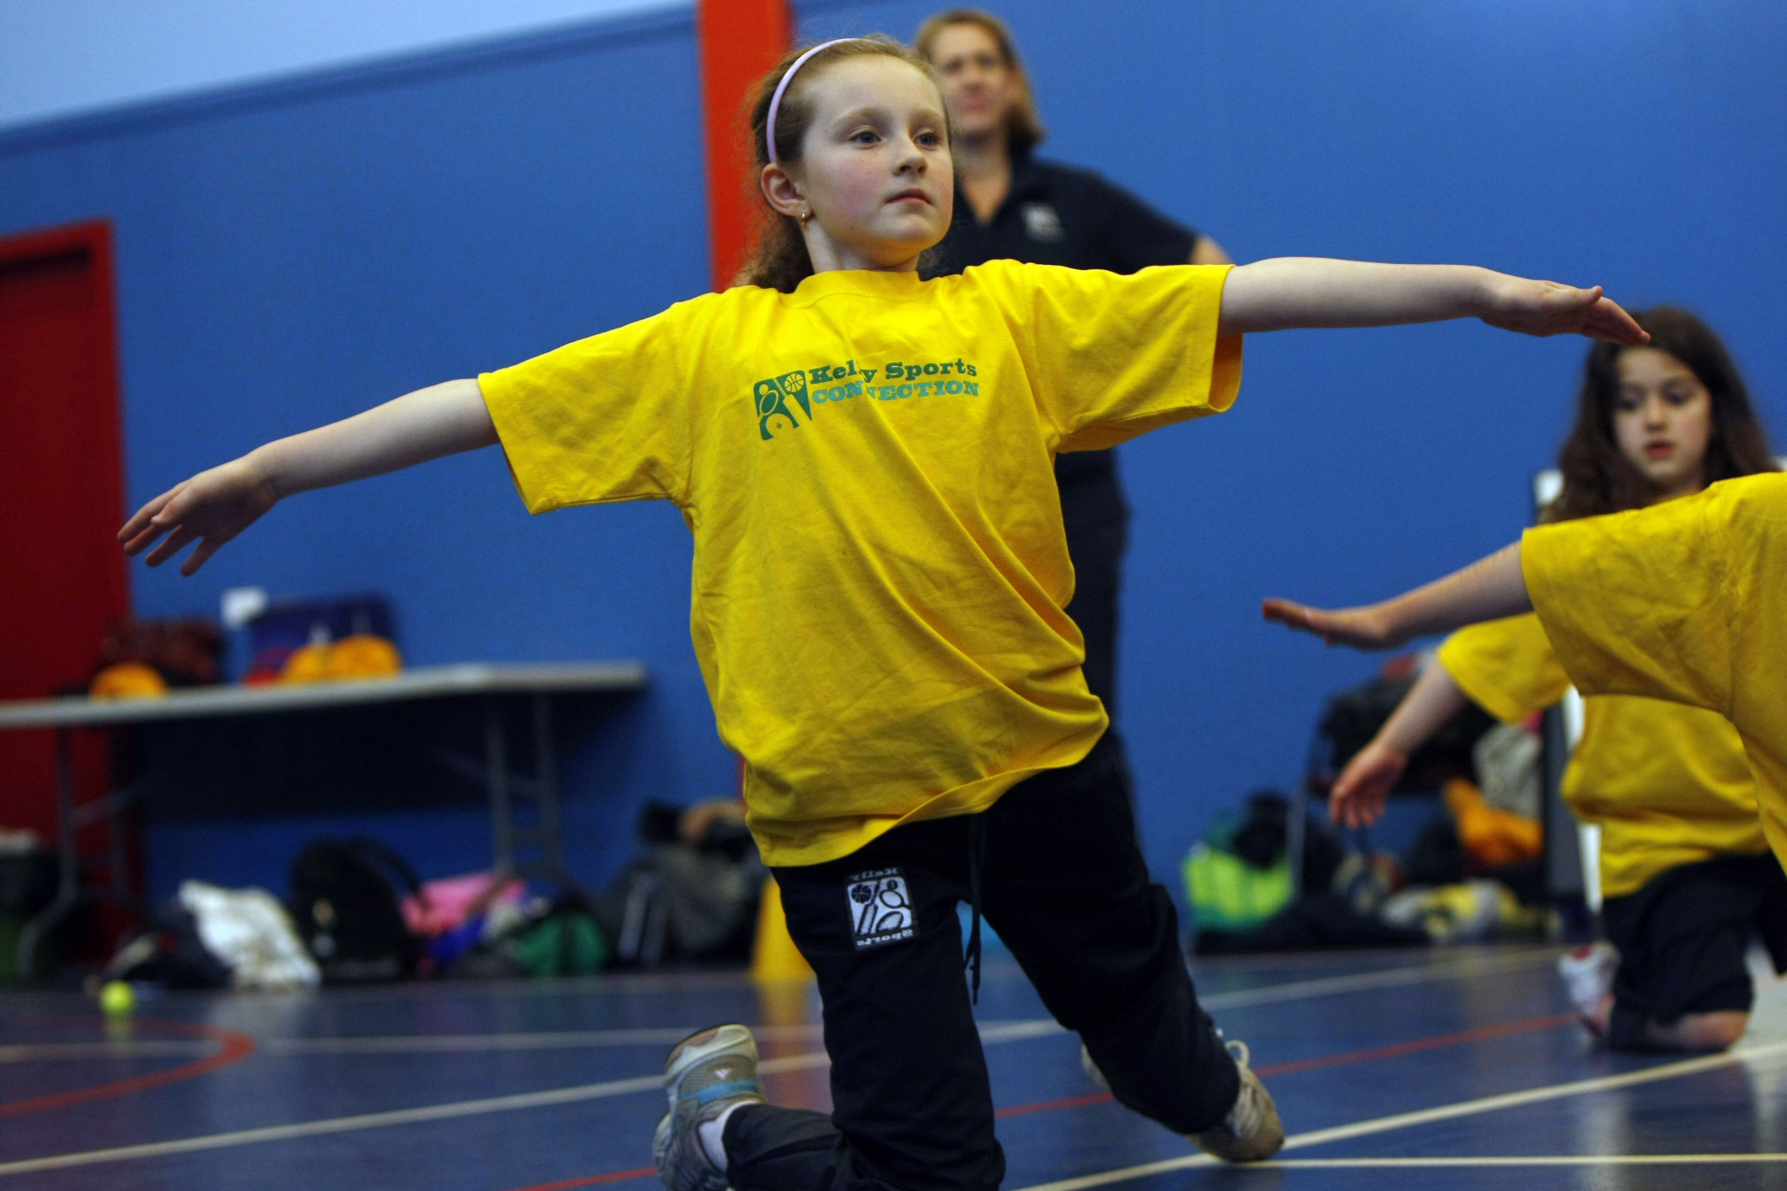
LET THE BEAT ENTER YOUR FEET! Our specialized Dance coaches can get your child’s hips swinging, feet rocking and heads bumping to all of modern contemporary music’s classics. Sign up fast as places are limited and let our coaches beat ignite your child’s feet!

COST: $100 (go to www.kellysports.com.au/zone/templestowe and search for your school).
It’s here online enrolments!
To enrol, please visit www.kellysports.com.au or
fill out the enrolment form & send with a cheque or credit card details to:
Kelly Sports PO BOX 71, Moonee Vale, VIC, 3055.
Payment options available!
Do not leave enrolment forms at the school office


VENUE: Our Lady of the Pines Primary School
ONLINE ENROLMENT
www.kellysports.com.au/zone/ templestowe

To enrol, please visit www.kellysports.com.au/templestowe or fill out
the enrolment form below and send with a cheque to:
PO BOX 3011, The Pines VIC 3109. Payment options available!
Do not leave enrolment forms at the school office.

It’s here online enrolments !
To enrol, please visit www.kellysports.com.au or
fill out the enrolment form & send with a cheque or credit card details to:
Kelly Sports PO BOX 71, Moonee Vale, VIC, 3055.
Payment options available!
Do not leave enrolment forms at the school office

ENROLMENT FORM
Super Spring Sports (After School) Dance (Lunchtime)
School: Year Level:
Name: Room No:
Address: Post Code:
Phone: Mobile/Work:
Email: Medical Conditions:

At the completion of after school clinics, does your child? Go to after care Get collected
Parents’ consent: I hereby authorise Kelly Sports to act on my behalf should my child require medical attention, and release
Kelly Sports Templestowe from any liability for injury incurred by my child at Kelly Sports programmes.
Payment Options: Go online and pay via Direct Deposit or credit card via Pay Pal.
Parent/Caregiver name: Signature:
Amount Paid: $

It’s here online enrolments !
To enrol, please visit www.kellysports.com.au or
fill out the enrolment form & send with a cheque or credit card details to:
Kelly Sports PO BOX 71, Moonee Vale, VIC, 3055.
Payment options available!
Do not leave enrolment forms at the school office

It’s here online enrolments !
To enrol, please visit www.kellysports.com.au or
fill out the enrolment form & send with a cheque or credit card details to:
Kelly Sports PO BOX 71, Moonee Vale, VIC, 3055.
Payment options available!
Do not leave enrolment forms at the school office

It’s here online enrolments !
To enrol, please visit www.kellysports.com.au or
fill out the enrolment form & send with a cheque or credit card details to:
Kelly Sports PO BOX 71, Moonee Vale, VIC, 3055.
Payment options available!
Do not leave enrolment forms at the school office

