

P.O. Box 3011, the Pines, 3109

M 0414 381 368
E davidkight@kellysports.com.au


MONTMORENCY SOUTH PRIMARY SCHOOL
WICKED WINTER SPORTS
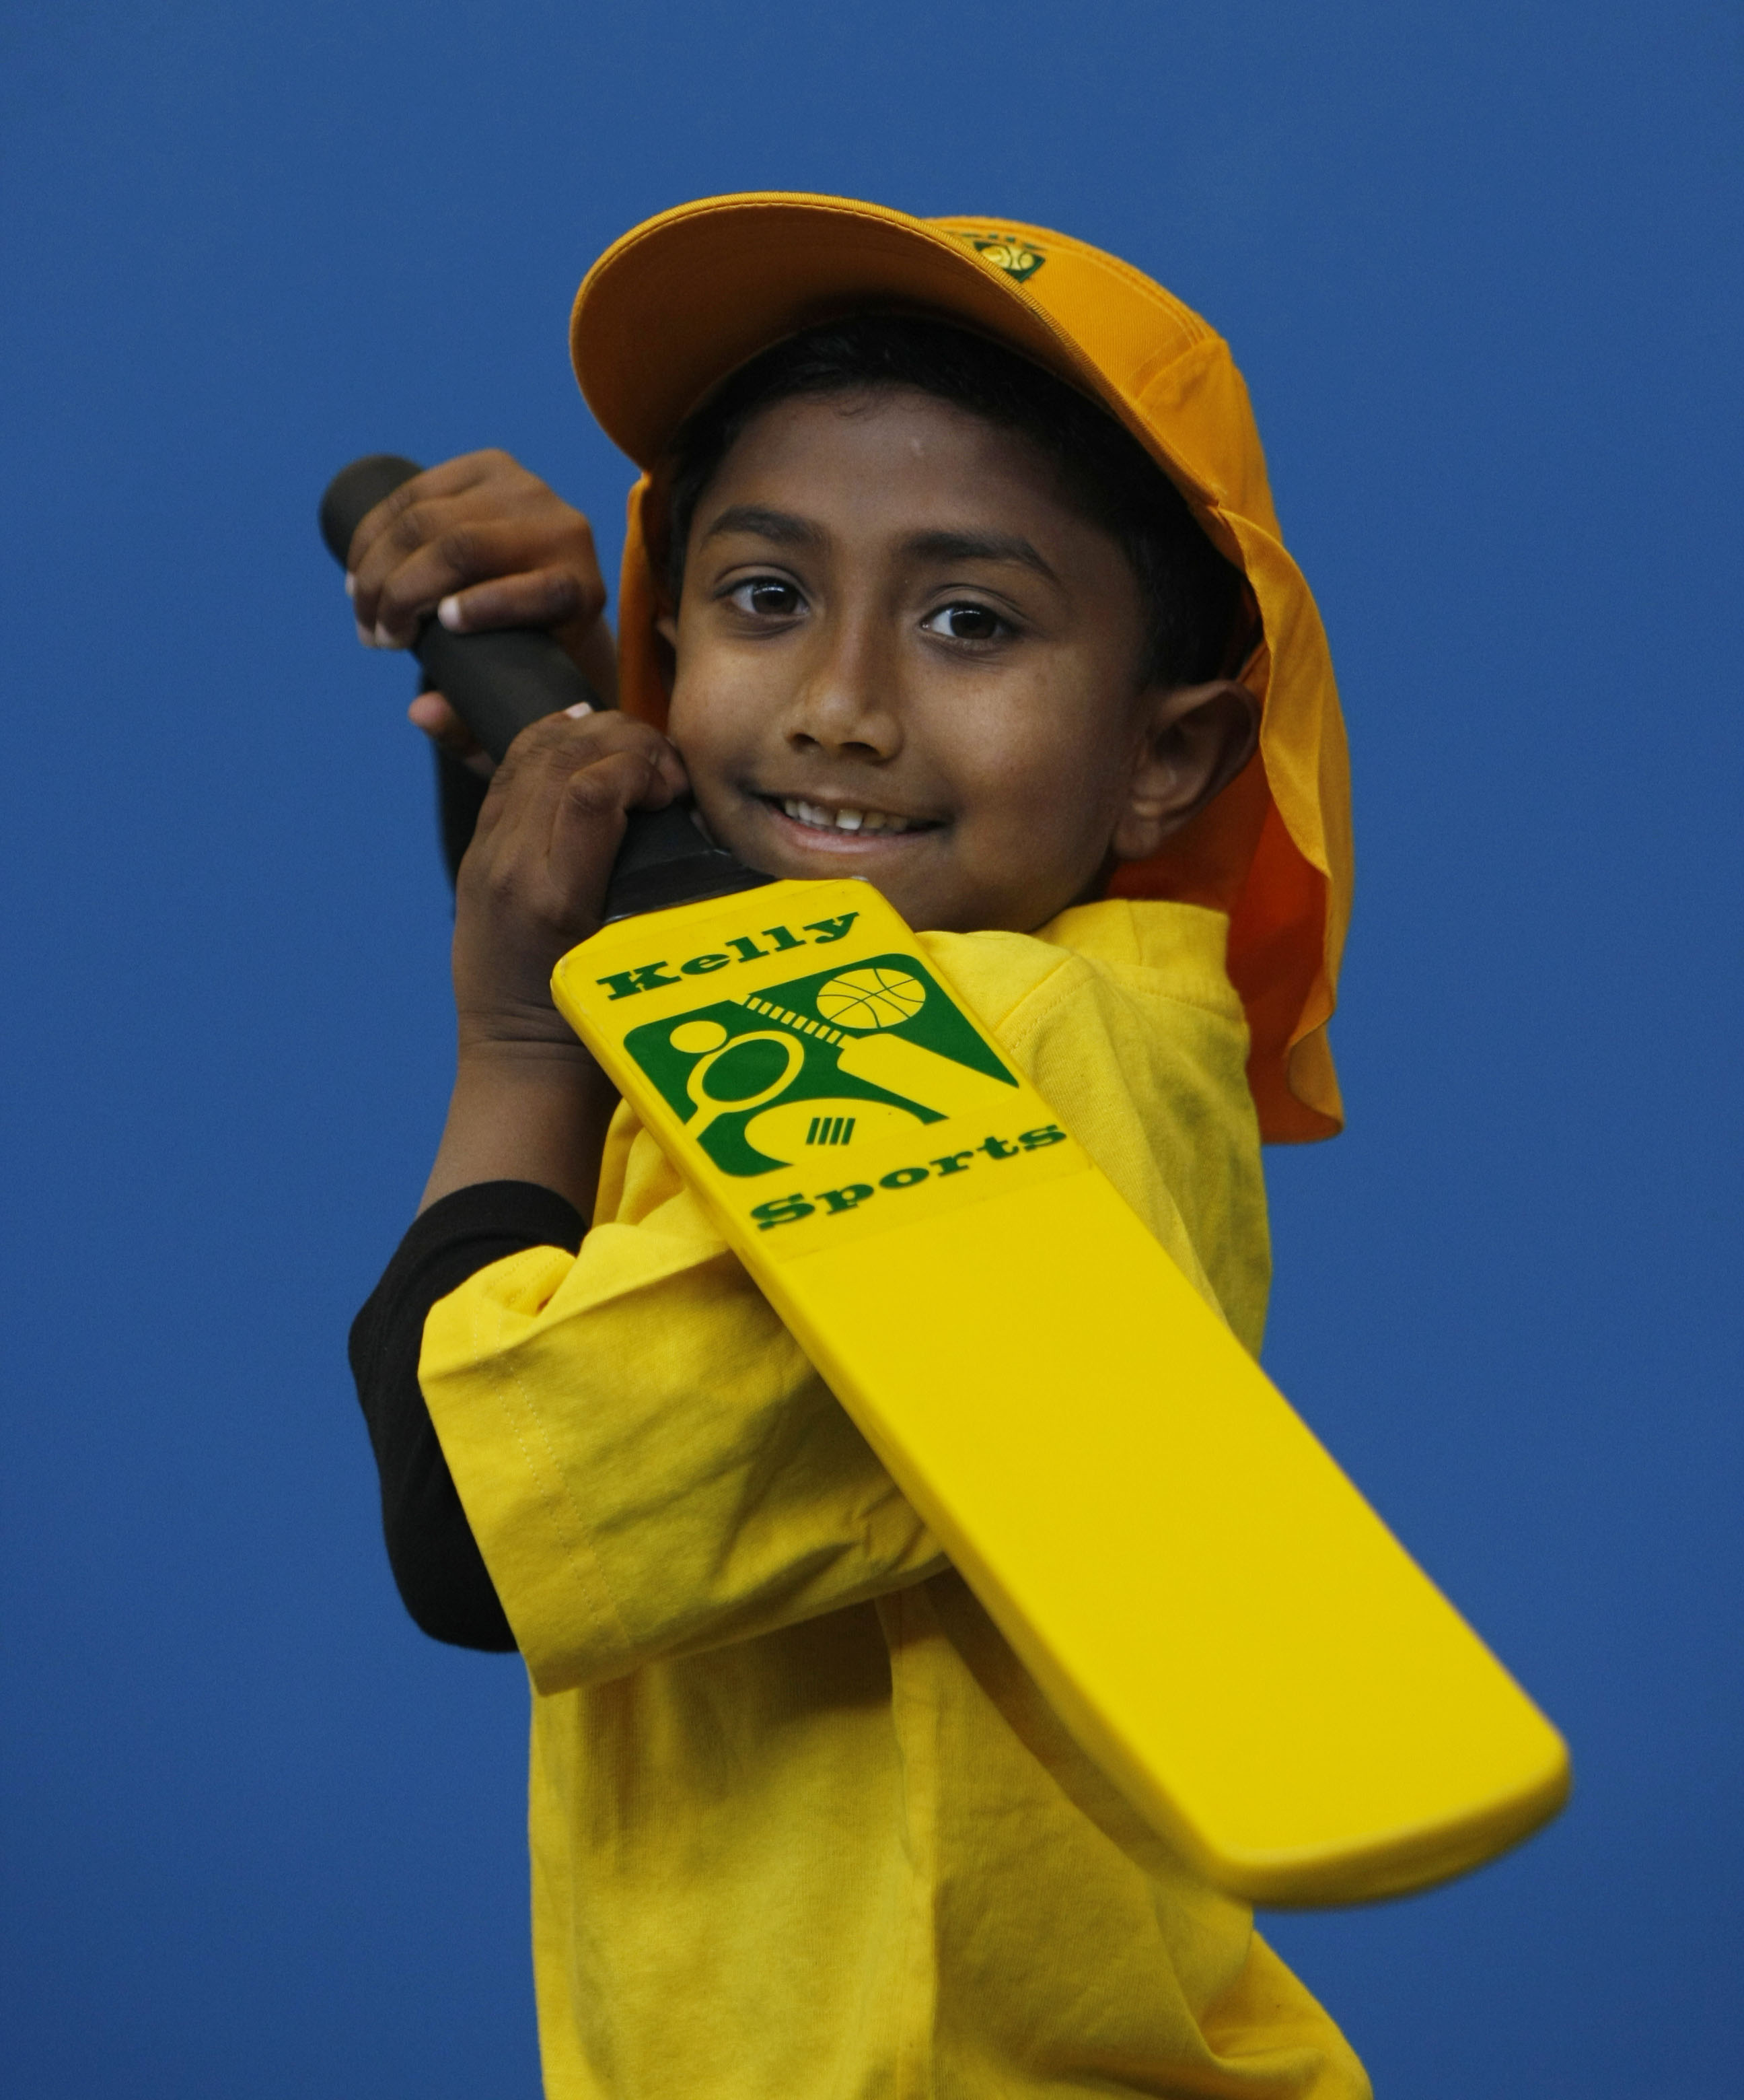
DONT MISS OUT ON KICKING A GOAL! WICKED WINTER SPORTS allows your child to play a range of dynamic and active programs run over 10 weeks; these include; Soccer, Football, Tee-Ball, Basketball and Netball! This Program will not only provide an essential base for your child's motor skills but help build awareness, co-ordination and friendship all in an enjoyable environment.
WHEN: Tuesday
COMMENCING: 15/7/2014
CONCLUDING: 16/9/2014
TIME: 11.10am – 12.00pm
YEAR LEVELS: P – 4
WHEN: Friday
COMMENCING: 18/7/2014
CONCLUDING: 19/9/2014
TIME: 3.40pm – 4.40pm
YEAR LEVELS: P – 4


DANCE
Shake, move and let the beat enter your feet with Kelly Sports. Our trained dance coaches can get your child’s hips swinging, heads bumping, feet rocking and bodies shaking to all of modern contemporary music’s classics. Sign up fast as places are limited and let our coaches beat ignite your child’s dancing feet.

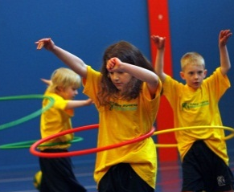

COST: $100 ( go to www.kellysports.com.au/zone/templestowe
It’s here online enrolments!
To enrol, please visit www.kellysports.com.au or
fill out the enrolment form & send with a cheque or credit card details to:
Kelly Sports PO BOX 71, Moonee Vale, VIC, 3055.
Payment options available!
Do not leave enrolment forms at the school office

and search for your school)
VENUE: Montmorency South Primary School

It’s here online enrolments!
To enrol, please visit www.kellysports.com.au or
fill out the enrolment form & send with a cheque or credit card details to:
Kelly Sports PO BOX 71, Moonee Vale, VIC, 3055.
Payment options available!
Do not leave enrolment forms at the school office

ENROLMENT FORM
Wicked Winter Sports (after school) Dance (Lunch time)
School: Year Level:
Name: Room No:
Address: Post Code:
Phone: Mobile/Work:
Email: Medical Conditions:

At the completion of after school clinics, does your child? Go to after care Get collected
Parents’ consent: I hereby authorise Kelly Sports to act on my behalf should my child require medical attention, and release
Kelly Sports Templestowe from any liability for injury incurred by my child at Kelly Sports programmes.
Parent/Caregiver name: Signature:
Amount Paid: $
To enrol, please visit www.kellysports.com.au/zone/templestowe
or fill out the below enrolment form & send with a cheque or credit
card details to: PO BOX 3011, The Pines ,VIC 3109. Payment options available! Do not leave enrolment forms at the school office.

ONLINE ENROLMENT
www.kellysports.com.au/zone/templestowe

It’s here online enrolments !
To enrol, please visit www.kellysports.com.au or
fill out the enrolment form & send with a cheque or credit card details to:
Kelly Sports PO BOX 71, Moonee Vale, VIC, 3055.
Payment options available!
Do not leave enrolment forms at the school office

It’s here online enrolments !
To enrol, please visit www.kellysports.com.au or
fill out the enrolment form & send with a cheque or credit card details to:
Kelly Sports PO BOX 71, Moonee Vale, VIC, 3055.
Payment options available!
Do not leave enrolment forms at the school office

It’s here online enrolments !
To enrol, please visit www.kellysports.com.au or
fill out the enrolment form & send with a cheque or credit card details to:
Kelly Sports PO BOX 71, Moonee Vale, VIC, 3055.
Payment options available!
Do not leave enrolment forms at the school office

