
P.O. Box 3011, The Pines, 3109

M 0414 381 368
E davidkight@kellysports.com.au

LOWER PLENTY PRIMARY SCHOOL


GYM FUN

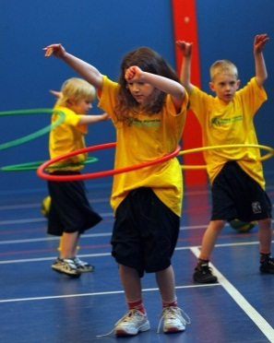
WHEN: Friday
COMMENCING: 6/02/2014
CONCLUDING: 27/03/2014
TIME: 1.40pm – 2.30pm
YEAR LEVELS: P – 4
Leap into fun in Term 1 with the Kelly Sports Team. This fast paced, highly active and non-stop program is an introduction for your child to the world of gymnastic. Colourful Ribbons, Entertaining Hula Hoops, Fantastic Rhythmical Routines, Doing Cartwheels and Group Dynamics allow your child to build up their thirst for energetic activities

COST: $80 ( go to www.kellysports.com.au and search for your school)
It’s here online enrolments !
To enrol, please visit www.kellysports.com.au or
fill out the enrolment form & send with a cheque or credit card details to:
Kelly Sports PO BOX 71, Moonee Vale, VIC, 3055.
Payment options available!
Do not leave enrolment forms at the school office


VENUE: Lower Plenty Primary School
To enrol, please visit www.kellysports.com.au
or fill out the below enrolment form & send with a cheque to:
PO BOX 3011, The Pines VIC 3109. Payment options
available! Do not leave enrolment forms at the school office.

ONLINE ENROLMENT
www.kellysports.com.au/zone/templestowe

It’s here online enrolments !
To enrol, please visit www.kellysports.com.au or
fill out the enrolment form & send with a cheque or credit card details to:
Kelly Sports PO BOX 71, Moonee Vale, VIC, 3055.
Payment options available!
Do not leave enrolment forms at the school office

ENROLMENT FORM
Gym Fun (Lunch time)
School: Year Level:
Name: Room No:
Address: Post Code:
Phone: Mobile/Work:
Email: Medical Conditions:

At the completion of after school clinics, does your child? Go to after care Get collected
Parents’ consent: I hereby authorise Kelly Sports to act on my behalf should my child require medical attention, and release
Kelly Sports Templestowe from any liability for injury incurred by my child at Kelly Sports programmes.
Payment Options: Go online and pay via Direct Deposit or credit card via Pay Pal.
Parent/Caregiver name: Signature:
Amount Paid: $
It’s here online enrolments !
To enrol, please visit www.kellysports.com.au or
fill out the enrolment form & send with a cheque or credit card details to:
Kelly Sports PO BOX 71, Moonee Vale, VIC, 3055.
Payment options available!
Do not leave enrolment forms at the school office

It’s here online enrolments !
To enrol, please visit www.kellysports.com.au or
fill out the enrolment form & send with a cheque or credit card details to:
Kelly Sports PO BOX 71, Moonee Vale, VIC, 3055.
Payment options available!
Do not leave enrolment forms at the school office

It’s here online enrolments !
To enrol, please visit www.kellysports.com.au or
fill out the enrolment form & send with a cheque or credit card details to:
Kelly Sports PO BOX 71, Moonee Vale, VIC, 3055.
Payment options available!
Do not leave enrolment forms at the school office

