
P.O. Box 3011, The Pines 3109

T 0414 381 368
E davidkight@kellysports.com.au


LOWER PLENTY PRIMARY SCHOOL
WICKED WINTER SPORTS
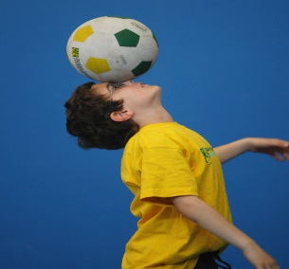
WHEN: Wednesday
COMMENCING: 22/07/2015
CONCLUDING: 16/09/2015
TIME: 3.40pm – 4.40pm
YEAR LEVELS: P – 4
DONT MISS OUT ON KICKING A GOAL! WICKED WINTER SPORTS allows your child to play a range of dynamic and active programs run over 9 weeks these include; Soccer, Football, Basketball, T-ball and Crazy Games! This Program will not only provide an essential base for your child's motor skills but help build awareness, co-ordination and friendship all in an enjoyable environment.


GYM FUN

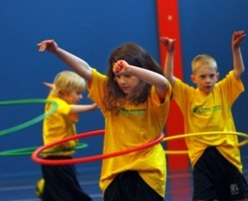
WHEN: Friday
COMMENCING: 24/07/2015
CONCLUDING: 18/09/2015
TIME: 1.30pm – 2.30pm
YEAR LEVELS: P – 4
This fun fast paced, highly active and non-stop program is an introduction for your child to the world of gymnastics. Colourful ribbons, Entertaining Hula Hoops, Incredible Rhythmical Routines and Group Dynamics. Allow your child to build their gymnastics skills and their thirst for exciting energetic activities.

COST: $90 ( go to www.kellysports.com.au and search for your school)
It’s here online enrolments!
To enrol, please visit www.kellysports.com.au or
fill out the enrolment form & send with a cheque or credit card details to:
Kelly Sports PO BOX 71, Moonee Vale, VIC, 3055.
Payment options available!
Do not leave enrolment forms at the school office

VENUE: Lower Plenty Primary School

To enrol, please visit www.kellysports.com.au or fill out the
below enrolment form & send with a cheque or credit card details to:
PO BOX 3011, The PinesVIC 3109. Payment options available!
Do not leave enrolment forms at the school office.

It’s here online enrolments!
To enrol, please visit www.kellysports.com.au or
fill out the enrolment form & send with a cheque or credit card details to:
Kelly Sports PO BOX 71, Moonee Vale, VIC, 3055.
Payment options available!
Do not leave enrolment forms at the school office

ENROLMENT FORM
Wicked Winter Sports (After school) Gym Fun (Lunch time)
School: Year Level:
Name: Room No:
Address: Post Code:
Phone: Mobile/Work:
Email: Medical Conditions:

At the completion of after school clinics, does your child? Go to after care Get collected
Parents’ consent
I hereby authorise Kelly Sports to act on my behalf should my child require medical attention, and release Kelly Sports Templestowe from
any liability for injury incurred by my child at Kelly Sports programmes.
I authorise the use by Kelly Sports of any photographs or video image of my child or legal charge for any reasonable purpose.
Parent/Caregiver name: Signature:
Amount Paid: $
ONLINE ENROLMENT
www.kellysports.com.au

It’s here online enrolments!
To enrol, please visit www.kellysports.com.au or
fill out the enrolment form & send with a cheque or credit card details to:
Kelly Sports PO BOX 71, Moonee Vale, VIC, 3055.
Payment options available!
Do not leave enrolment forms at the school office

It’s here online enrolments !
To enrol, please visit www.kellysports.com.au or
fill out the enrolment form & send with a cheque or credit card details to:
Kelly Sports PO BOX 71, Moonee Vale, VIC, 3055.
Payment options available!
Do not leave enrolment forms at the school office

It’s here online enrolments !
To enrol, please visit www.kellysports.com.au or
fill out the enrolment form & send with a cheque or credit card details to:
Kelly Sports PO BOX 71, Moonee Vale, VIC, 3055.
Payment options available!
Do not leave enrolment forms at the school office

