
P.O. Box 3011, The Pines 3109
T 0414 381 368
Special Offer
$9.50/week
for 7 weeks
when you enrol
on-line!

E davidkight@kellysports.com.au


Goodstart Eltham
FUNDAMENTAL
SKILLS PROGRAM

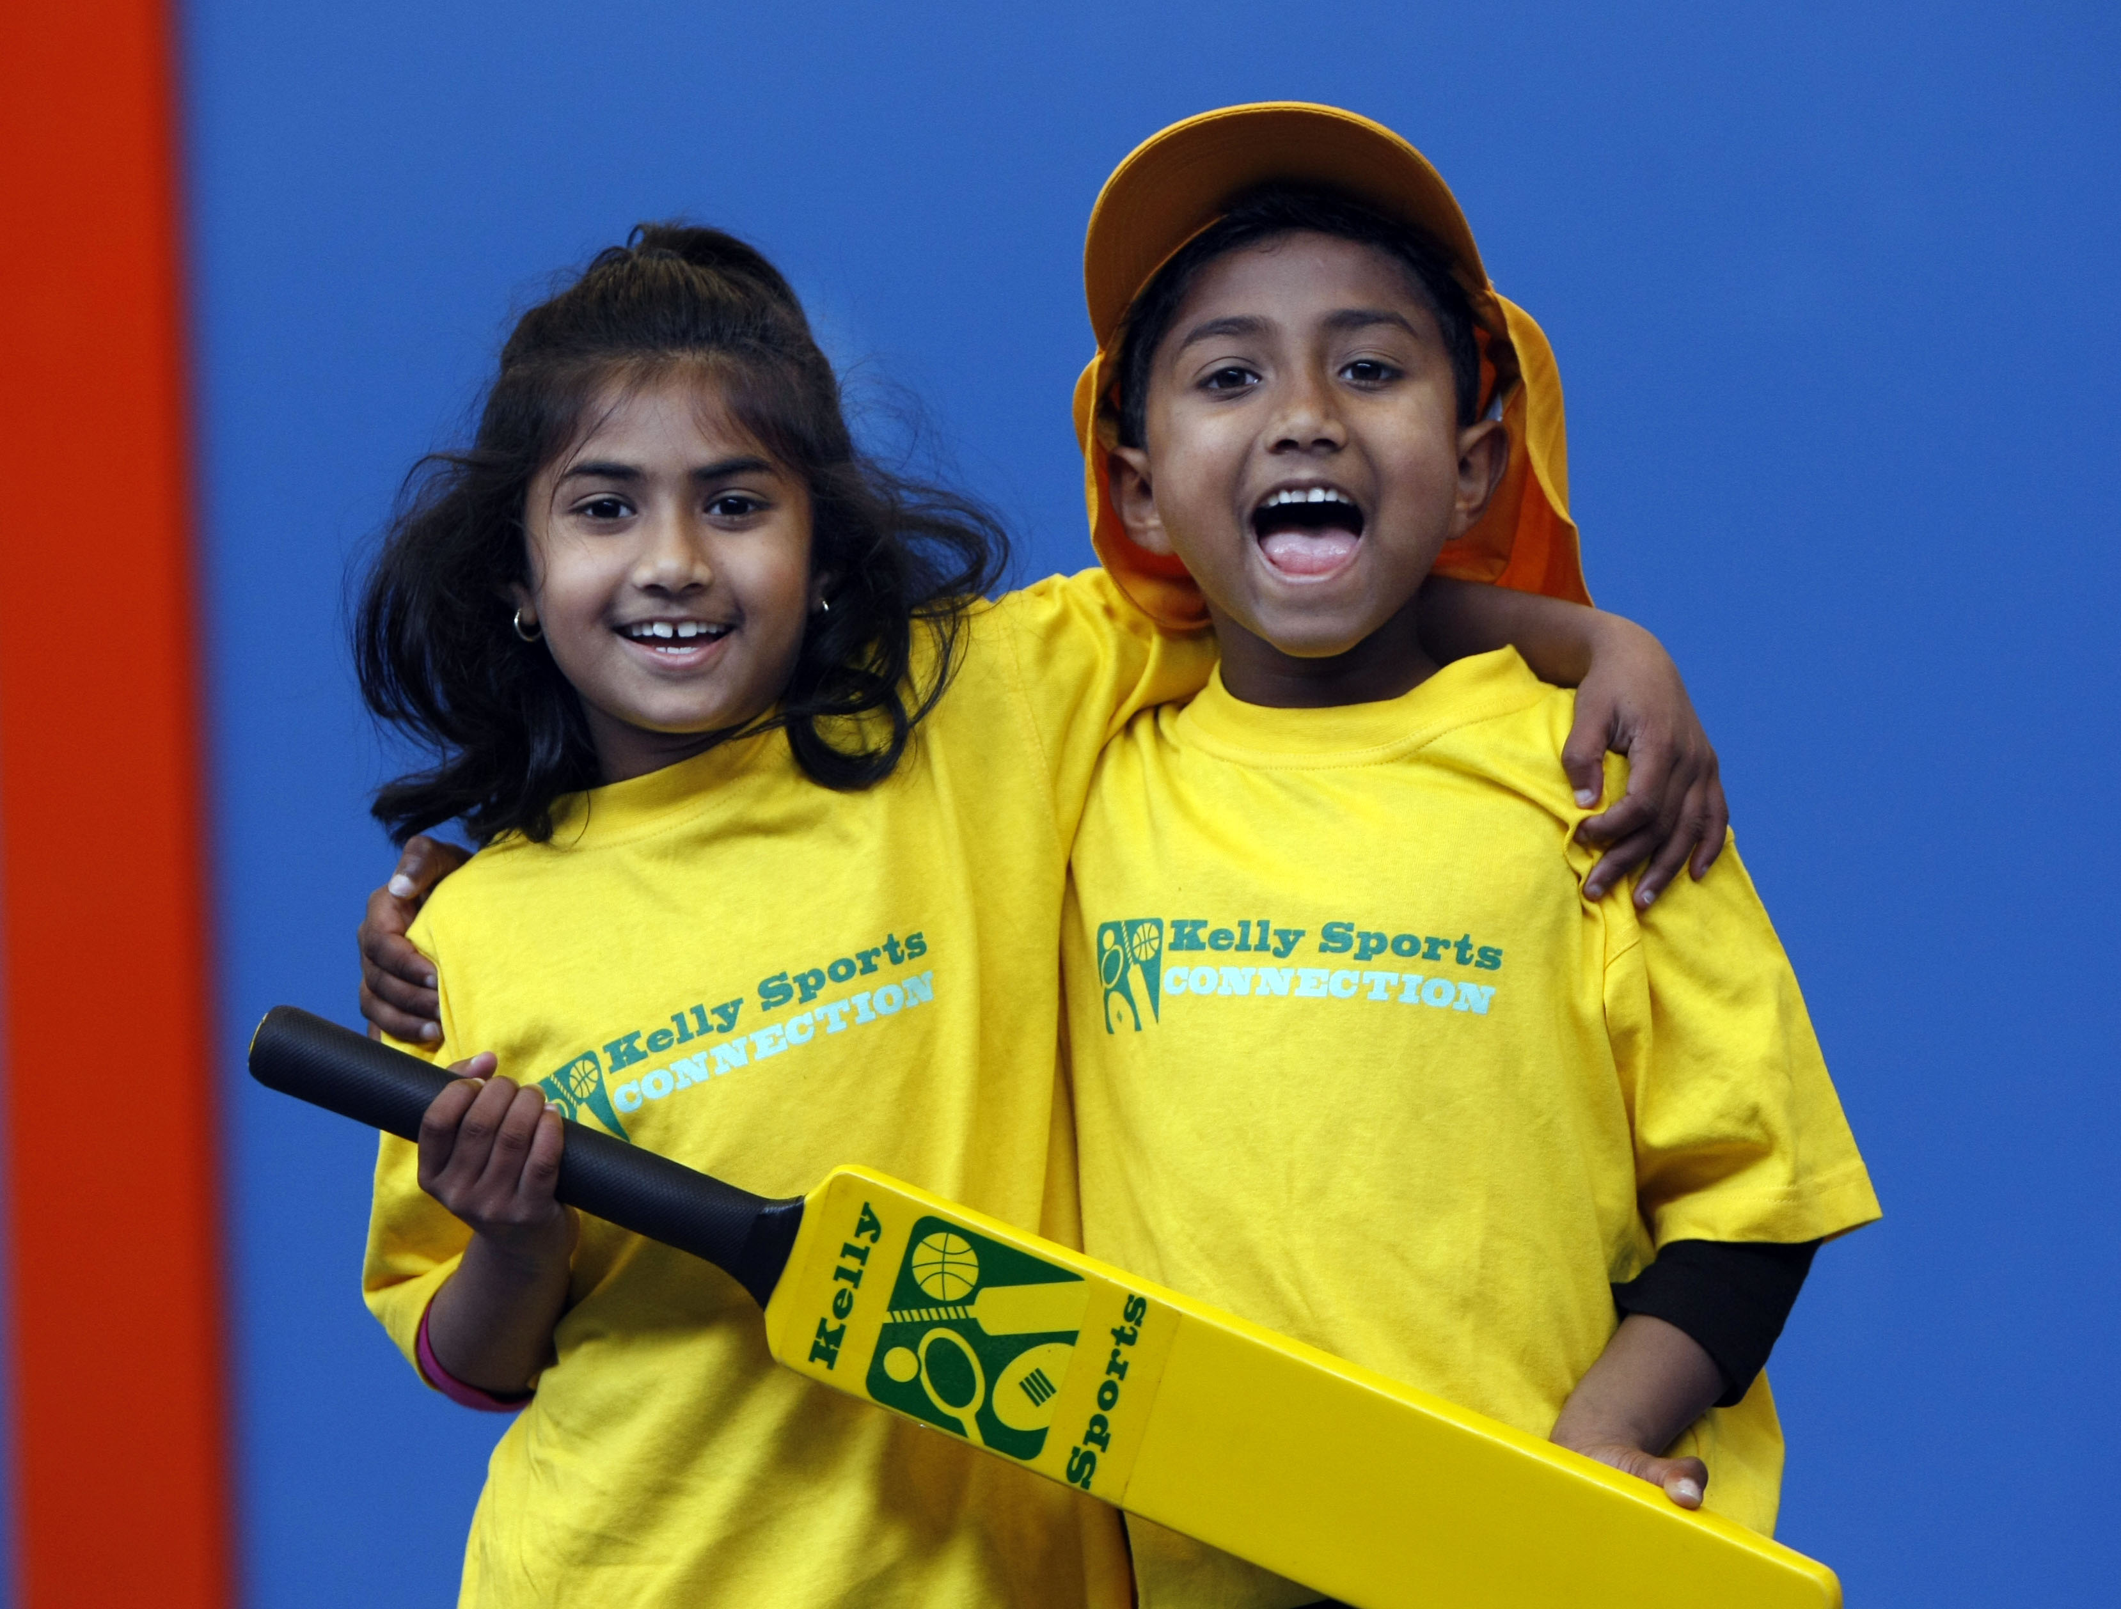
Kelly Sports runs programmes to teach children the fundamentals of sport. This 22 WEEK program is all inclusive with high participation. Our key aims are to develop and enhance the following skills – running, jumping, catching, throwing, passing, kicking and striking:
The Fundamental Skills Program includes:
- Motor Skill Development
- Balance and Hand- Eye Cordination
- Introduction to a variety of sports -Soccer, Basketball, Cricket, Hockey, Football and more.

WHEN: Monday
COMMENCING: 13/7/2015
CONCLUDING: 7/12/2015
TIME: 10.00am – 10.30am
TIME: 10.30am – 11.00am

COST: $ 114- 3 weeks credit for Monday holidays missed in Semester One (enrol online – go to www.kellysports.com.au
It’s here online enrolments !
To enrol, please visit www.kellysports.com.au or
fill out the enrolment form & send with a cheque or credit card details to:
Kelly Sports PO BOX 71, Moonee Vale, VIC, 3055.
Payment options available!
Do not leave enrolment forms at the school office

and search for your school)
VENUE: Good Start Early Learning Centre

It’s here online enrolments !
To enrol, please visit www.kellysports.com.au or
fill out the enrolment form & send with a cheque or credit card details to:
Kelly Sports PO BOX 71, Moonee Vale, VIC, 3055.
Payment options available!
Do not leave enrolment forms at the school office

ENROLMENT FORM
School: Year Level:
Name: Room No:
Address: Post Code:
Phone: Mobile/Work:
Email: Medical Conditions:

At the completion of after school clinics, does your child? Go to after care Get collected
Parents’ consent: I hereby authorise Kelly Sports to act on my behalf should my child require medical attention, and release
Kelly Sports Templestowe from any liability for injury incurred by my child at Kelly Sports programmes.
COST: Payment Options-Credit Card and Direct Deposit are options when enrolling online.
Parent/Caregiver name: Signature:
Amount Paid: $

To enrol, please visit www.kellysports.com.au
or fill out the below enrolment form & send with a cheque to: PO BOX 3011, The Pines VIC 3109. Payment
options available! Do not leave enrolment forms at the school office.

ONLINE ENROLMENT
www.kellysports.com.au

It’s here online enrolments !
To enrol, please visit www.kellysports.com.au or
fill out the enrolment form & send with a cheque or credit card details to:
Kelly Sports PO BOX 71, Moonee Vale, VIC, 3055.
Payment options available!
Do not leave enrolment forms at the school office

It’s here online enrolments !
To enrol, please visit www.kellysports.com.au or
fill out the enrolment form & send with a cheque or credit card details to:
Kelly Sports PO BOX 71, Moonee Vale, VIC, 3055.
Payment options available!
Do not leave enrolment forms at the school office

It’s here online enrolments !
To enrol, please visit www.kellysports.com.au or
fill out the enrolment form & send with a cheque or credit card details to:
Kelly Sports PO BOX 71, Moonee Vale, VIC, 3055.
Payment options available!
Do not leave enrolment forms at the school office

