Special for 10 weeks
when you enrol
on-line!

P.O. Box 3011, The Pines 3109
T 0414 381 368
Special Offer
$9.50/week
for 7 weeks

E davidkight@kellysports.com.au


Donvale Childcare
FUNDAMENTAL
SKILLS PROGRAM

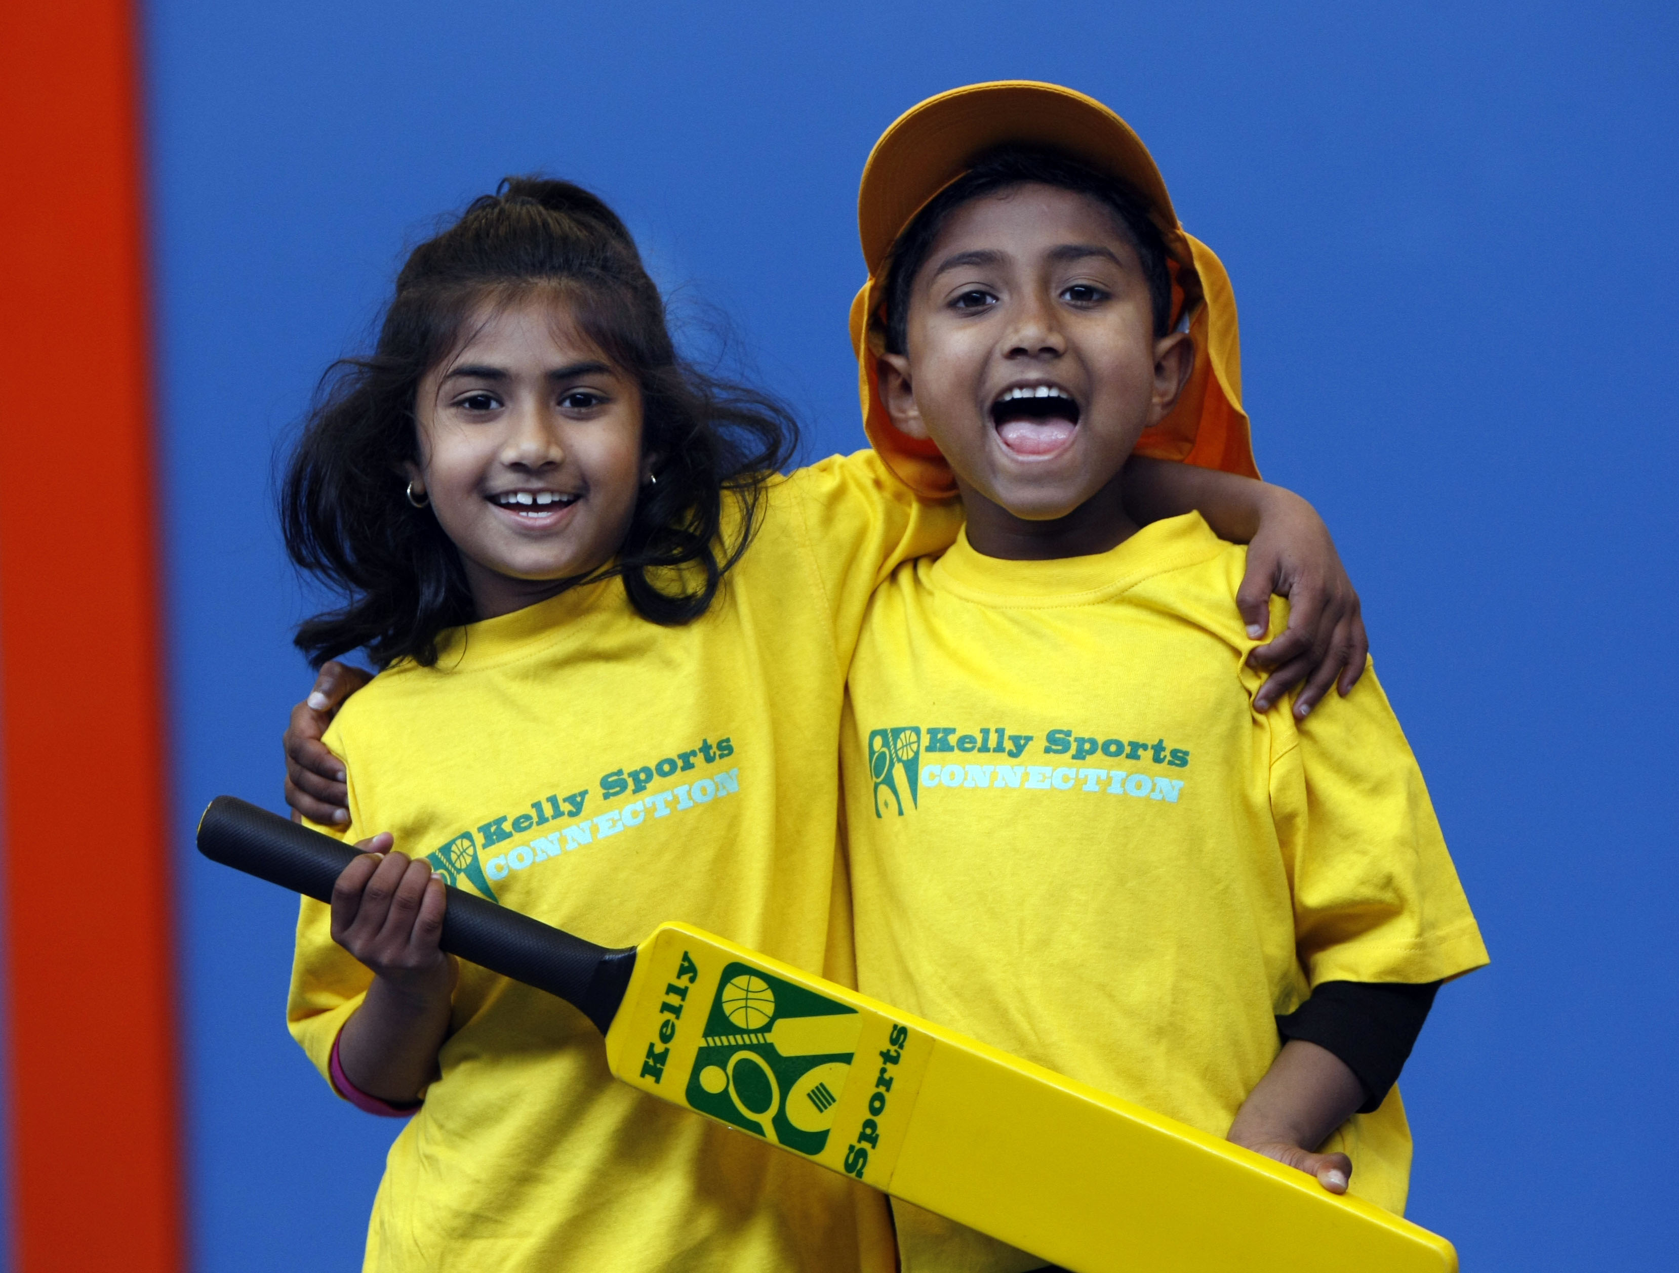
Kelly Sports runs programmes to teach children the fundamentals of sport. This 21 WEEK program is all inclusive with high participation. Our key aims are to develop and enhance the following skills – running, jumping, catching, throwing, passing, kicking and striking:
The Fundamental Skills Program includes:
- Motor Skill Development
- Balance and Hand- Eye Cordination
- Introduction to a variety of sports -Soccer, Basketball, Cricket, Hockey, Football and more.

WHEN: Tuesday
COMMENCING: 15/7/2014
CONCLUDING: 9/12/2014
TIME:Pre-K 10.30am – 11.00am
TIME:Kinder 11.00am – 11.30am


COST: $Just 120 for 21 weeks,Cup Day not included.
It’s here online enrolments !
To enrol, please visit www.kellysports.com.au or
fill out the enrolment form & send with a cheque or credit card details to:
Kelly Sports PO BOX 71, Moonee Vale, VIC, 3055.
Payment options available!
Do not leave enrolment forms at the school office

It’s here online enrolments !
To enrol, please visit www.kellysports.com.au or
fill out the enrolment form & send with a cheque or credit card details to:
Kelly Sports PO BOX 71, Moonee Vale, VIC, 3055.
Payment options available!
Do not leave enrolment forms at the school office

ENROLMENT FORM
School: Year Level:
Name: Room No:
Address: Post Code:
Phone: Mobile/Work:
Email: Medical Conditions:

At the completion of after school clinics, does your child? Go to after care Get collected
Parents’ consent: I hereby authorise Kelly Sports to act on my behalf should my child require medical attention, and release
Kelly Sports Templestowe from any liability for injury incurred by my child at Kelly Sports programmes.
Payment Options: Go online and pay via Direct Deposit or credit card via Pay Pal.
Parent/Caregiver name: Signature:
Amount Paid: $
To enrol, please visit www.kellysports.com.au/templestowe
or fill out the below enrolment form & send with a cheque or credit
card details to: PO BOX 3011, The Pines VIC 3109. Payment
options available!

ONLINE ENROLMENT
www.kellysports.com.au/zone/templestowe

It’s here online enrolments !
To enrol, please visit www.kellysports.com.au or
fill out the enrolment form & send with a cheque or credit card details to:
Kelly Sports PO BOX 71, Moonee Vale, VIC, 3055.
Payment options available!
Do not leave enrolment forms at the school office

It’s here online enrolments !
To enrol, please visit www.kellysports.com.au or
fill out the enrolment form & send with a cheque or credit card details to:
Kelly Sports PO BOX 71, Moonee Vale, VIC, 3055.
Payment options available!
Do not leave enrolment forms at the school office

It’s here online enrolments !
To enrol, please visit www.kellysports.com.au or
fill out the enrolment form & send with a cheque or credit card details to:
Kelly Sports PO BOX 71, Moonee Vale, VIC, 3055.
Payment options available!
Do not leave enrolment forms at the school office

