
P.O. Box 3011, The Pines 3109
Special Offer

T 0414 381 368
E davidkight@kellysports.com.au


ANDERSON’S CREEK PRIMARY SCHOOL
GYM FUN

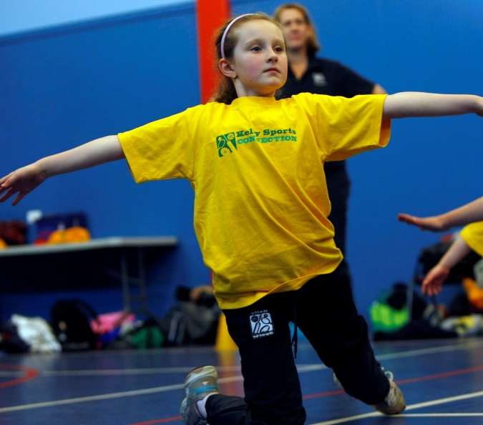

This fun fast paced, highly active and non-stop program is an introduction for your child to the world of gymnastics. Colorful ribbons, Entertaining Hula Hoops, Incredible Rhythmical Routines and Group Dynamics. Allow your child to build their gymnastics skills and their thirst
for exciting energetic activities.

WHEN: Thursday
COMMENCING: 8/10/2015
CONCLUDING: 10/12/2015
TIME: 1.00pm – 1.50pm
YEAR LEVELS: P – 4

COST: $100 (go to www.kellysports.com.au and search for your school)
It’s here online enrolments !
To enrol, please visit www.kellysports.com.au or
fill out the enrolment form & send with a cheque or credit card details to:
Kelly Sports PO BOX 71, Moonee Vale, VIC, 3055.
Payment options available!
Do not leave enrolment forms at the school office

VENUE: Anderson’s Creek Primary School

It’s here online enrolments !
To enrol, please visit www.kellysports.com.au or
fill out the enrolment form & send with a cheque or credit card details to:
Kelly Sports PO BOX 71, Moonee Vale, VIC, 3055.
Payment options available!
Do not leave enrolment forms at the school office

ENROLMENT FORM
School: Year Level:
Name: Room No:
Address: Post Code:
Phone: Mobile/Work:
Email: Medical Conditions:

At the completion of after school clinics, does your child? Go to after care Get collected
Parents’ consent
I hereby authorise Kelly Sports to act on my behalf should my child require medical attention, and release Kelly Sports Templestowe from
any liability for injury incurred by my child at Kelly Sports programmes.
I authorise the use by Kelly Sports of any photographs or video image of my child or legal charge for any reasonable purpose.
Parent/Caregiver name: Signature:
Amount Paid: $ Credit card payment:

To enrol, please visit www.kellysports.com.au or fill out the
below enrolment form & send with a cheque to:
PO BOX 3011, The Pines 3109. Payment options available!
Do not leave enrolment forms at the school office.

ONLINE ENROLMENT
www.kellysports.com.au

It’s here online enrolments !
To enrol, please visit www.kellysports.com.au or
fill out the enrolment form & send with a cheque or credit card details to:
Kelly Sports PO BOX 71, Moonee Vale, VIC, 3055.
Payment options available!
Do not leave enrolment forms at the school office

It’s here online enrolments !
To enrol, please visit www.kellysports.com.au or
fill out the enrolment form & send with a cheque or credit card details to:
Kelly Sports PO BOX 71, Moonee Vale, VIC, 3055.
Payment options available!
Do not leave enrolment forms at the school office

It’s here online enrolments !
To enrol, please visit www.kellysports.com.au or
fill out the enrolment form & send with a cheque or credit card details to:
Kelly Sports PO BOX 71, Moonee Vale, VIC, 3055.
Payment options available!
Do not leave enrolment forms at the school office

