

P.O. Box 71, Moonee Vale 3055
T (03) 9384 2204
FOLLOW US
ONLINE

F (03) 9384 2205

E mitch@kellysports.com.au





GOODSTART DONCASTER EAST
FUNDAMENTAL MOTOR SKILLS

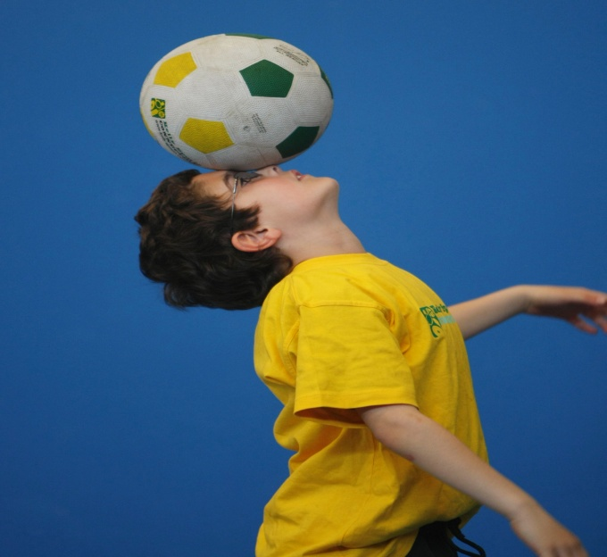
WHEN: Thursday
COMMENCING: 08/02/18
CONCLUDING: 28/06/18
TIME: 9.30am- 10.30am
COST: $152
No seesions during easter school holidays
Kelly Sports is offering our famous fundamental motor skills program. Our sports program consists of fun-filled sports activities using bean bags, tennis balls, soccer balls, hula hoops, colourful ribbons, juggling scarfs and more! Our focus as always with kinder aged children is fun, excitement, maximum participation and of course fundamental motor skill development including jumping, bouncing, striking, catching, throwing, balance and hand-eye coordination.

$152 For Semester 1 2018 – 19 Weeks Total

It’s here online enrolments !
To enrol, please visit www.kellysports.com.au or
fill out the enrolment form & send with a cheque or credit card details to:
Kelly Sports PO BOX 71, Moonee Vale, VIC, 3055.
Payment options available!
Do not leave enrolment forms at the school office

NEW IMPROVED ONLINE BOOKING SYSTEM!!!
SIMPLY GO TO WWW.KELLYSPORTS.COM.AU ENTER YOUR POST CODE AND ENROL FROM THERE. OR
FILL OUT THE BELOW ENROLMENT FOR & SEND WITH A CHEQUE OR CREDIT CARDS DETAILS TO:
PO BOX 71, MOONEE VALE, 3055
PAYMENT OPTIONS AVALIABLE!

ENROLMENT FORM

School: Year Level:
Name: Room No:
Address: Post Code:
Phone: Mobile/Work:
Email: Medical Conditions:

At the completion of after school clinics, does your child? Go to after care Get collected
Parents’ consent: I hereby authorise Kelly Sports to act on my behalf should my child require medical attention, and release
Kelly Sports from any liability for injury incurred by my child at Kelly Sports programs.
Parent/Caregiver name: Signature:
Amount Paid: $ Credit card payment: Visa Master card
Card Number: Expiry Date: /CVV:
THINGS TO KNOW
Kelly Sports is a Registered Child Care provider
Don’t leave forms at the School Office
Spaces are limited so please make sure you enrol online or return form to Kelly Sports.

It’s here online enrolments !
To enrol, please visit www.kellysports.com.au or
fill out the enrolment form & send with a cheque or credit card details to:
Kelly Sports PO BOX 71, Moonee Vale, VIC, 3055.
Payment options available!
Do not leave enrolment forms at the school office

It’s here online enrolments !
To enrol, please visit www.kellysports.com.au or
fill out the enrolment form & send with a cheque or credit card details to:
Kelly Sports PO BOX 71, Moonee Vale, VIC, 3055.
Payment options available!
Do not leave enrolment forms at the school office

It’s here online enrolments !
To enrol, please visit www.kellysports.com.au or
fill out the enrolment form & send with a cheque or credit card details to:
Kelly Sports PO BOX 71, Moonee Vale, VIC, 3055.
Payment options available!
Do not leave enrolment forms at the school office

