
P.O. Box 71, Moonee Vale 3055

T (03) 9384 2204
F (03) 9384 2205

E mitch@kellysports.com.au


SERPELL PRIMARY SCHOOL

AWESOME AUTUMN SPORTS - CRICKET-SOCCER-BASKETBALL-HOCKEY T- TEAM GAMES
Start the new school term by enrolling in this fantastic Kelly sports program. Join up with your friends and develop your skills in a fun, safe an exciting sporting environment. Our experienced coaches aim to develop and enhance the wide range of sporting skills of your child including kicking catching & throwing while also improving strength, flexibility, hand-eye co-ordination, Spatial awareness, co-operative and teamwork

WHEN: Monday
COMMENCING: 23/4/2018
CONCLUDING: 25/6/2018
TIME: 3.40pm – 4.40pm
YEAR LEVELS: P – 4

JAZZ FUNK
Jazz – Funk takes elements of both Hip Hop and Jazz, combined into one dance style that gives students a chance to release energy and dance with power and passion. Our experience staff will work on a brand new routine through out the term to showcase to parents and friends. Sign up fast as students will have a fantastic time learning the new moves in our high intensity, excitement-filled dance environment.

WHEN: Tuesday
COMMENCING: 24/4/2018
CONCLUDING: 26/6/2018
TIME: 12.30pm – 1.30pm
YEAR LEVELS: P – 4

GYM FUN
This fun fast paced, highly active and non-stop program is an introduction for your child to the world of gymnastics. Colourful ribbons, Entertaining Hula Hoops, Incredible Rhythmical Routines and Group Dynamics. Allow your child to build their gymnastics skills and their thirst
for exciting energetic activities.

WHEN: Thursday
COMMENCING: 26/4/2018
CONCLUDING: 28/6/2018
TIME: 12.30pm – 1.30pm
YEAR LEVEL P – 4

COST: Monday $108 for 9 weeks – Tuesday & Thursday $120 for 10 weeks
It’s here online enrolments !
To enrol, please visit www.kellysports.com.au or
fill out the enrolment form & send with a cheque or credit card details to:
Kelly Sports PO BOX 71, Moonee Vale, VIC, 3055.
Payment options available!
Do not leave enrolment forms at the school office

VENUE: Serpell Primary School
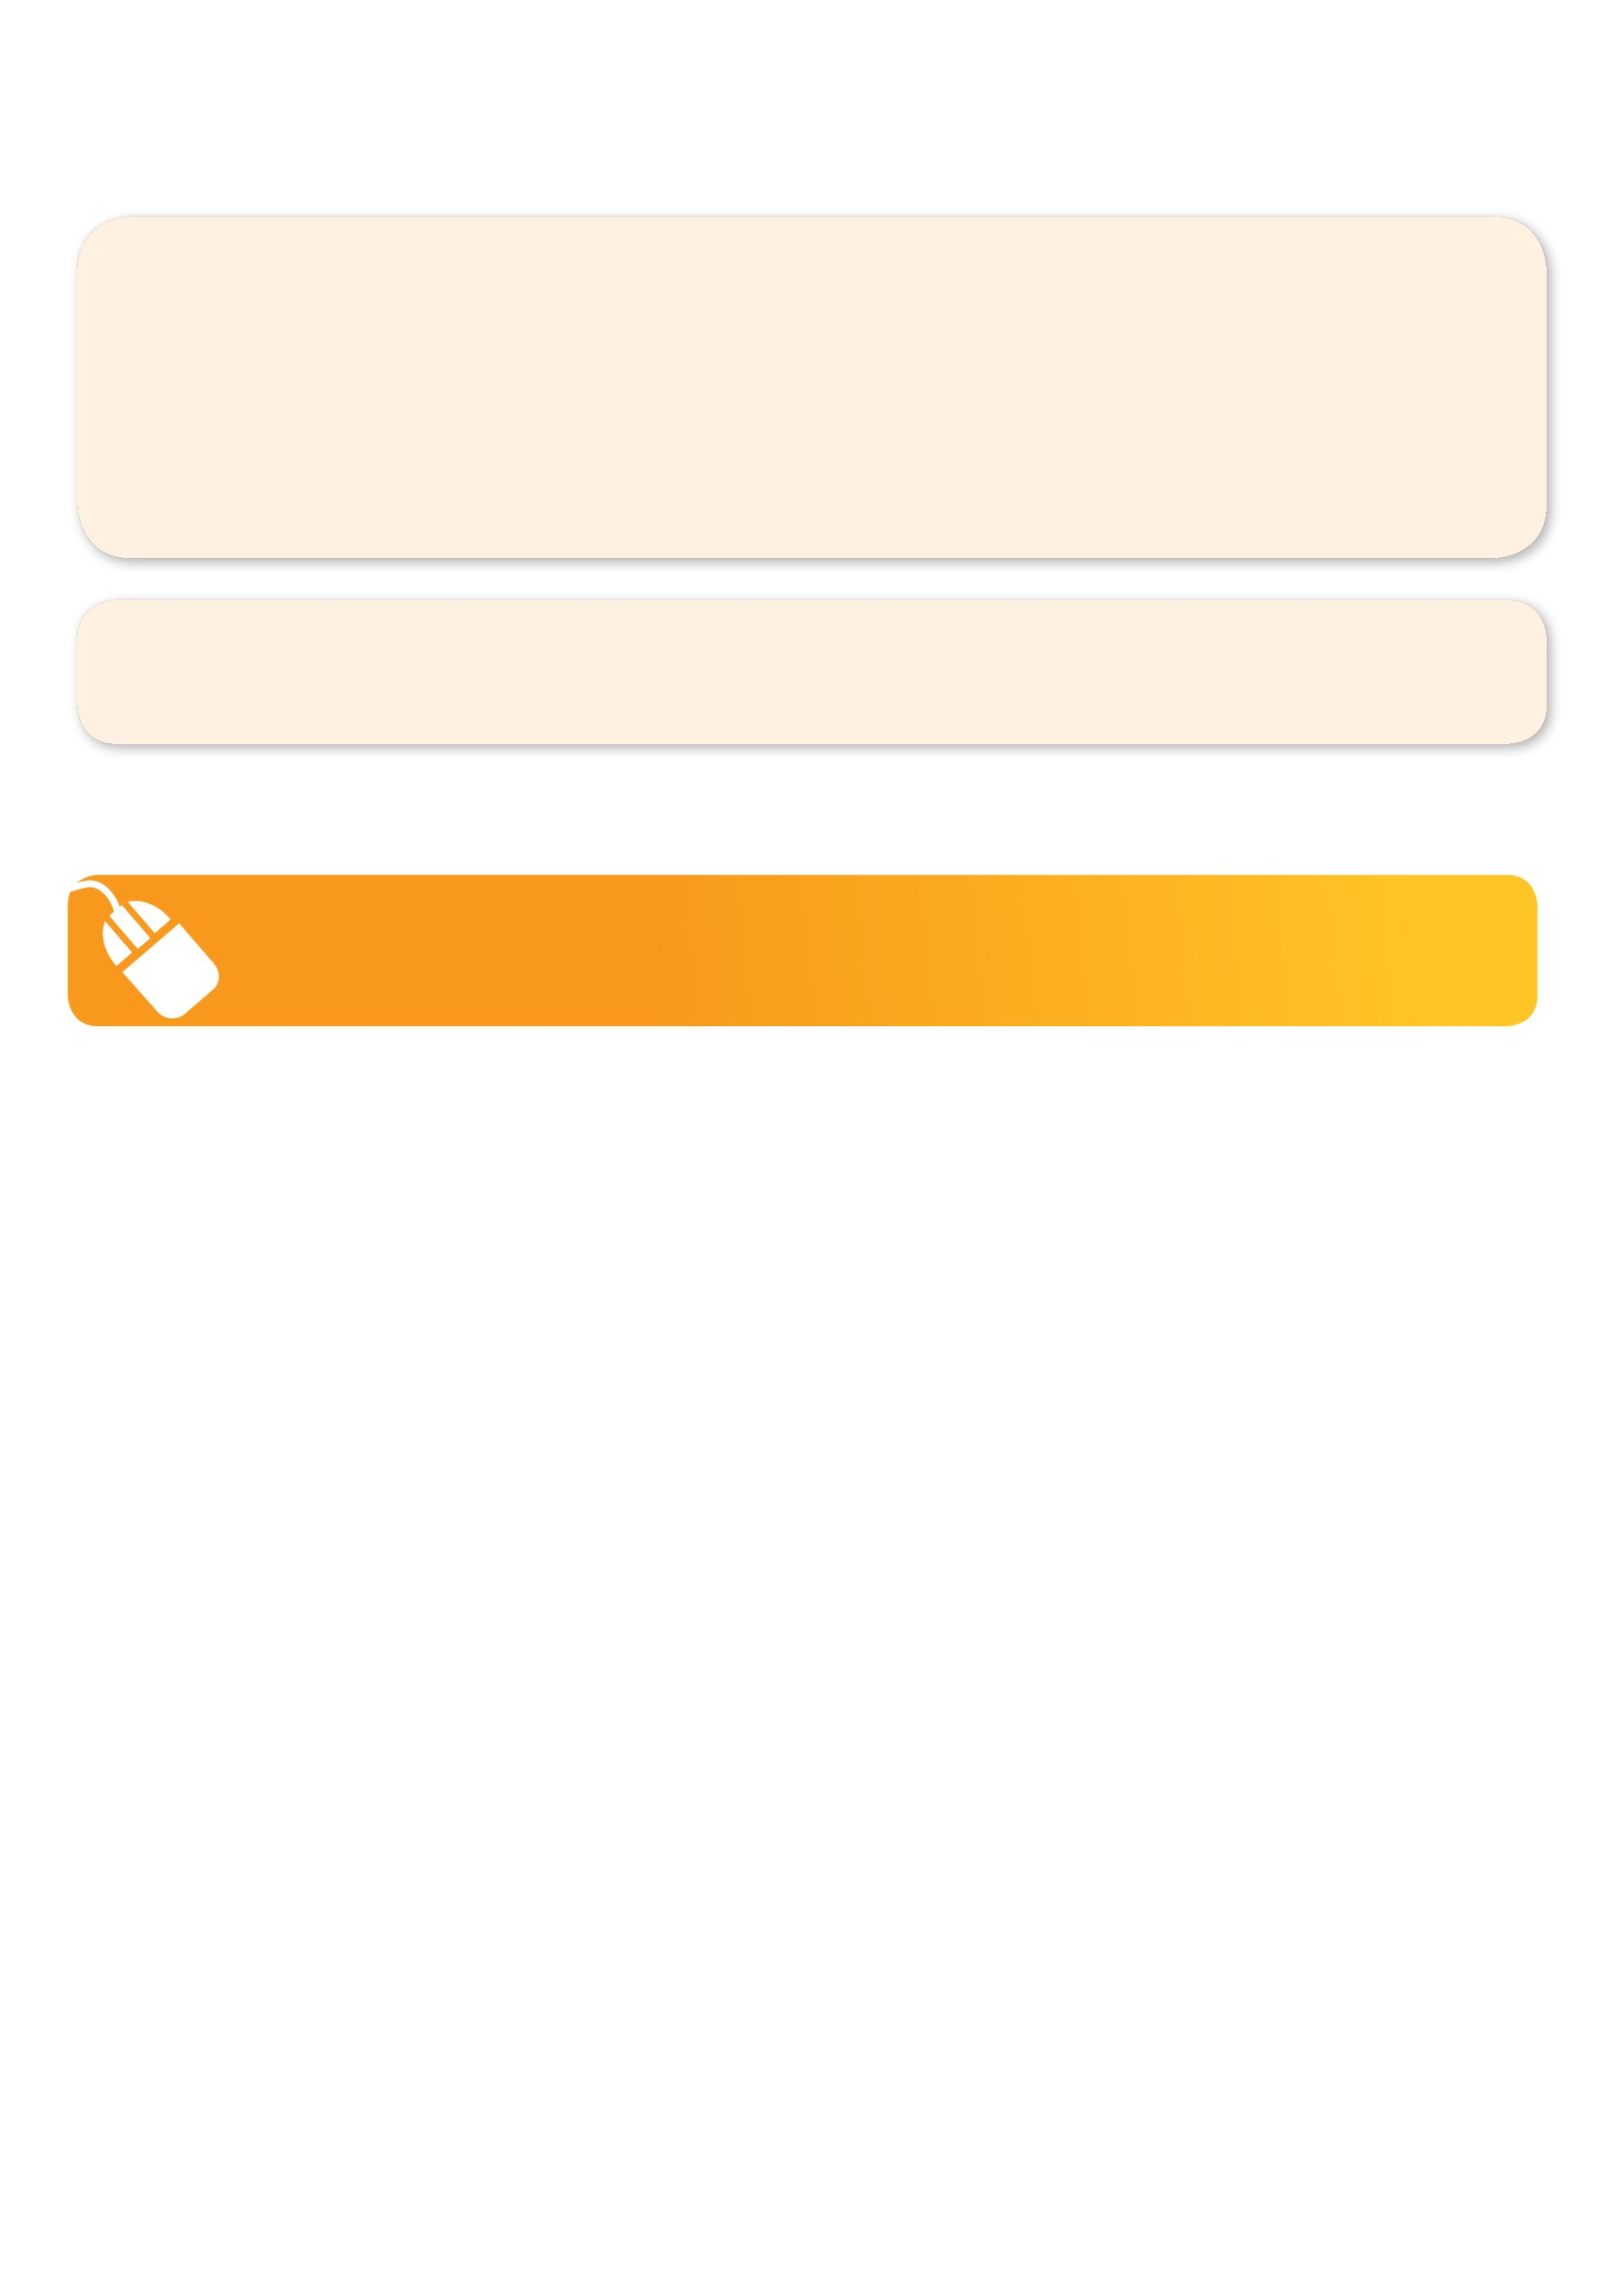
NEW IMPROVED ONLINE BOOKING SYSTEM!!!
SIMPLY GO TO WWW.KELLYSPORTS.COM.AU ENTER YOUR POST CODE AND ENROL FROM THERE. OR
FILL OUT THE BELOW ENROLMENT FORM & SEND WITH A CHEQUE OR CREDIT CARDS DETAILS TO:
PO BOX 71, MOONEE VALE, 3055
PAYMENT OPTIONS AVAILABLE!

It’s here online enrolments !
To enrol, please visit www.kellysports.com.au or
fill out the enrolment form & send with a cheque or credit card details to:
Kelly Sports PO BOX 71, Moonee Vale, VIC, 3055.
Payment options available!
Do not leave enrolment forms at the school office

ENROLMENT FORM
Awesome Autumn Sports (After school) Jazz Funk(Lunchtime) Gym Fun (Lunchtime)
School: Year Level:
Name: Room No:
Address: Post Code:
Phone: Mobile/Work:
Email: Medical Conditions:

At the completion of after school clinics, does your child? Go to after care Get collected
Parents’ consent
I hereby authorise Kelly Sports to act on my behalf should my child require medical attention, and release Kelly Sports Templestowe from
any liability for injury incurred by my child at Kelly Sports programmes.
I authorise the use by Kelly Sports of any photographs or video image of my child or legal charge for any reasonable purpose.
Parent/Caregiver name: Signature:
Amount Paid: $
It’s here online enrolments !
To enrol, please visit www.kellysports.com.au or
fill out the enrolment form & send with a cheque or credit card details to:
Kelly Sports PO BOX 71, Moonee Vale, VIC, 3055.
Payment options available!
Do not leave enrolment forms at the school office

It’s here online enrolments !
To enrol, please visit www.kellysports.com.au or
fill out the enrolment form & send with a cheque or credit card details to:
Kelly Sports PO BOX 71, Moonee Vale, VIC, 3055.
Payment options available!
Do not leave enrolment forms at the school office

It’s here online enrolments !
To enrol, please visit www.kellysports.com.au or
fill out the enrolment form & send with a cheque or credit card details to:
Kelly Sports PO BOX 71, Moonee Vale, VIC, 3055.
Payment options available!
Do not leave enrolment forms at the school office

