
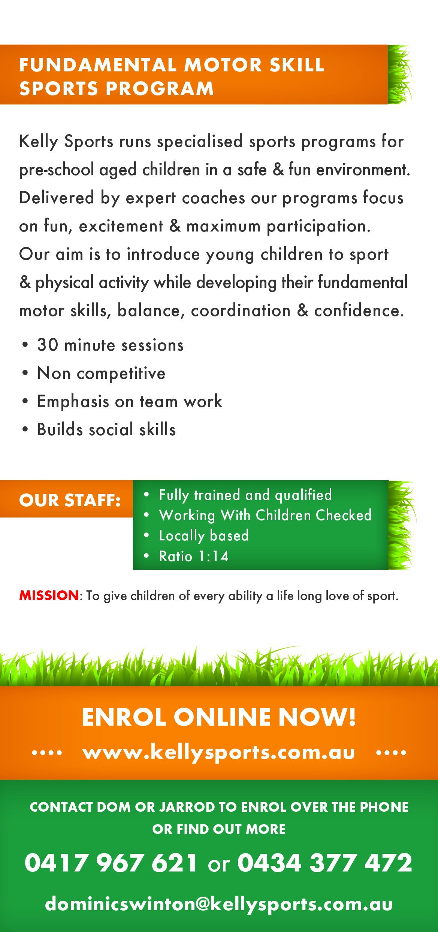
UNDERAM BOWL

- Hold the ball in one hand
- Hang your arm straight to the ground so the ball is next to your leg
- Step your opposite foot forward and bend your legs a little bit
- Swing your arm backwards, ready to bowl
- Swing forwards and let go of the ball so it rolls along the ground

