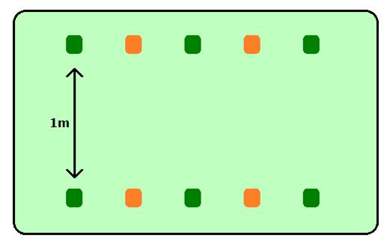


BASKETBALL: THROW AND CATCH

THROW:
- Hold the ball with both hands
- Turn hands so your fingers touch your chest
- Push the ball towards your partners chest
CATCH:
- Hold both arms forwards - nice and straight, palms facing the sky
- Cuddle the ball to your chest

