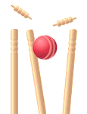



- Put your hands together to make a bowl of soup
- Step your feet a little bit apart, so that they aren’t close to each other
- Bend your legs and crouch down so that you are almost sitting on the ground (like a frog)
- Put your bowl of soup on the ground so that it is ready to scoop up the ball
- Scoop up the ball
and close your hands
around it so that it
can’t get away
FROGGY FIELDING

