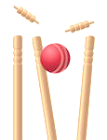


BATTING
- Place your ball onto your tee
- Hold the cricket bat with both hands – put your favourite hand down low and your other hand up high
- Rest the end of the bat on the ground, just to the side of your toes – make sure the flat side is looking at the ball
- Swing the back backwards just a little bit, and then swing through
FIELDING
- Make sure that you are ready when your partner hits their ball – facing and
watching the ball
- Once the ball has been hit,
chase after it as quick as you
can
- Trap the ball to stop it from
getting any further, they scoop
it up and run it back to the tee

CRICKET: BATTING AND FIELDING

