
FOLLOW US
ONLINE

Lara May-Whitcombe
NSW State Manager
T 0497 065 621

E lara@kellysports.com.au



Spunky Monkeys Bangor
FUNDAMENTAL MOTOR SKILLS

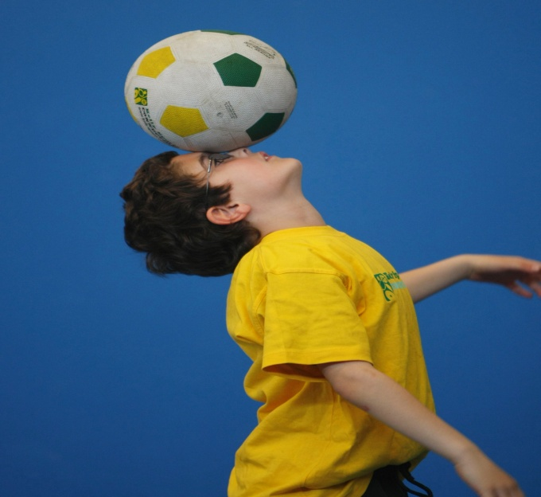
WHEN: Wednesday’s
COMMENCING: 2/5/2018
CONCLUDING: 4/7/2018
TIME: 10.30am-11:30am
YEAR LEVELS: 2+ years
COST: $75
SESSIONS: 10

Kelly Sports is back offering our famous fundamental motor skills program. Our ten week program consists of fun-filled sports activities using bean bags, tennis balls, soccer balls, footies, basketballs, volleyballs and more! Our focus as always with Pre School aged children is fun, excitement, maximum participation and of course fundamental motor skill development - including jumping, bouncing, kicking, striking, catching, throwing, balance and hand-eye coordination.

GET IN QUICK FOR TERM TWO 2018; PLACES ARE FILLING FAST!

$75 FOR OUR 10-WEEK PROGRAM
NEW IMPROVED ONLINE BOOKING SYSTEM!!!
SIMPLY GO TO WWW.KELLYSPORTS.COM.AU ENTER YOUR POST CODE AND ENROL FROM THERE. OR
FILL OUT THE BELOW ENROLMENT FOR & RETURN TO THE OFFICE
PAYMENT OPTIONS AVALIABLE!

It’s here online enrolments !
To enrol, please visit www.kellysports.com.au or
Fill out the enrolment form & return to your centre
Kelly Sports PO BOX 71, Moonee Vale, VIC, 3055.
Payment options available!
Do not leave enrolment forms at the school office

ENROLMENT FORM
Wednesday Fundamental Motor Skills Program
Pre School: : Date of Birth: __
Child’s Name:
Address: Post Code:
Phone: Mobile/Work:
Email: Medical Conditions:
Parents’ consent: I hereby authorise Kelly Sports to act on my behalf should my child require medical attention, and release
Kelly Sports NSW from any liability for injury incurred by my child at Kelly Sports programs. I understand photos and videos may be taken throughout the sessions and used for promotional means; please get in touch if you do not want your child included.
Parent/Caregiver name: Signature:
Amount Paid: $ Credit card payment: Visa Master card
Card Number: Expiry Date: /CVV:

THINGS TO KNOW
Kelly Sports is a Registered Child Care provider
Spaces are limited so please make sure you enrol online or return form to Kelly Sports.

It’s here online enrolments !
To enrol, please visit www.kellysports.com.au or
fill out the enrolment form & send with a cheque or credit card details to:
Kelly Sports PO BOX 71, Moonee Vale, VIC, 3055.
Payment options available!
Do not leave enrolment forms at the school office

It’s here online enrolments !
To enrol, please visit www.kellysports.com.au or
fill out the enrolment form & send with a cheque or credit card details to:
Kelly Sports PO BOX 71, Moonee Vale, VIC, 3055.
Payment options available!
Do not leave enrolment forms at the school office

It’s here online enrolments !
To enrol, please visit www.kellysports.com.au or
fill out the enrolment form & send with a cheque or credit card details to:
Kelly Sports PO BOX 71, Moonee Vale, VIC, 3055.
Payment options available!
Do not leave enrolment forms at the school office

