
ST JOSEPH’S MERNDA
P (03) 9384 2204
M 0403 149 391
E mitch@kellysports.com.au


JAZZ FUNK

Jazz – Funk takes elements of both Hip Hop and Jazz, combined into one dance style that gives students a chance to release energy and dance with power and passion. Our experience staff will work on a brand new routine through out the term to showcase to parents and friends. Sign up fast as students will have a fantastic time learning the new moves in our high intensity, excitement-filled dance environment
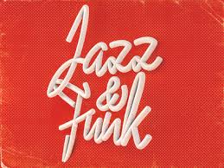


How To Enrol?
Please visit www.kellysports.com.au/events and search for your school.
Our new booking system requires upfront payments to secure your position. For more information, please call the head office.

"The Kelly Sports Programs offer our students opportunities for physical activities; including dance & multi-sports. Conveniently located on our school grounds, they are popular with students and their families. Staff are skilled in working with young people to love active participation.”


Amanda Hay, Principal – Newtown Primary School
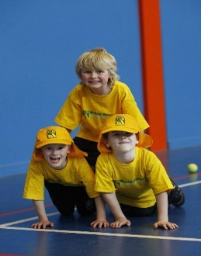
CLASS INFORMATION
Only 20 spots available so sign up fast to secure your position
At the end of the term parents will be invited to an open class to watch the full dance routine.

Come and join us every Tuesday at Lunch time.

When: Tuesdays
Starts: 30th April
Finishes: 25th June
Time: 11:00am – 12:00pm
Year Levels: Prep – 4
Cost: $118.80 (Inc GST)

