
LITTLE LEARNERS
EARLY LEARNING P (03) 9384 2204
M 0403 149 391

E mitch@kellysports.com.au
Fundamental Motor Skills
Kelly Sports is offering our famous fundamental motor skills program again in Term 4.
Our program consists of fun-filled sports activities including Soccer, Basketball and AFL while also using bean bags, tennis balls, hula hoops, and more! Our focus as always with kinder aged children is fun, excitement, maximum participation and of course fundamental motor skill development including jumping, bouncing, striking, catching, throwing, balance and hand-eye coordination.

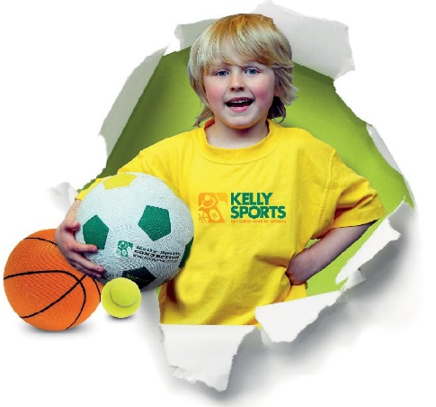

How To Enrol?
Please visit www.kellysports.com.au/events and search for your school.
Our new booking system requires upfront payments to secure your position. For more information, please call the head office.


"The Kelly Sports Programs offer our students opportunities for physical activities; including dance & multi-sports. Conveniently located on our school grounds, they are popular with students and their families. Staff are skilled in working with young people to love active participation.”


Amanda Hay, Principal – Newtown Primary School
CLASS INFORMATION
10 weeks and 2 weekly classes. Classes will run for 30 minutes. Sign up fast to secure your position.

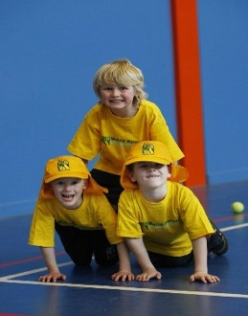

When: Friday
Starts: 19th October
Finishes: 12th December
Time: 2pm to 2.30pm (12 spots)
Year Levels: Pre kinder & Kinder
Cost: $81(Inc GST)

When: Wednesday
Starts: 17th October
Finishes: 12th December
Time: 2pm to 3pm (24 spots, 30 min class)
Year Levels: Pre kinder & Kinder
Cost: $81 (Inc GST)

