
GREENHILLS
PRIMARY SCHOOL P (03) 9384 2204
M 0403 149 391

E mitch@kellysports.com.au

BASKETBALL CLUB – Lunch Time Tuesdays
Come and join us at lunch time for our 2nd term of Basketball Club. This Basketball Program includes all the skill and activities required to help enhance your child's skills, and get them on the way to being the next Basketball Superstar. Hop on board and shoot a goal this term.

AWESOME AUTUMN SPORTS– After School Tuesdays
Kelly Sports is back in Term 2 for a AWESOME AUTUMN OF SPORTS!!
Our Kelly Sports classes are all inclusive, fun & interactive with a key focus on maximum participation. Each week children will be introduced to new sports & activities in a positive environment. It’s a fantastic way to get your child active while having fun as well as building confidence and social skills!

How To Enrol?
Please visit www.kellysports.com.au/events and search for your school.
Our new booking system requires upfront payments to secure your position. For more information, please call the head office.


"The Kelly Sports Programs offer our students opportunities for physical activities; including dance & multi-sports. Conveniently located on our school grounds, they are popular with students and their families. Staff are skilled in working with young people to love active participation.”


Amanda Hay, Principal – Newtown Primary School
CLASS INFORMATION
Only 15 spots available for each program so sign up fast to secure your position
Multi Sports includes Soccer, Basketball, AFL & Hockey, plus we will incorporate our Kelly Sports Modified games children love.
Come and join us every Tuesday at lunch & straight after school.
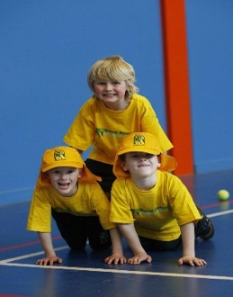
When: Tuesdays
Starts: 30th April
Finishes: 25th June
Sports: 3:40pm – 4:40pm
Bball: 1:00pm – 2:00pm
Year Levels: Prep – 4
Cost: $118.80 (Inc GST)

