

8 Knightsbridge Place, Diamond Creek, 3089

T (03) 9438 2469
M 0403 121 289
E michaelhogg@kellysports.com.au

WATTLE GLEN PRIMARY SCHOOL

DYNAMIC DANCE

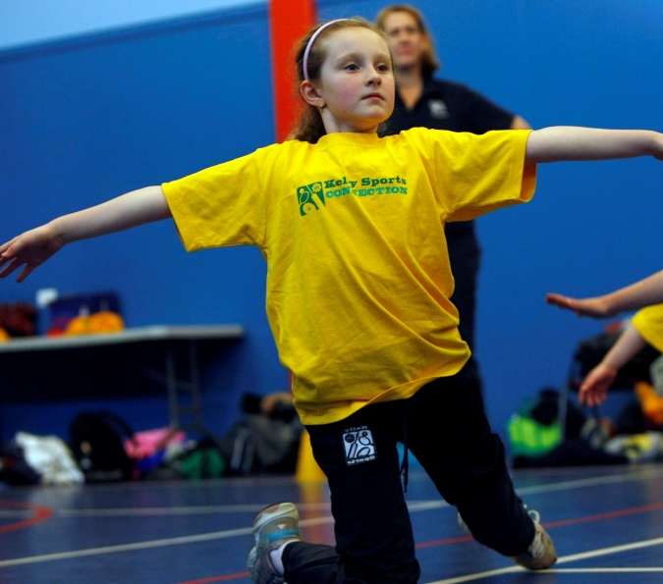
LET THE BEAT ENTER YOU FEET! Our specialized Dance coaches can get your child’s hips swinging, feet rocking and heads bumping to all of modern contemporary music’s classics. Sign up fast as places are limited and let our coaches beat; ignite your child’s feet!

WHEN: Friday
COMMENCING: 05/02/2016
CONCLUDING: 18/03/2016
TIME: 1.30pm – 2.25pm
YEAR LEVELS: P – 6

COST: $70 (enrol online – go to www.kellysports.com.au and search for your school)
It’s here online enrolments !
To enrol, please visit www.kellysports.com.au or
fill out the enrolment form & send with a cheque or credit card details to:
Kelly Sports PO BOX 71, Moonee Vale, VIC, 3055.
Payment options available!
Do not leave enrolment forms at the school office

VENUE: Wattle Glen Primary School

To enrol, please visit www.kellysports.com.au
or fill the below enrolment form & send credit card details to:
8 Knightsbridge Place, Diamond Creek, 3089. Payment options available!
Do not leave enrolment forms at the school office.

It’s here online enrolments !
To enrol, please visit www.kellysports.com.au or
fill out the enrolment form & send with a cheque or credit card details to:
Kelly Sports PO BOX 71, Moonee Vale, VIC, 3055.
Payment options available!
Do not leave enrolment forms at the school office

ONLINE ENROLMENT
www.kellysports.com.au/zone/plentyvalley

ENROLMENT FORM
School: Year Level:
Name: Room No:
Address: Post Code:
Phone: Mobile/Work:
Email: Medical Conditions:

At the completion of after school clinics, does your child? Go to after care Get collected

Parents’ consent I hereby authorise Kelly Sports to act on my behalf should my child require medical attention, and release Kelly Sports Plenty Valley from any liability for injury incurred by my child at Kelly Sports programmes.

Parent/Caregiver name: Signature:
Amount Paid: $ Credit card payment: Visa Mastercard
Card Number: Expiry Date: /
CVV Number:
It’s here online enrolments !
To enrol, please visit www.kellysports.com.au or
fill out the enrolment form & send with a cheque or credit card details to:
Kelly Sports PO BOX 71, Moonee Vale, VIC, 3055.
Payment options available!
Do not leave enrolment forms at the school office

It’s here online enrolments !
To enrol, please visit www.kellysports.com.au or
fill out the enrolment form & send with a cheque or credit card details to:
Kelly Sports PO BOX 71, Moonee Vale, VIC, 3055.
Payment options available!
Do not leave enrolment forms at the school office

It’s here online enrolments !
To enrol, please visit www.kellysports.com.au or
fill out the enrolment form & send with a cheque or credit card details to:
Kelly Sports PO BOX 71, Moonee Vale, VIC, 3055.
Payment options available!
Do not leave enrolment forms at the school office

