

8 Knightsbridge Place, Diamond Creek, 3089
Early Bird Rate
$10 discount
when you enrol
before 15/07/14.

T (03) 9438 2469
M 0403 121 289

E michaelhogg@kellysports.com.au


GREENHILLS PRIMARY SCHOOL
WICKED WINTER SPORTS
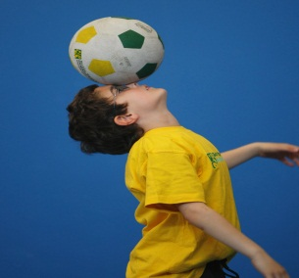
WHEN: Tuesday
COMMENCING: 15/07/2014
CONCLUDING: 09/09/2014
TIME: 3.40pm – 4.40pm
YEAR LEVELS: P – 4
DON’T MISS OUT ON THIS HOT CATCH! WICKED WINTER SPORTS allows your child to play a range of dynamic and active programs run over 9 weeks; these include: Lots of different community based Sports, Running games and ball based fun games! This Program will not only provide an essential base for your child's motor skills and help build awareness, co-ordination and friendship all in an enjoyable environment


DYNAMIC DANCE

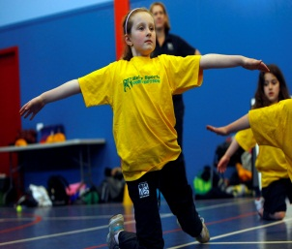
WHEN: Tuesday
COMMENCING: 15/07/2014
CONCLUDING: 09/09/2014
TIME: 1.00pm – 1.50pm
YEAR LEVELS: P – 6
LET THE BEAT ENTER YOU FEET! Our specialized Dance coaches can get your child’s hips swinging, feet rocking and heads bumping to all of modern contemporary music’s classics. Sign up fast as places are limited and let our coaches beat; ignite your child’s feet!

COST $90 (enrol before 15/07/14 for $80.00 at www.kellysports.com.au and search for your school)
It’s here online enrolments !
To enrol, please visit www.kellysports.com.au or
fill out the enrolment form & send with a cheque or credit card details to:
Kelly Sports PO BOX 71, Moonee Vale, VIC, 3055.
Payment options available!
Do not leave enrolment forms at the school office

VENUE Greenhills Primary School

It’s here online enrolments !
To enrol, please visit www.kellysports.com.au or
fill out the enrolment form & send with a cheque or credit card details to:
Kelly Sports PO BOX 71, Moonee Vale, VIC, 3055.
Payment options available!
Do not leave enrolment forms at the school office

To enrol, please visit www.kellysports.com.au or fill out the below enrolment form & send with a cheque or
credit card details to: 8 Knightsbridge Place, Diamond Creek,3089.
Do not leave enrolment forms at the school office.

ENROLMENT FORM
Wicked Winter Sports (After School) Dynamic Dance (Lunch time)
School: Year Level:
Name: Room No:
Address: Post Code:
Phone: Mobile/Work:
Email: Medical Conditions:

At the completion of after school clinics, does your child? Go to after care Get collected
Parents’ consent: I hereby authorise Kelly Sports to act on my behalf should my child require medical attention, and release
Kelly Sports Plenty Valley from any liability for injury incurred by my child at Kelly Sports programmes.
Parent/Caregiver name: Signature:

Amount Paid: $ Credit card payment: Visa Mastercard

Card Number: Expiry Date: /
CVV Number:
ONLINE ENROLMENT
www.kellysports.com.au

It’s here online enrolments !
To enrol, please visit www.kellysports.com.au or
fill out the enrolment form & send with a cheque or credit card details to:
Kelly Sports PO BOX 71, Moonee Vale, VIC, 3055.
Payment options available!
Do not leave enrolment forms at the school office

It’s here online enrolments !
To enrol, please visit www.kellysports.com.au or
fill out the enrolment form & send with a cheque or credit card details to:
Kelly Sports PO BOX 71, Moonee Vale, VIC, 3055.
Payment options available!
Do not leave enrolment forms at the school office

It’s here online enrolments !
To enrol, please visit www.kellysports.com.au or
fill out the enrolment form & send with a cheque or credit card details to:
Kelly Sports PO BOX 71, Moonee Vale, VIC, 3055.
Payment options available!
Do not leave enrolment forms at the school office

