
GREENHILLS
PRIMARY SCHOOL P (03) 9384 2204
M 0403 149 391

E mitch@kellysports.com.au

HIP HOP – Lunch Time Tuesdays
Kelly Sports welcomes HIP HOP back in Term 1! In this program Students will have the opportunity to move, groove, spin and bop to the sound of hip hop beats alongside our very experienced dance instructor. You will have a fantastic time learning the new moves in our high intensity, excitement-filled dance environment. At the end of the term the kids will have learnt a new performance to showcase to their parents.
SIZZLING SUMMER SPORTS– After School Tuesdays
Kelly Sports is back in Term 1 for a SIZZLING SUMMER OF SPORTS!!
Our Kelly Sports classes are all inclusive, fun & interactive with a key focus on maximum participation. Each week children will be introduced to new sports & activities in a positive environment. It’s a fantastic way to get your child active while having fun as well as building confidence and social skills!

How To Enrol?
Please visit www.kellysports.com.au/events and search for your school.
Our new booking system requires upfront payments to secure your position. For more information, please call the head office.


"The Kelly Sports Programs offer our students opportunities for physical activities; including dance & multi-sports. Conveniently located on our school grounds, they are popular with students and their families. Staff are skilled in working with young people to love active participation.”


Amanda Hay, Principal – Newtown Primary School
CLASS INFORMATION
Only 15 spots available for each program so sign up fast to secure your position
Multi Sports includes Soccer, Basketball, Cricket & Tennis, plus we will incorporate our Kelly Sports Modified games children love.
Come and join us every Tuesday at lunch & straight after school.
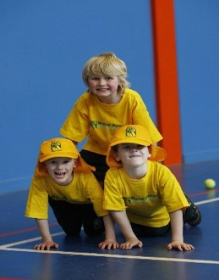
When: Tuesdays
Starts: 5th February
Finishes: 2nd April
Sports: 3:40pm – 4:40pm
Dance: 1:00pm – 2:00pm
Year Levels: Prep – 4
Cost: $118.80 (Inc GST)

