
ST JOSEPHS CATHOLIC
PRIMARY SCHOOL P (03) 9384 2204
M 0403 149 391

E mitch@kellysports.com.au
STREET DANCE
Breaking, Popping and Locking! Our Dance coaches can get your child’s hips swinging, feet rocking and heads bumping to the original street dancing. Street dance is a FUSION of styles that your child can enjoy dancing out to. Sign up fast as places are limited for our program and let our coaches beat, ignite your child’s feet!

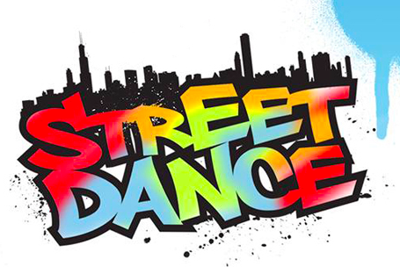


ONLINE ENROLMENT www.kellysports.com.au

To enrol, please visit www.kellysports.com.au, and search for your
school. Our booking system requires credit card upfront payments to
secure your position. For more information, please call the head office.




CLASS INFORMATION
Only 14 spots available for each program so sign up fast to secure your position
At the end of the term, Parents will be invited to our last class for a performance of the routine the kids have been working on.
Sign up anytime and only pay for the remaining weeks in the term - $13.20 per week
When: Tuesday’s
Starts: 23rd July
Finishes: 17th September
Time: 11am – 12pm
Year Levels: Prep – 4
Cost: $118.80 Inc GST

"The Kelly Sports Programs offer our students opportunities for physical activities; including dance & multi-sports. Conveniently located on our school grounds, they are popular with students and their families. Staff are skilled in working with young people to love active participation.”

Amanda Hay, Principal – Newtown Primary School
