
P.O. Box 3180, Joondalup, W.A. 6027
T 0438 833 746
E davewhite@kellysports.com.au


GOODSTART EARLY LEARNING MERRIWA
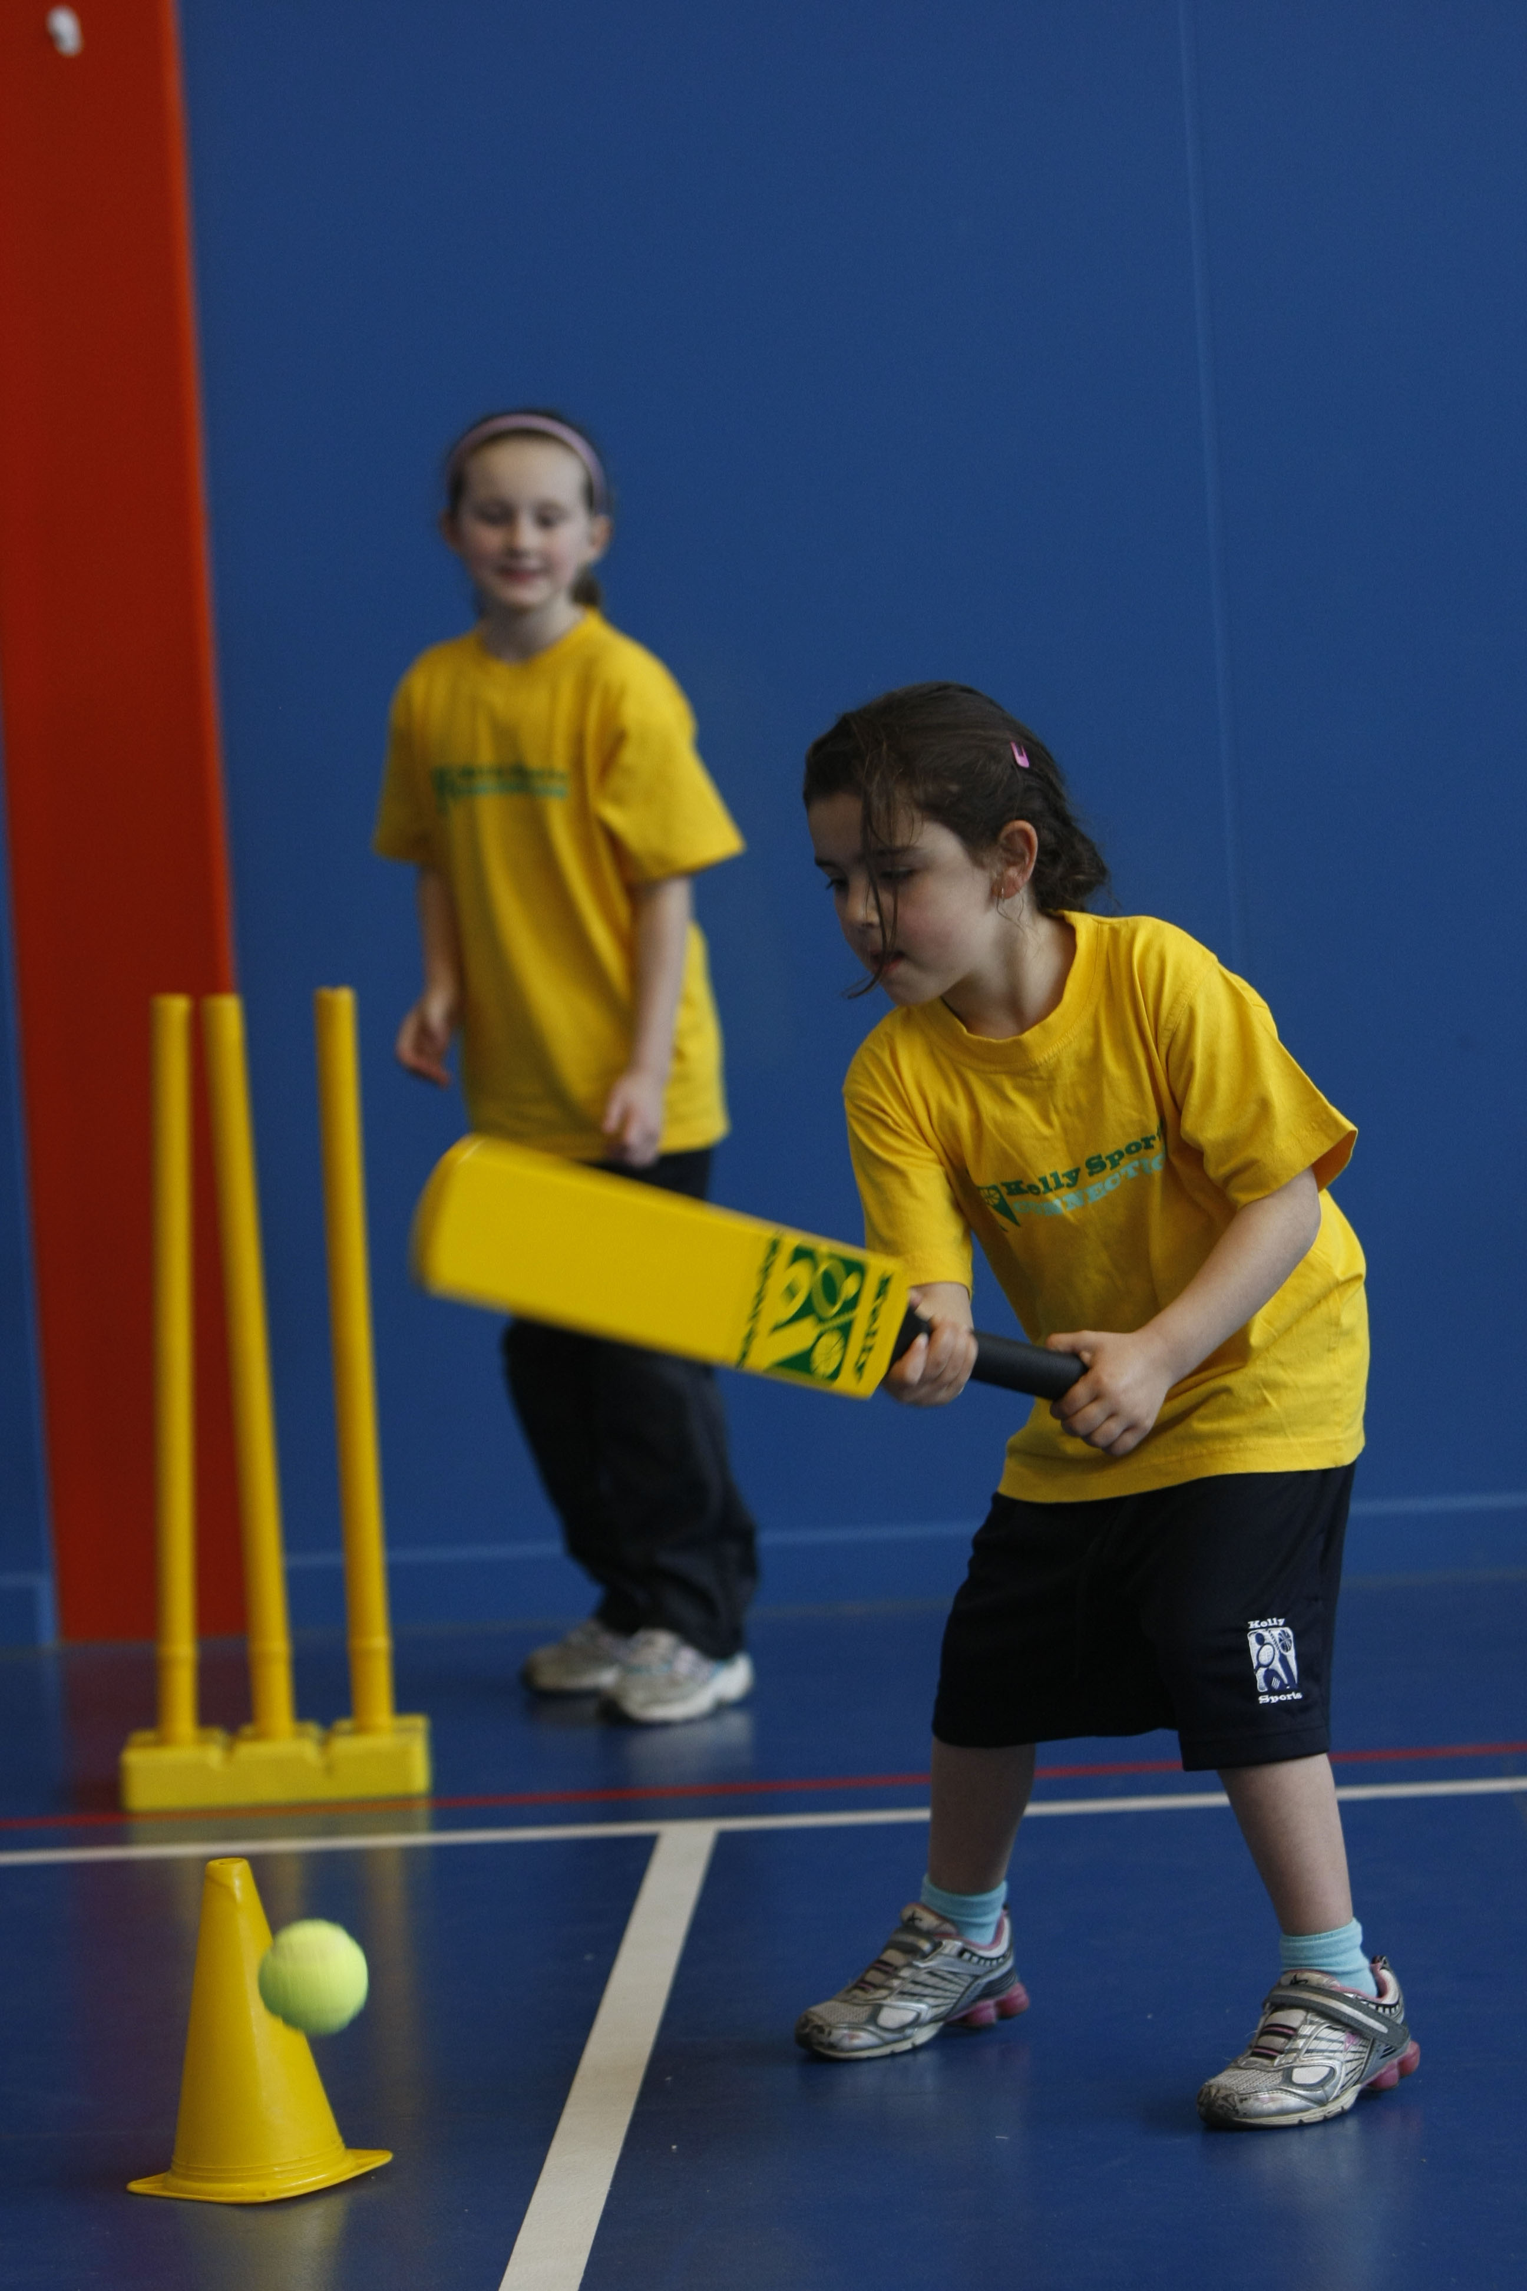
FUNDAMENTAL
SKILLS PROGRAM

Kelly Sports runs half hour programmes to teach children the fundamentals of sport. This 7 WEEK program is all inclusive with high participation. Our key aims are to develop and enhance the following skills – running, jumping, catching, throwing, passing, kicking and striking:
The Fundamental Skills Program includes:
- Motor Skill Development
- Balance and Hand- Eye Cordination
- Introduction to a variety of sports -Soccer, Basketball, Football.

WHEN: Tuesday

COMMENCING: 06/10/2015

CONCLUDING: 17/11/2015

TIME: 10:00am – 10:30am

COST: $45 (enrol online go to www.kellysports.com.au and search for your school/centre)
It’s here online enrolments !
To enrol, please visit www.kellysports.com.au or
fill out the enrolment form & send with a cheque or credit card details to:
Kelly Sports PO BOX 71, Moonee Vale, VIC, 3055.
Payment options available!
Do not leave enrolment forms at the school office


VENUE: Goodstart Early Learning Merriwa
It’s here online enrolments !
To enrol, please visit www.kellysports.com.au or
fill out the enrolment form & send with a cheque or credit card details to:
Kelly Sports PO BOX 71, Moonee Vale, VIC, 3055.
Payment options available!
Do not leave enrolment forms at the school office

To enrol, please visit www.kellysports.com.au and search for your school/centre or fill out the enrolment form below & send with a cheque or credit card details to: PO BOX 3180 Joondalup W.A. 6027. Payment options available! Do not leave enrolment forms at the school office.

ONLINE ENROLMENT
www.kellysports.com.au

ENROLMENT FOR
School: Year Level:
Name: Room No:
Address: Post Code:
Phone: Mobile/Work:
Email: Medical Conditions:

Cardholder Name: Signature:

Amount Paid: $ Credit card payment: Visa Mastercard CVV No.

Card Number: Expiry Date: /
It’s here online enrolments !
To enrol, please visit www.kellysports.com.au or
fill out the enrolment form & send with a cheque or credit card details to:
Kelly Sports PO BOX 71, Moonee Vale, VIC, 3055.
Payment options available!
Do not leave enrolment forms at the school office

It’s here online enrolments !
To enrol, please visit www.kellysports.com.au or
fill out the enrolment form & send with a cheque or credit card details to:
Kelly Sports PO BOX 71, Moonee Vale, VIC, 3055.
Payment options available!
Do not leave enrolment forms at the school office

It’s here online enrolments !
To enrol, please visit www.kellysports.com.au or
fill out the enrolment form & send with a cheque or credit card details to:
Kelly Sports PO BOX 71, Moonee Vale, VIC, 3055.
Payment options available!
Do not leave enrolment forms at the school office

