
P.O. Box 3180, Joondalup, W.A. 6027
T 0438 833 746
E davewhite@kellysports.com.au


GOODSTART EARLY LEARNING JOONDALUP
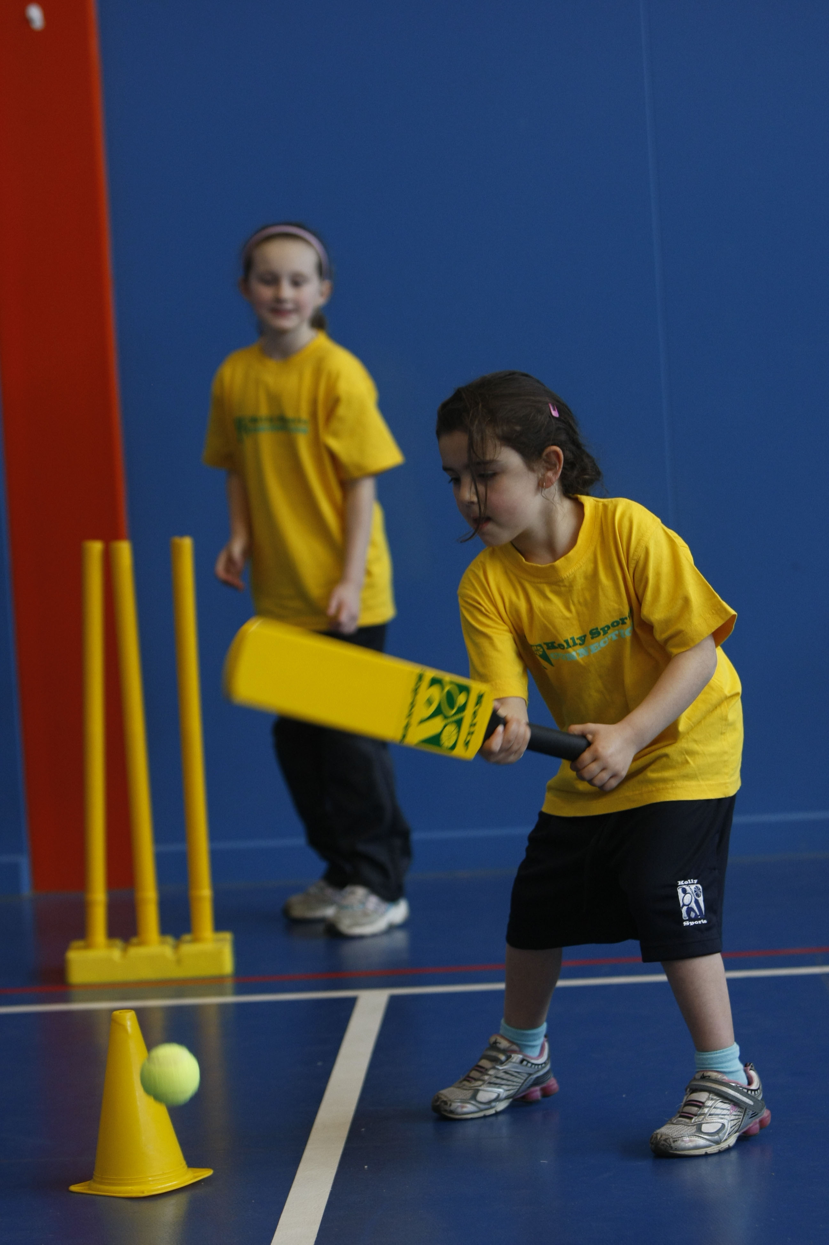
FUNDAMENTAL
SKILLS PROGRAM

Kelly Sports runs half hour programmes to teach children the fundamentals of sport. This 7 WEEK program is all inclusive with high participation. Our key aims are to develop and enhance the following skills – running, jumping, catching, throwing, passing, kicking and striking:
The Fundamental Skills Program includes:
- Motor Skill Development
- Balance and Hand- Eye Cordination
- Introduction to a variety of sports -Soccer, Basketball, Football.

WHEN: Wednesday

COMMENCING: 18/02/2015

CONCLUDING: 01/04/2015

TIME: 1:30pm – 2:00pm

COST: $45 (enrol online go to www.kellysports.com.au and search for your school/centre)
It’s here online enrolments !
To enrol, please visit www.kellysports.com.au or
fill out the enrolment form & send with a cheque or credit card details to:
Kelly Sports PO BOX 71, Moonee Vale, VIC, 3055.
Payment options available!
Do not leave enrolment forms at the school office


VENUE: Goodstart Early Learning Joondalup
It’s here online enrolments !
To enrol, please visit www.kellysports.com.au or
fill out the enrolment form & send with a cheque or credit card details to:
Kelly Sports PO BOX 71, Moonee Vale, VIC, 3055.
Payment options available!
Do not leave enrolment forms at the school office

ENROLMENT FORM
School: __________________________________________________________________________ Year Level:
Name: Room No:
Address: Post Code:
Phone: Mobile/Work:
Email: Medical Conditions:

Cardholder Name: Signature:

Amount Paid: $ Credit card payment: Visa Mastercard CCV No.

Card Number: Expiry Date: /
To enrol, please visit www.kellysports.com.au and search for your school/centre or fill out the enrolment form below & send with a cheque or credit card details to: PO BOX 3180 Joondalup W.A. 6027. Payment options available! Do not leave enrolment forms at the school office.

ONLINE ENROLMENT
www.kellysports.com.au

It’s here online enrolments !
To enrol, please visit www.kellysports.com.au or
fill out the enrolment form & send with a cheque or credit card details to:
Kelly Sports PO BOX 71, Moonee Vale, VIC, 3055.
Payment options available!
Do not leave enrolment forms at the school office

It’s here online enrolments !
To enrol, please visit www.kellysports.com.au or
fill out the enrolment form & send with a cheque or credit card details to:
Kelly Sports PO BOX 71, Moonee Vale, VIC, 3055.
Payment options available!
Do not leave enrolment forms at the school office

It’s here online enrolments !
To enrol, please visit www.kellysports.com.au or
fill out the enrolment form & send with a cheque or credit card details to:
Kelly Sports PO BOX 71, Moonee Vale, VIC, 3055.
Payment options available!
Do not leave enrolment forms at the school office

