
ST JOHNS
PRIMARY SCHOOL P (03) 9384 2204
E stephan@kellysports.com.au

START OF YEAR HIP-HOP – Lunch Time Monday’s
IT’S THE START OF THE YEAR AND IT’S TIME TO DANCE!
Join us in Term 1 for our HIP-HOP program for boys and girls. This program will combine both Hip Hop and Cheerleading to create a new and fresh routine. You will have a fantastic time learning the new moves in our high intensity, excitement-filled dance environment. Book early for this incredibly fun program!
SUMMER MULTI SPORTS – After School Thursday’s
Come and experience all the fun in our 9 week Kelly Sports
Summer Multi Sport program.
Our Kelly Sports classes are all inclusive, fun & interactive with a key focus on maximum participation. Each week children will be introduced to new sports & activities in a positive environment. It’s a fantastic way to get your child active while having fun as well as building confidence and social skills!




"The Kelly Sports Programs offer our students opportunities for physical activities; including dance & multi-sports. Conveniently located on our school grounds, they are popular with students and their families. Staff are skilled in working with young people to love active participation.”
How To Enrol?
Please visit www.kellysports.com.au/events and search for your school.
Our new booking system requires upfront payments to secure your position. For more information, please call the head office.

Amanda Hay, Principal – Newtown Primary School

CLASS INFORMATION
Only 14 spots available for each program so sign up fast to secure your position
Summer Multi Sports include Soccer, Hockey, Basketball, Crazy games, plus we will incorporate our Kelly Sports Modified games children love.

Come & join us at lunch every Monday at lunch and afterschool every Thursday
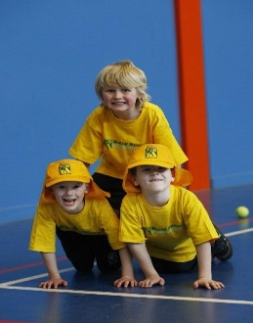
START OF YEAR HIP HOP - MONDAYS
Dates: 4th February to 1st April
Time: 11am – 12pm
Year Levels: Prep – 4
Cost: $105.60 (Inc GST) (11th March – Labour Day no session)
SUMMER MULIT SPORTS – THURSDAYS
Dates: 7th February to 4th April
Time: 3:20pm – 4:20pm
Year Levels: Prep – 4
Cost: $118.80 (Inc GST)

