

P.O. Box 71, Moonee Vale 3055
Only $12 per week!
T (03) 9384 2204

E stephan@kellysports.com.au


HEIDELBERG PRIMARY SCHOOL
WHEN: Monday
COMMENCING: 29/04/19
CONCLUDING: 24/06/19
TIME: 1pm – 1.50pm
YEAR LEVELS: P – 4
COST (GST inc): $105.60
No session June 10th Queens Bday

JAZZ FUNK


Jazz – Funk takes elements of both Hip Hop and Jazz, combined into one dance style that gives students a chance to release energy and dance with power and passion. Our experience staff will work on a brand new routine through out the term to showcase to parents and friends. Sign up fast as students will have a fantastic time learning the new moves in our high intensity, excitement-filled dance environment.


SUPER SOCCER

Learn how to play like your heroes and have lots of fun learning all the skills in the game of SOCCER. The Kelly Sports team will teach you all the basic skills in a safe and challenging environment. If you already play soccer this is your chance to take your game to the next level!

WHEN: Monday
COMMENCING: 29/04/19
CONCLUDING: 24/06/19
TIME: 3.40pm - 4.40pm
YEAR LEVELS: P – 4
COST (GST inc): $105.60
No session June 10th Queens Bday

AWESOME AUTUMN SPORTS
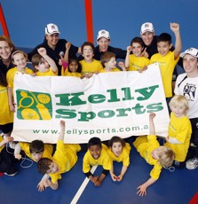
WHEN: Wednesday
COMMENCING: 01/05/19
CONCLUDING: 26/06/19
TIME: 3.40pm – 4.40pm
YEAR LEVELS: P – 4
COST (INC GST): $118.80

Our Kelly Sports classes are all inclusive, fun and interactive with a key focus on maximum participation. Each week children will be introduced to new sports and activities in a positive environment. It’s a fantastic way to get your child active while having fun as well as building confidence and social skills!

It’s here online enrolments !
To enrol, please visit www.kellysports.com.au or
fill out the enrolment form & send with a cheque or credit card details to:
Kelly Sports PO BOX 71, Moonee Vale, VIC, 3055.
Payment options available!
Do not leave enrolment forms at the school office

It’s here online enrolments !
To enrol, please visit www.kellysports.com.au or
fill out the enrolment form & send with a cheque or credit card details to:
Kelly Sports PO BOX 71, Moonee Vale, VIC, 3055.
Payment options available!
Do not leave enrolment forms at the school office

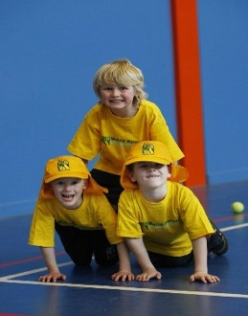
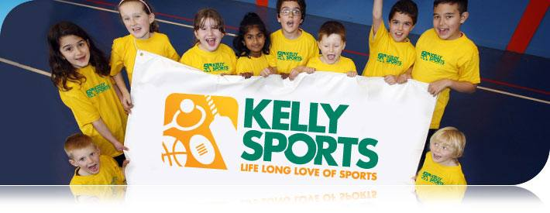
CLASS INFORMATION
Only 14 spots available for each session so sign up fast to secure your position
Activities include Soccer, AFL, Basketball & Hockey, plus we will incorporate our Kelly Sports Modified games children love

Come and join us in Term 2.

It’s here online enrolments !
To enrol, please visit www.kellysports.com.au or
fill out the enrolment form & send with a cheque or credit card details to:
Kelly Sports PO BOX 71, Moonee Vale, VIC, 3055.
Payment options available!
Do not leave enrolment forms at the school office

It’s here online enrolments !
To enrol, please visit www.kellysports.com.au or
fill out the enrolment form & send with a cheque or credit card details to:
Kelly Sports PO BOX 71, Moonee Vale, VIC, 3055.
Payment options available!
Do not leave enrolment forms at the school office

It’s here online enrolments !
To enrol, please visit www.kellysports.com.au or
fill out the enrolment form & send with a cheque or credit card details to:
Kelly Sports PO BOX 71, Moonee Vale, VIC, 3055.
Payment options available!
Do not leave enrolment forms at the school office

