
ST JOHNS
PRIMARY SCHOOL P (03) 9384 2204
E stephan@kellysports.com.au

JAZZ FUNK – Lunch Time Monday’s
Jazz – Funk takes elements of both Hip Hop and Jazz, combined into one dance style that gives students a chance to release energy and dance with power and passion. Our experience staff will work on a brand new routine through out the term to showcase to parents and friends. Sign up fast as students will have a fantastic time learning the new moves in our high intensity, excitement-filled dance environment.

AWESOME AUTUMN SPORTS – After School Thursday’s
Kelly Sports is back in Term 2 for a AWESOME AUTUMN SPORTS!!
Our Kelly Sports classes are all inclusive, fun & interactive with a key focus on maximum participation. Each week children will be introduced to new sports & activities in a positive environment. It’s a fantastic way to get your child active while having fun as well as building confidence and social skills!




"The Kelly Sports Programs offer our students opportunities for physical activities; including dance & multi-sports. Conveniently located on our school grounds, they are popular with students and their families. Staff are skilled in working with young people to love active participation.”
How To Enrol?
Please visit www.kellysports.com.au/events and search for your school.
Our new booking system requires upfront payments to secure your position. For more information, please call the head office.

Amanda Hay, Principal – Newtown Primary School

CLASS INFORMATION
Only 14 spots available for each program so sign up fast to secure your position
Summer Multi Sports include Soccer, Hockey, Basketball & AFL plus we will incorporate our Kelly Sports Modified games children love.

Come & join us at lunch every Monday at lunch and afterschool every Thursday
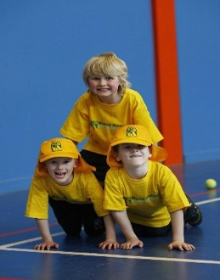
JAZZ FUNK- MONDAYS
Dates: 29th April to 24th June
Time: 11am – 12pm
Year Levels: Prep – 4
Cost: $105.60 (Inc GST) (10th June due to Queen’s Birthday No Session)
AWESOME AUTUMN SPORTS – THURSDAYS
Dates: 2nd May to 27th June
Time: 3:20pm – 4:20pm
Year Levels: Prep – 4
Cost: $118.80 (Inc GST)



