

P.O. Box 71, Moonee Vale 3055
FOLLOW US ONLINE!

T (03) 9384 2204
F (03) 9384 2205

E mitch@kellysports.com.au






ST JOHNS P.S
AWESOME AUTUMN SPORTS
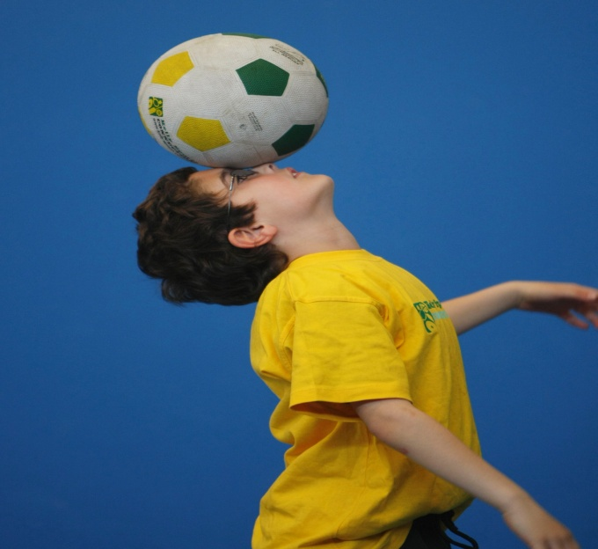
WHEN: Thursday
COMMENCING: 19/4/18
CONCLUDING: 28/6/18
TIME: 3.40pm – 4.40pm
YEAR LEVELS: P – 4
COST: $132
AFL -SOCCER-BASKETBALL-HOCKEY – TEAM GAMES
Start the new school term by enrolling in this fantastic Kelly sports program. Join up with your friends and develop your skills in a fun, safe an exciting sporting environment. Our experienced coaches aim to develop and enhance the wide range of sporting skills of your child including kicking catching & throwing while also improving strength, flexibility, hand-eye co-ordination, Spatial awareness, co-operative and teamwork



WHEN: Monday
COMMENCING: 23/4/18
CONCLUDING: 25/6/18
TIME: 11.00am – 12pm
YEAR LEVELS: P – 4
COST: $120
No session 11th June (Queens Bday)

JAZZ FUNK

Jazz – Funk gives students a chance to release energy and dance with power and passion. Our experience staff will work on a brand new routine through out the term to showcase to parents and friends. Sign up fast as students will have a fantastic time learning the new moves in our high intensity, excitement-filled dance environment.


NEW IMPROVED ONLINE BOOKING SYSTEM!!!
SIMPLY GO TO WWW.KELLYSPORTS.COM.AU ENTER YOUR POST CODE AND ENROL FROM THERE. OR
FILL OUT THE BELOW ENROLMENT FORM & SEND WITH A CHEQUE OR CREDIT CARDS DETAILS TO:
PO BOX 71, MOONEE VALE, 3055
PAYMENT OPTIONS AVALIABLE!

It’s here online enrolments !
To enrol, please visit www.kellysports.com.au or
fill out the enrolment form & send with a cheque or credit card details to:
Kelly Sports PO BOX 71, Moonee Vale, VIC, 3055.
Payment options available!
Do not leave enrolment forms at the school office

It’s here online enrolments !
To enrol, please visit www.kellysports.com.au or
fill out the enrolment form & send with a cheque or credit card details to:
Kelly Sports PO BOX 71, Moonee Vale, VIC, 3055.
Payment options available!
Do not leave enrolment forms at the school office

ENROLMENT FORM
Awesome Autumn Sports Jazz Funk
School: Year Level:
Name: Room No:
Address: Post Code:
Phone: Mobile/Work:
Email: Medical Conditions:

At the completion of after school clinics, does your child? Go to after care Get collected
Parents’ consent: I hereby authorise Kelly Sports to act on my behalf should my child require medical attention, and release
Kelly Sports Nth West from any liability for injury incurred by my child at Kelly Sports programs.
Parent/Caregiver name: Signature:
Amount Paid: $ Credit card payment: Visa Master card
Card Number: Expiry Date: /CVV:
THINGS TO KNOW
Kelly Sports is a Registered Child Care provider
Don’t leave forms at the School Office
Spaces are limited so please make sure you enrol online or return form to Kelly Sports.

It’s here online enrolments !
To enrol, please visit www.kellysports.com.au or
fill out the enrolment form & send with a cheque or credit card details to:
Kelly Sports PO BOX 71, Moonee Vale, VIC, 3055.
Payment options available!
Do not leave enrolment forms at the school office

It’s here online enrolments !
To enrol, please visit www.kellysports.com.au or
fill out the enrolment form & send with a cheque or credit card details to:
Kelly Sports PO BOX 71, Moonee Vale, VIC, 3055.
Payment options available!
Do not leave enrolment forms at the school office

It’s here online enrolments !
To enrol, please visit www.kellysports.com.au or
fill out the enrolment form & send with a cheque or credit card details to:
Kelly Sports PO BOX 71, Moonee Vale, VIC, 3055.
Payment options available!
Do not leave enrolment forms at the school office

