

P.O. Box 492,Essendon Nth 3041
M 0410 588 800
Hurry
Places
Limited

E jordan@kellysports.com.au

ST BERNADETTES P.S
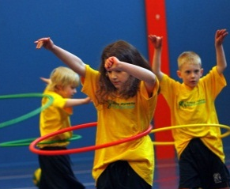
DANCE DANCE DANCE

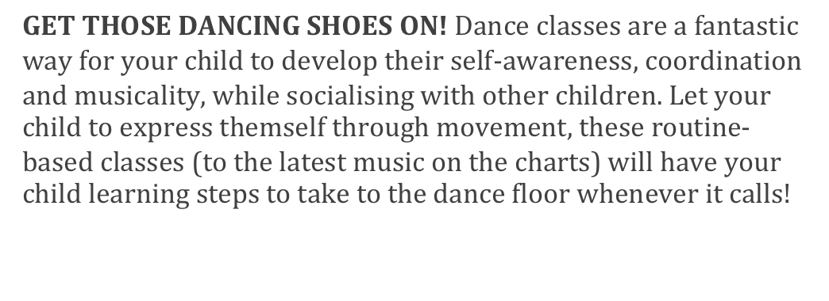

WHEN: Tuesday
COMMENCING: 29/07/14
CONCLUDING: 16/09/14
TIME: Lunchtime
YEAR LEVELS: P - 6

WILD WINTER SPORTS

SIGN UP FOR WILD WINTER OF SPORTS THIS TERM! Our sports program will ensure your child will develop new skills, build coordination and awareness and increase their confidence. This 8 week program will allow your child to play a range of different sports; these include: Crazy Games, Soccer, Football, and Hockey. Your child will learn how to play fairly and have fun all in an enjoyable environment.

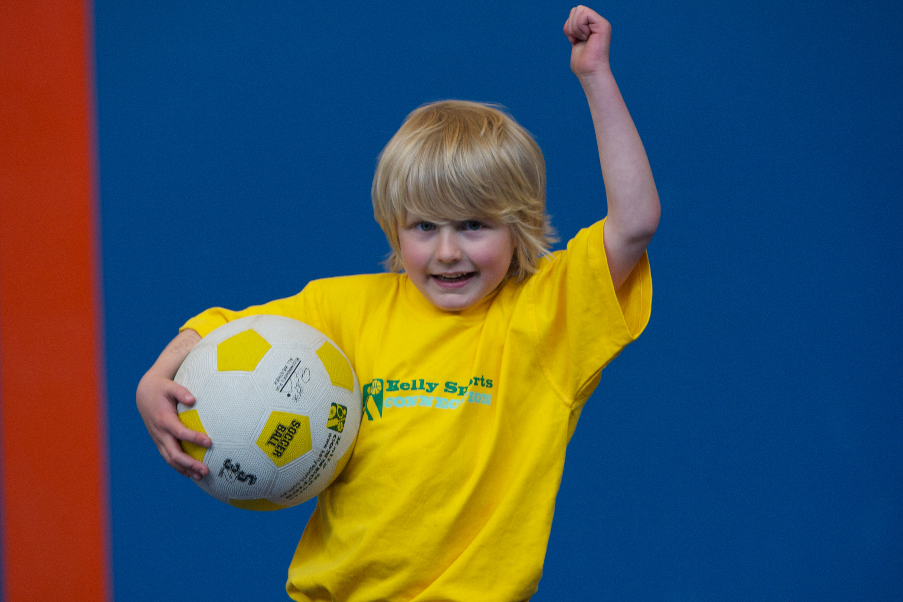
WHEN: Tuesday
COMMENCING: 29/07/14
CONCLUDING: 16/09/14
TIME: 3:40 – 5:00
YEAR LEVELS: P – 6

COST: $80 (enrol at www.kellysports.com.au/zone/Ivanhoe& search your school)
VENUE: ST BERNADETTE’S PRIMARY SCHOOL – Cunningham Centre if cold/wet weather


To enrol, please visit www.kellysports.com.au/zone/Ivanhoe
or fill out the below enrolment form & send with a cheque or credit
card details to: PO BOX 492, Essendon Nth VIC 3041. Do not leave enrolment forms at the school office.

ONLINE ENROLMENT
www.kellysports.com.au/zone/ivanhoe

ENROLMENT FORM
AWESOME AUTUMN SPORTS (After School) DANCE DANCE DANCE (Lunch)
School: Year Level:
Name: Room No:
Address: Post Code:
Phone: Mobile/Work:
Email: Medical Conditions:

At the completion of after school clinics, does your child? Go to after care Get collected
Parents’ consent: I hereby authorise Kelly Sports to act on my behalf should my child require medical attention, and release
Kelly Sports Ivanhoe from any liability for injury incurred by my child at Kelly Sports programmes.
Parent/Caregiver name: Signature:
Amount Paid: $ Credit card payment: Visa Master card CCV
Card Number: Expiry Date: /
It’s here online enrolments !
To enrol, please visit www.kellysports.com.au or
fill out the enrolment form & send with a cheque or credit card details to:
Kelly Sports PO BOX 71, Moonee Vale, VIC, 3055.
Payment options available!
Do not leave enrolment forms at the school office

It’s here online enrolments !
To enrol, please visit www.kellysports.com.au or
fill out the enrolment form & send with a cheque or credit card details to:
Kelly Sports PO BOX 71, Moonee Vale, VIC, 3055.
Payment options available!
Do not leave enrolment forms at the school office

It’s here online enrolments !
To enrol, please visit www.kellysports.com.au or
fill out the enrolment form & send with a cheque or credit card details to:
Kelly Sports PO BOX 71, Moonee Vale, VIC, 3055.
Payment options available!
Do not leave enrolment forms at the school office

It’s here online enrolments !
To enrol, please visit www.kellysports.com.au or
fill out the enrolment form & send with a cheque or credit card details to:
Kelly Sports PO BOX 71, Moonee Vale, VIC, 3055.
Payment options available!
Do not leave enrolment forms at the school office

