

P.O. Box 71, Moonee Vale 3055
FOLLOW US ONLINE!

T (03) 9384 2204
F (03) 9384 2205

E mitch@kellysports.com.au






MARY IMMACUALTE P.S
SPRING MULTI SPORTS
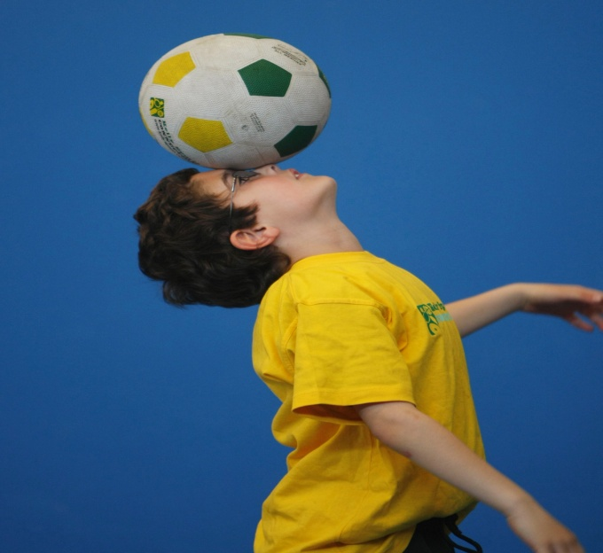
BASKETBALLL – CRICKET – SOCCER – HOCKEY – CRAZY GAMES
This program is a fantastic way to challenge and improve your child’s motor and coordination skills. Our experienced coaches aim to develop and enhance the wide range of sporting skills of your child, including catching, kicking, throwing and Striking, all within a FUN and very SAFE environment.

WHEN: Tuesday
COMMENCING: 17/10/17
CONCLUDING: 19/12/17
TIME: 1.10pm – 2pm
YEAR LEVELS: P – 4
COST: $108
No session 7th Nov (Melb Cup)


CRAZY GAMES


WHEN: Thursday
COMMENCING: 19/10/17
CONCLUDING: 14/12/17
TIME: 1.20pm – 2.10pm
YEAR LEVELS: P – 4
COST: $108

Crazy games is a fun games based program with lots of active games. These games give your child the opportunity to learn a range of fundamental skills used through out a all sports such as kicking, catching, throwing, striking, jumping, running, spatial awareness and decision making. All in a fun and exciting environment.

GET IN QUICK FOR TERM 4 AS PLACES FILLING FAST
It’s here online enrolments !
To enrol, please visit www.kellysports.com.au or
fill out the enrolment form & send with a cheque or credit card details to:
Kelly Sports PO BOX 71, Moonee Vale, VIC, 3055.
Payment options available!
Do not leave enrolment forms at the school office


$108 FOR 9 WEEK PORGRAM
NEW IMPROVED ONLINE BOOKING SYSTEM!!!
SIMPLY GO TO WWW.KELLYSPORTS.COM.AU ENTER YOUR POST CODE AND ENROL FROM THERE. OR
FILL OUT THE BELOW ENROLMENT FORM & SEND WITH A CHEQUE OR CREDIT CARDS DETAILS TO:
PO BOX 71, MOONEE VALE, 3055
PAYMENT OPTIONS AVALIABLE!

It’s here online enrolments !
To enrol, please visit www.kellysports.com.au or
fill out the enrolment form & send with a cheque or credit card details to:
Kelly Sports PO BOX 71, Moonee Vale, VIC, 3055.
Payment options available!
Do not leave enrolment forms at the school office

ENROLMENT FORM
Spring Multi Sports Crazy Games
School: Year Level:
Name: Room No:
Address: Post Code:
Phone: Mobile/Work:
Email: Medical Conditions:

At the completion of after school clinics, does your child? Go to after care Get collected
Parents’ consent: I hereby authorise Kelly Sports to act on my behalf should my child require medical attention, and release
Kelly Sports Nth West from any liability for injury incurred by my child at Kelly Sports programs.
Parent/Caregiver name: Signature:
Amount Paid: $ Credit card payment: Visa Master card
Card Number: Expiry Date: /CVV:
THINGS TO KNOW
Kelly Sports is a Registered Child Care provider
Don’t leave forms at the School Office
Spaces are limited so please make sure you enrol online or return form to Kelly Sports.

It’s here online enrolments !
To enrol, please visit www.kellysports.com.au or
fill out the enrolment form & send with a cheque or credit card details to:
Kelly Sports PO BOX 71, Moonee Vale, VIC, 3055.
Payment options available!
Do not leave enrolment forms at the school office

It’s here online enrolments !
To enrol, please visit www.kellysports.com.au or
fill out the enrolment form & send with a cheque or credit card details to:
Kelly Sports PO BOX 71, Moonee Vale, VIC, 3055.
Payment options available!
Do not leave enrolment forms at the school office

It’s here online enrolments !
To enrol, please visit www.kellysports.com.au or
fill out the enrolment form & send with a cheque or credit card details to:
Kelly Sports PO BOX 71, Moonee Vale, VIC, 3055.
Payment options available!
Do not leave enrolment forms at the school office

